Hackney District NEU

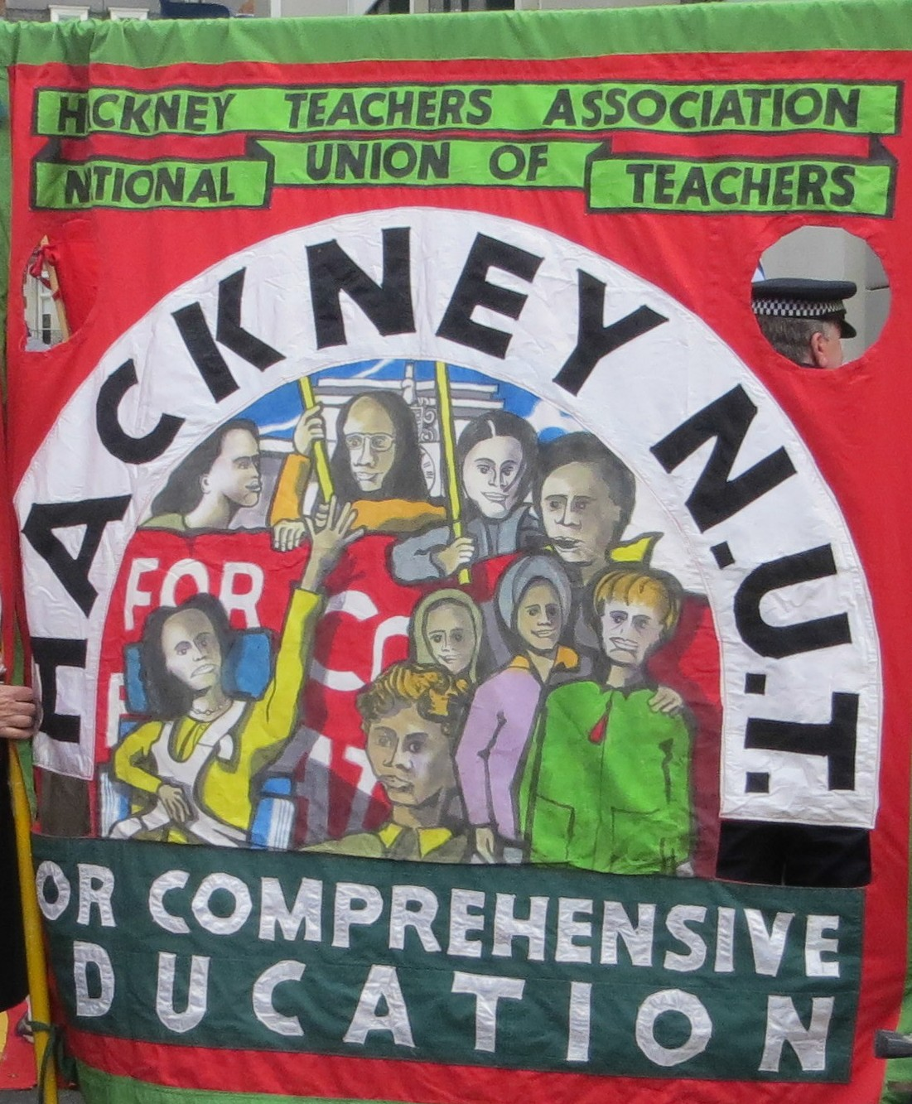

Developing Equalities in Schools for Staff and Students
Revised Handbook

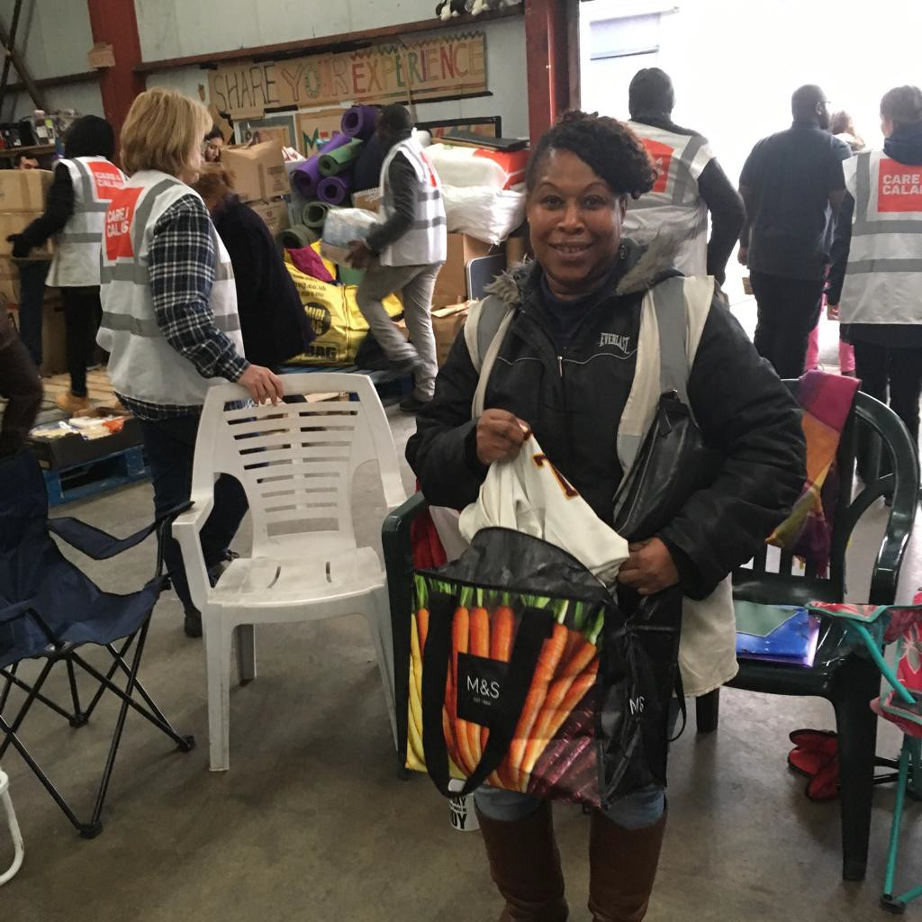
In Memory of Claire Gray, Joint Equalities Officer Hackney NEU/NUT 2015-2019.
Claire unexpectedly and very sadly died in March 2019. She was a reception teacher at Holmleigh School and was always an active trade unionist. She always fought for Equality and the rights of all teachers, staff and children.

Published by Hackney NEU District , National Education Union
First Published Hackney NUT, June 2017 . Revised March 2019
- ­‐15 Florfield Road, Reading Lane, London E8 1DT 0208 985 2056

Edited by Richard Rieser Joint Equalities Officer
With many thanks to the following for their contributions and support Susie Burrows, Carole Buxton, Hester Enthoven , Dawn Gill, Sean Glancy, Anna Gluckstein, Claire Gray, Conor McCrory, Imbar Tamari, Michael Watts and Michael Vance.

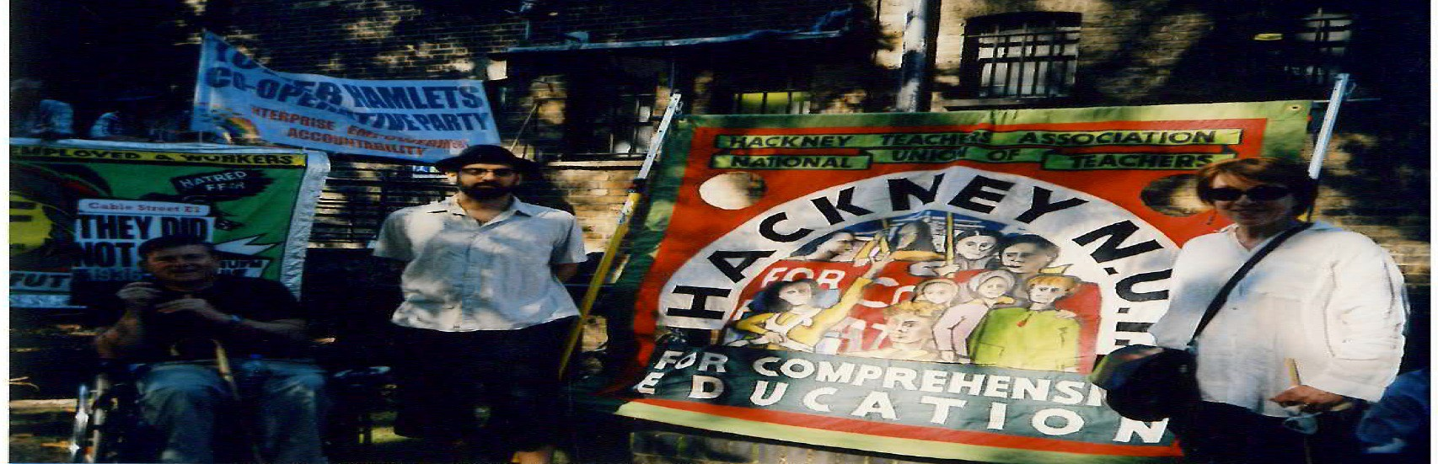
Commemoration of Battle of Cable Street 70 years.

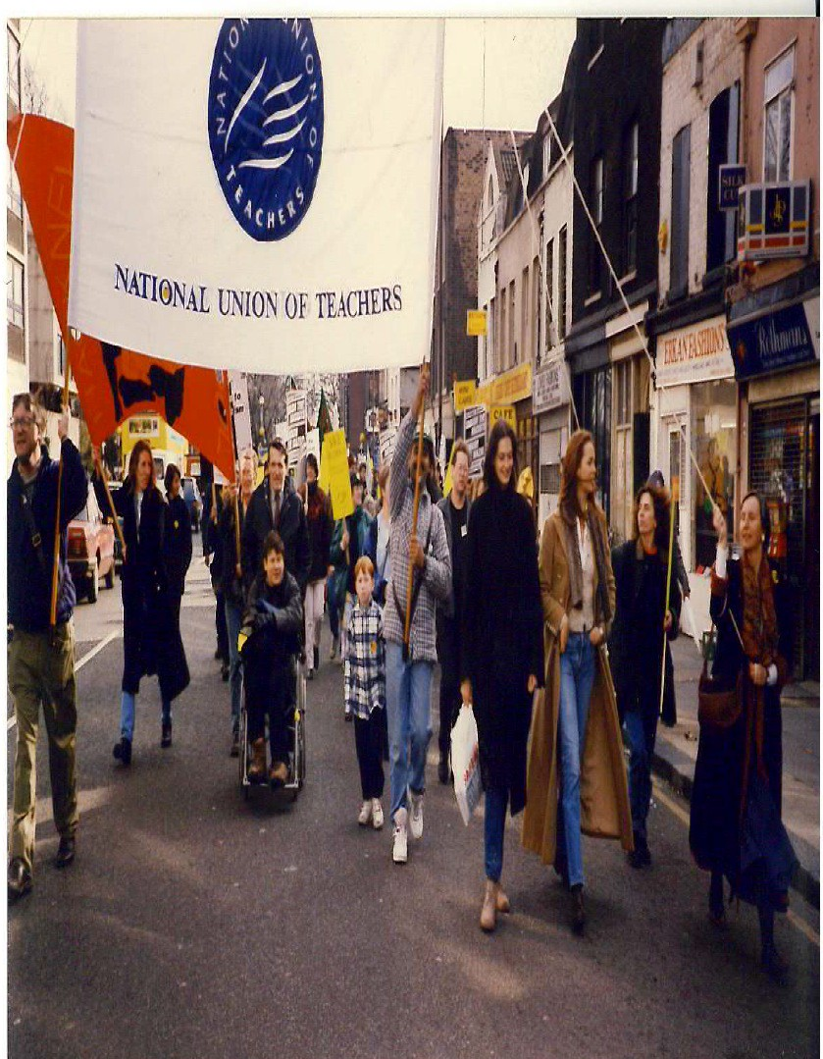

TUC March Against Racism 1991

Contents
Intoduction Richard Rieser 4-­‐6
Statutory Requirements for Equalities in Schools. Richard Rieser 6-­‐8 Declaration from Challenging Sexism in London Schools ,15th Nov 2014 9
The inclusion and attainment of Gypsy, Roma and Traveller pupils. Sean Glancy 10-­‐11

Primary Clasroom
Equalities in Reception. Claire Gray 12 Equalities in Year 2 Class. Hester Enthoven 13
Equality in Primary Classroom Year 3. Michael Watts 14
Developing an Inclusion Policy in the Setting/Class for EY/KS. Susie Burrows 15-­‐18
Challenging Bullying and Discriminatory Language in our School and Developing a Circle of Friends at St Matthias Primary. Susie Burrows 18-­‐19
Early Years/ Primary Books.19-­‐20

Secondary School Curriculum
Gender, science education , genetics and equality. Conor McCrory 21-­‐22
Challenging Sexism in Secondary Schools: Reflections, strategies. Mike Vance 22-­‐26 Raising Disability in the Secondary Classroom. Richard Rieser 26-­‐28
Tackling disablist language in schools: 10 top tips. Anti Bullying Alliance 28-­‐29 Diversity and Equality at Stoke Newington. Anna Gluckstein 30
‘Who makes up our community?’ Stoke Newington School Presentation for Drop Down Day. 31-­‐36 Equalities and the National Curriculum. (KS1-­‐3-­‐History and Geography). Dawn Gill 37-­‐45
Equality Resources. 46-­‐52

Equality for School Staff
Case Studies. 53-­‐54
Barriers Visible and Invisible: the impact of Racism on BME teachers. The Runnymede Trust and NUT summary. Dr Zubaida Haque and Sian Elliott 2017. 55-­‐56
Pregnancy Rights. 57-­‐59 Harrassment protection. 60-­‐61 Staff Equality Resources. 62-­‐63
Notes: What will I take back to school? 64

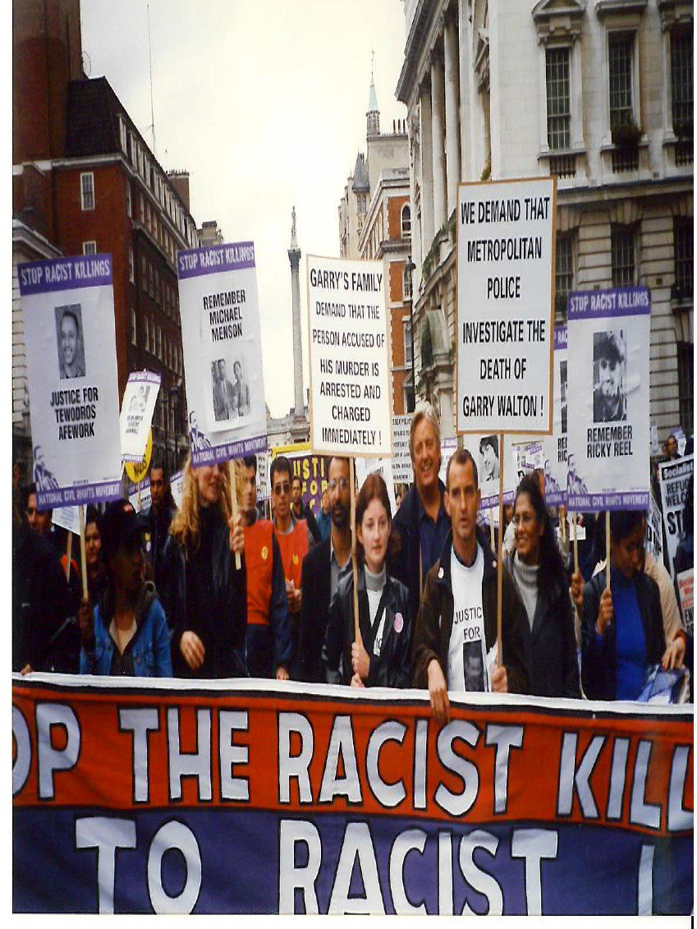
Intoduction The members of Hackney Teachers’ Association have a long and proud record of challenging prejudice and discrimination in schools for staff, amongst pupils and in the community. This guide is to help carry on this tradition in the changing circumstances in which we live.

Some examples show the diversity of the HTA’s approach. Bringing the first successful motion on LGBT rights to NUT Conference, with City of Leicester (1988). Putting this into practice: supporting sacked nursery workers at Market Nursery (1983), building a national campaign of support for the victimised head teacher of Kingsmead school–
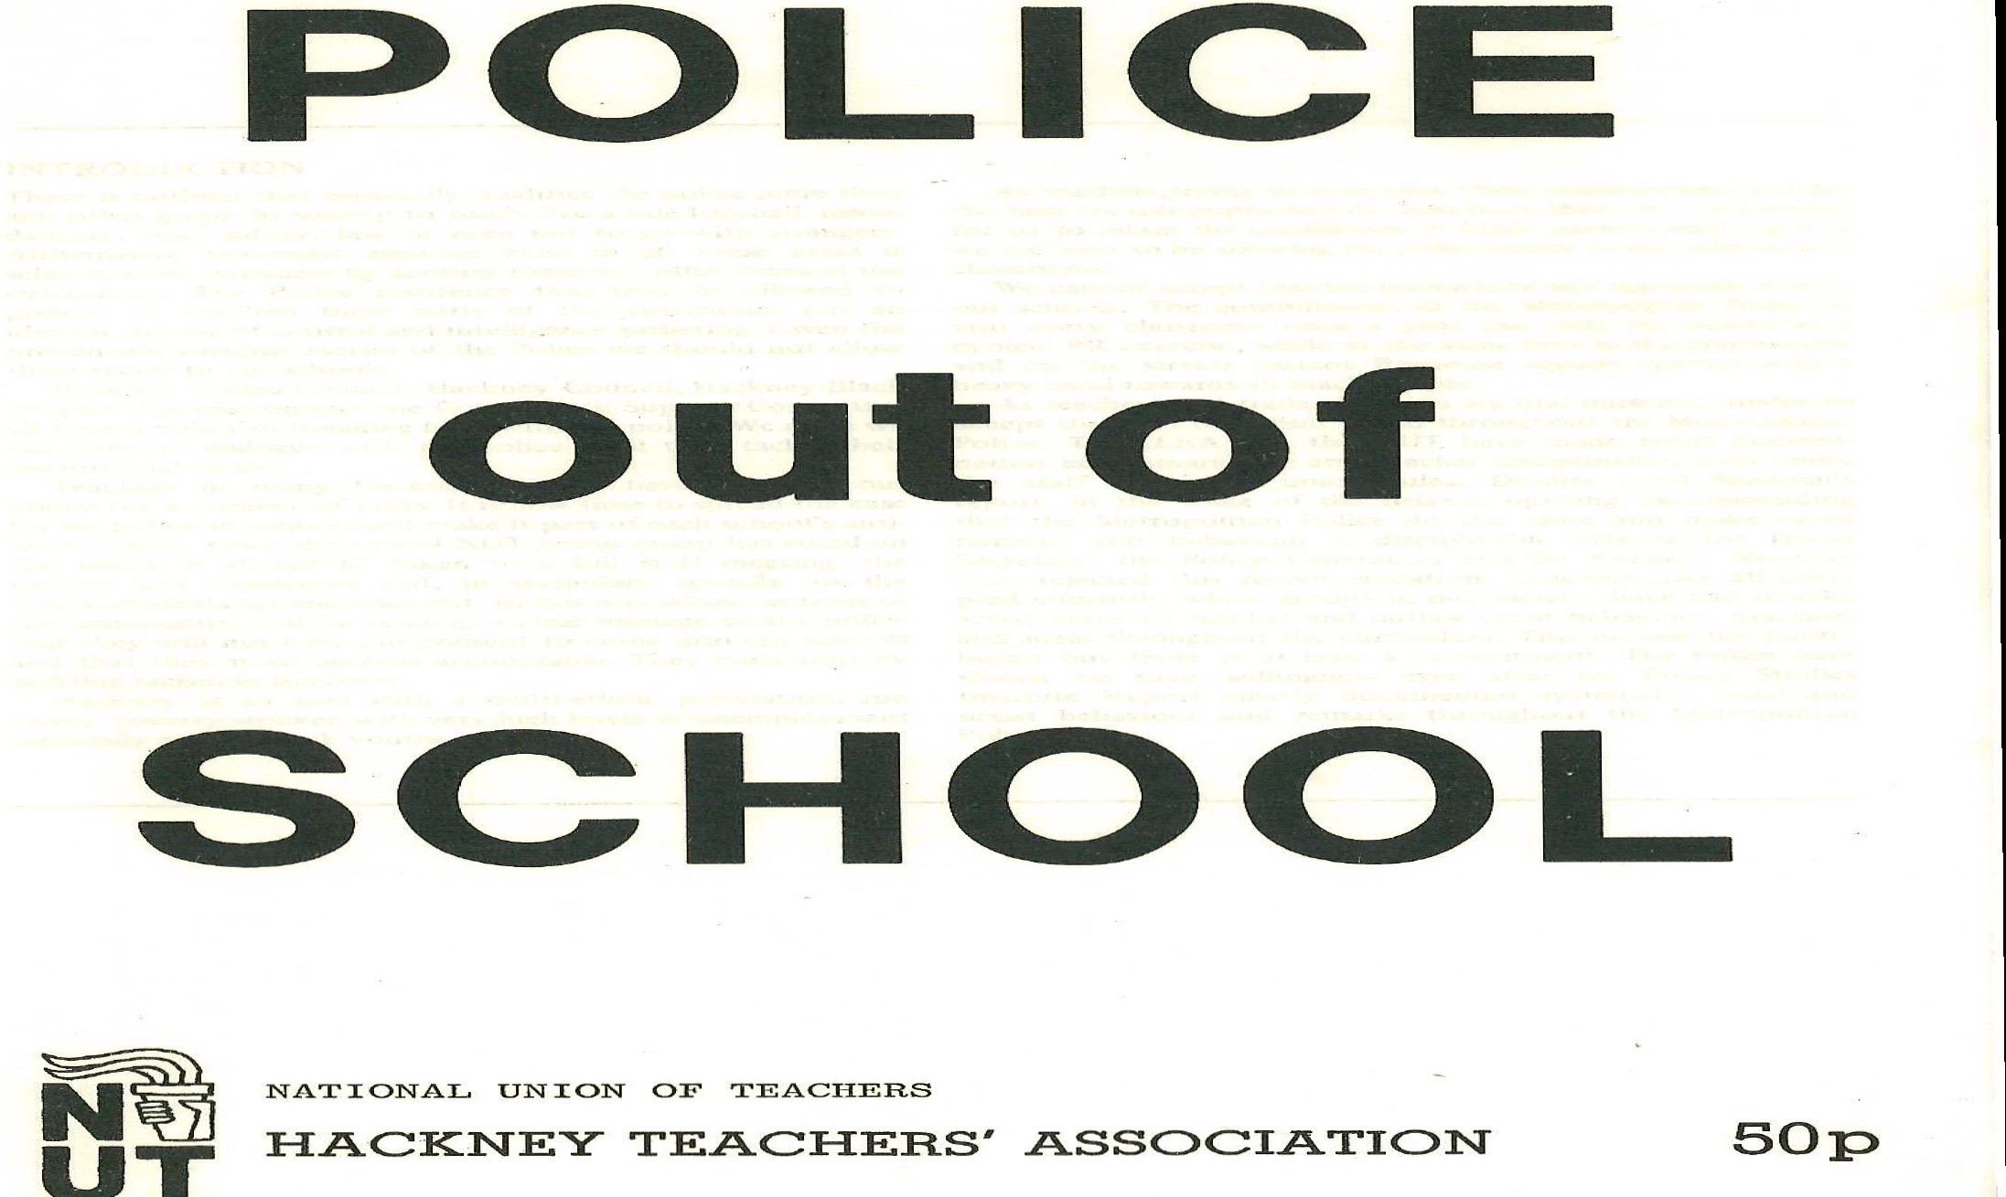
Jane Brown (1994). Challenging institutional discrimination against Black teachers and setting up the first Black Teachers Conference inwork time (1981). This led to the London Conference (1983). Championing Anti-­‐Racist teaching with motions to Conference since
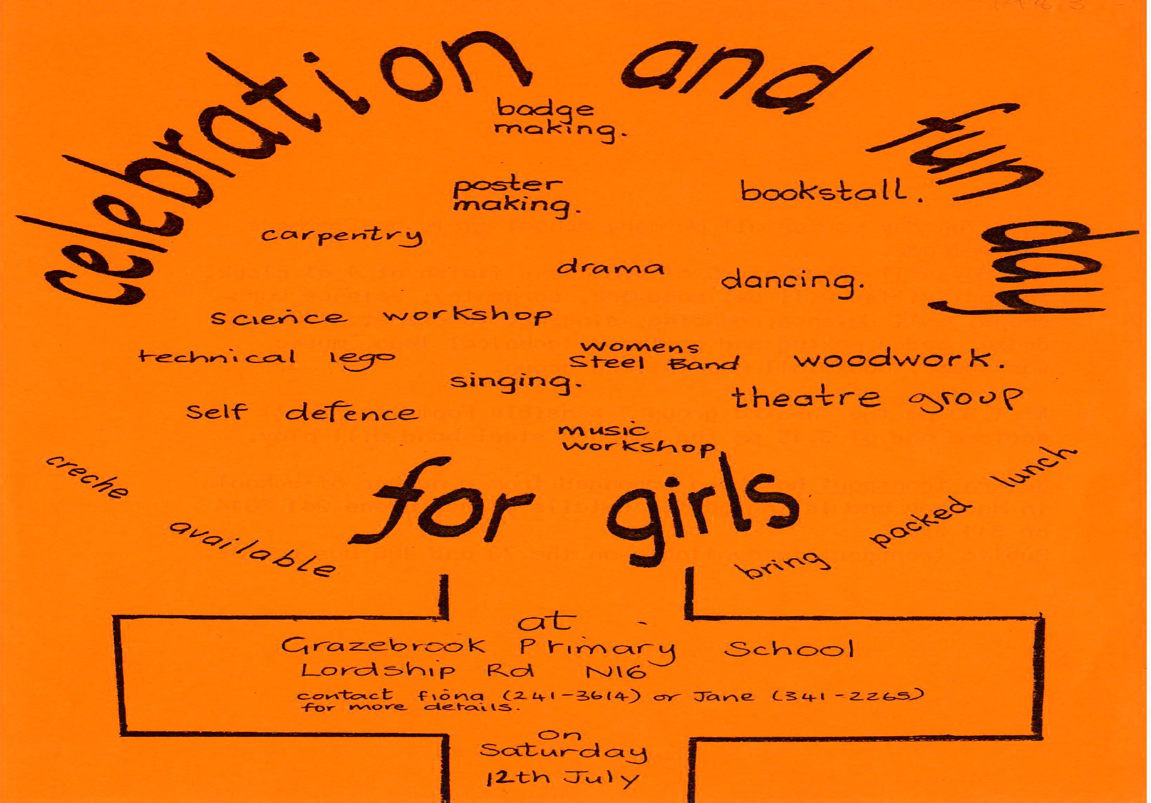
1982. Policy of ‘No Police in Schools’, pre-­‐Macpherson, when the Met was riddled with institutional racism (1986/7). Running numerous anti-­‐deportation campaigns, including the Hasbudaks. Consistently challenging racism and fascism in the community. Challenging Anti-­‐Semitism and running a day at William Patten (1984). Challenging

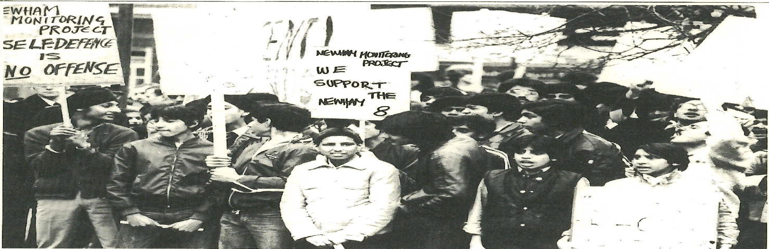
Conference (1999). Hackney Association has led on Disability Equality for teachers and Inclusion for Disabled Children with first successful motions at Conference (1989 &1996). More recently, running an Equalities Day (2014) and a London Anti-­‐ Sexist Day (2015); supporting refugees and keeping Equalities on general meeting agendas
Sexism, supporting a Girls’ Day at Stoke Newington (1982), a day for primary girls at Grazebrook (1983). Day Conference on Combating Racism, Sexism and Class Bias (1986). Anti-­‐Racism in Schools Day

The importance of equality runs through the NUT’s work, so that its members have a voice in the Union, in the classroom and in broader society, and do not face barriers to promotion, representation or participation. We believe that all children and young people should have equal access to a good school and an education system which treats staff and pupils fairly.
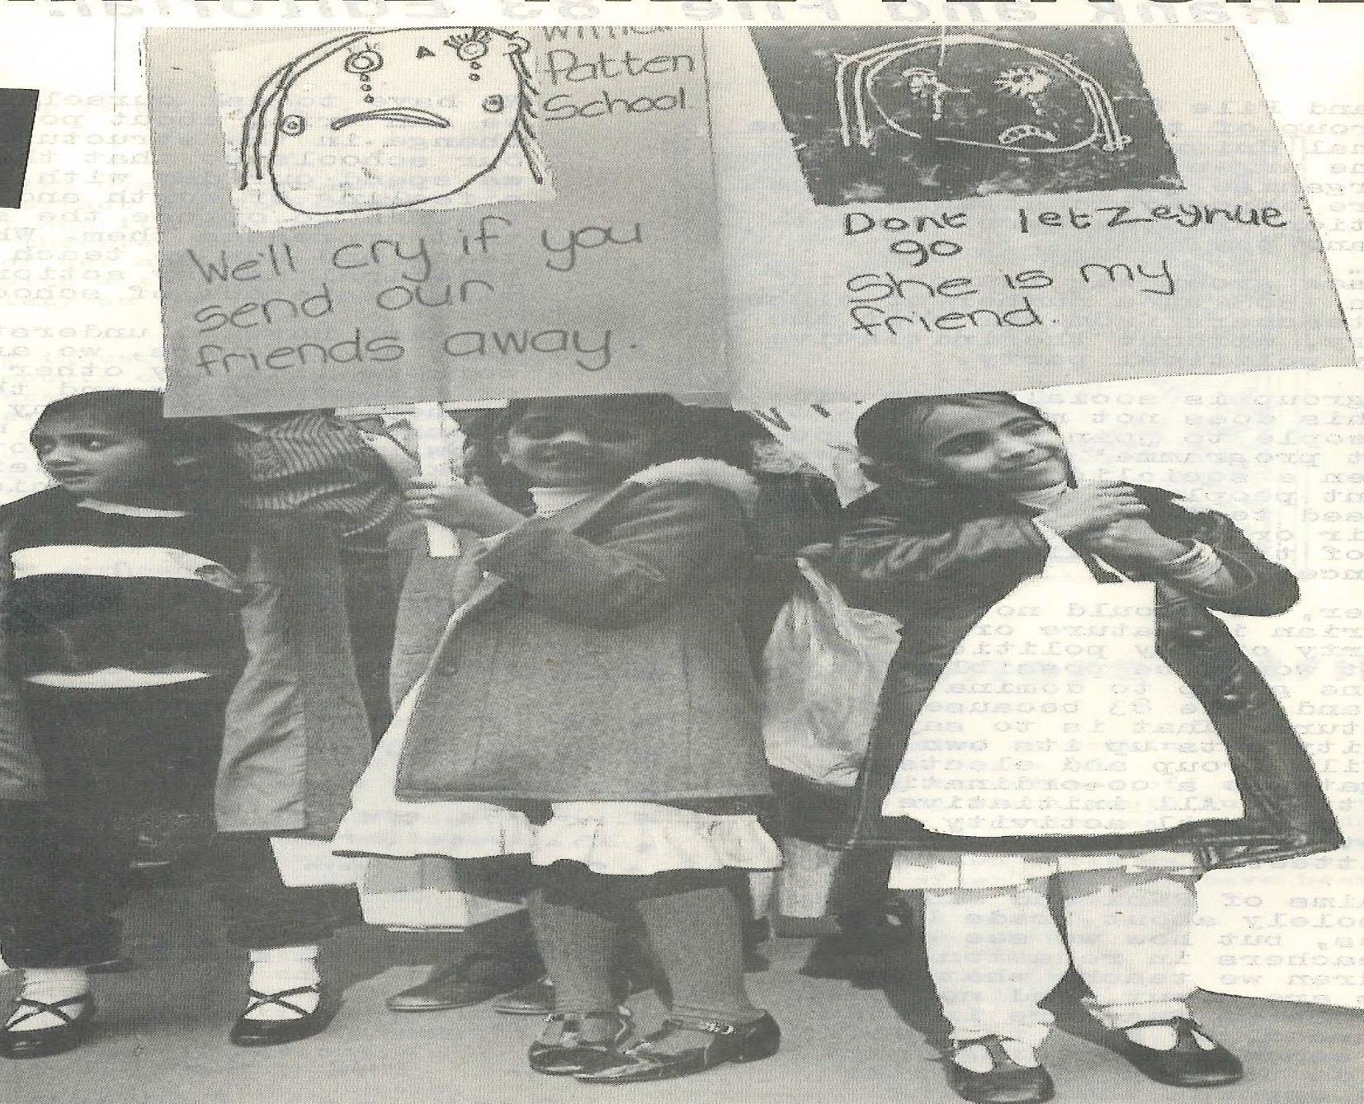
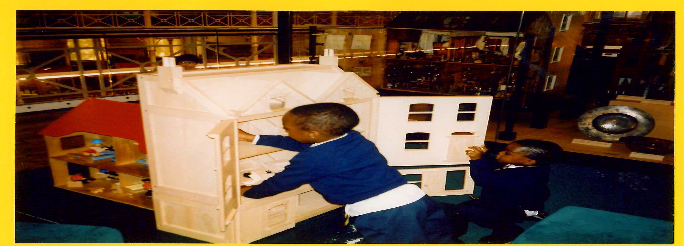
The NUT condemns all forms of racism, prejudice and stereotyping. Racist behaviour must not be legitimised by UKIP and other far right groups promoting religious hatred, Islamophobia and Anti Semitism. We campaign for a broad curriculum with a world view, as teachers will not be part of a narrow concept of Britishness. Schools need to provide safe spaces for all children and young people, free from all

prejudice and negative language or attitudes which lead to bullying. Schools can create a culture and ethos which challenges harmful behaviour and ensures that all parents and pupils are welcome and safe. Schools need to take active steps to counter prejudice, welcome and listen to
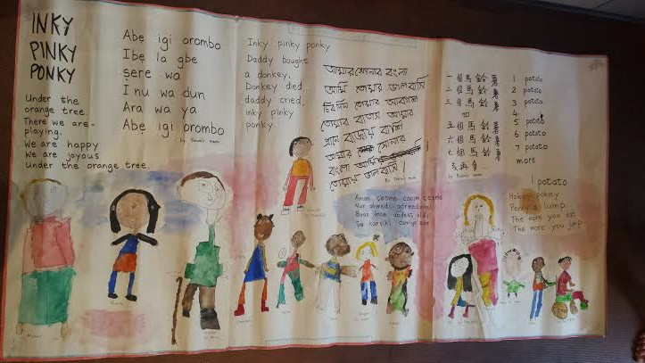
parents and have a positive approach to every child’s strengths.

classrooms, schools and community. Together we can help build an inclusive society.
The Equalities Act of 2010 requires all publicly funded schools to promote equality in all their policies and practices under the General Equality Duty for pupils, staff and parents. The NUT is a strong advocate of Human Rights in our

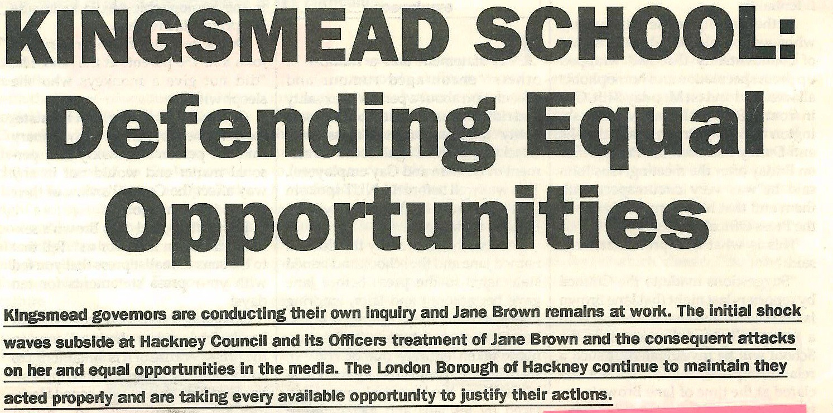
Statutory Requirement for Equality in Schools
1994

Schools, colleges and local authorities are under a statutory duty to be proactive in the elimination of discrimination, harassment and in the promotion of equal opportunities for both staff and pupils. This means they must assess the impact of their policies and practices on the people affected by them and take steps to remove any barriers that come to light where it is proportionate to do so.
- Schools, colleges and local authorities also have a statutory duty to foster good relations between people who share a particular protected characteristic and those who do not.
- Protected characteristics encompass age, disability, gender reassignment, pregnancy and maternity, race, religion or belief, sex and sexual orientation.
- Local authorities and the governing bodies of maintained schools, academies and colleges with 150 or more employees have a specific legal duty to annually publish information about the workforce which demonstrates compliance with the general equality duty. Public authorities in Wales are required to publish information about employees each year regardless of the size of their workforce.
- All schools and colleges in England, regardless of the size of their workforce, should publish equality information about their employees each year to demonstrate compliance with the general equality duty, even where there is no specific legal obligation for them to do so.

Duty to Promote Equality Section 149

Eliminating discrimination
All bodies subject to the general duty must consider the need to eliminate any unlawful discriminatory conduct. This means considering how to eliminate discrimination, harassment and victimisation and other unlawful discriminatory conduct on grounds of a protected characteristic when making decisions or policies.
Example: a school has a record of increasing sexist cyber-­‐bullying of teachers. This could be tackled by reviewing and enforcing the school behaviour policy, the school IT policy and introducing a whole school approach to challenging sexism and gender stereotypes.

Advancing equality of opportunity
All bodies subject to the general duty must consider the need to advance equality of opportunity between people who share a relevant characteristic and those who do not share that characteristic. Bodies should reflect on the need to remove or minimise disadvantage, take steps to meet people’s needs, and encourage people to participate in public or in other activities.
Example: the racial diversity of a school governing body does not reflect the racial diversity of the school or the local community. The school could invite members of local community groups to stand as school governors when elections are due.

Fostering good relations
All bodies, subject to the general duty must make informed decisions in order to foster good relations between people who share a relevant characteristic and those who do not share that characteristic. Bodies should always consider the need to tackle prejudice and promote respect and understanding.
Example: a sixth form college is notified that a transgender student has been subjected to verbal abuse and offensive graffiti. The student union and college management could, in consultation with the student, address the prejudice and promote understanding of the needs of trans-­‐people through the curriculum and reiterating and enforcing the college harassment and bullying procedure.

Taking ‘positive action’ in the workplace or for students Under the Equality Act, an employer can take what the law terms ‘positive action’ to help employees or job applicants it thinks:
  - are at a disadvantage because of a protected characteristic, and/or
  - are under-­‐represented in the organisation, or whose participation in the organisation is disproportionately low, because of a protected characteristic and/or
  - have specific needs connected to a protected characteristic. An employer must be able to show evidence that any positive action is reasonably considered and will not discriminate against others. If it can, it may legally:
  - take proportionate steps to remove any barriers or disadvantages
  - provide support, training and encouragement to increase the participation of people with a particular protected characteristic. There is no legal necessity for an employer to take -­‐ or consider taking -­‐ positive action if it does not wish to do so

Protected characteristics
The general duty applies in respect of age, disability, gender reassignment, pregnancy and maternity (at work), race, religion or belief, sex (including equal pay), and sexual orientation. Marriage and civil partnership are covered only by the duty to eliminate discrimination at work. The coalition government decided not to extend the equality duty to address socio-­‐economic disadvantage.

Scope of the Public Sector Duty
Any ‘body’ with a public education function is subject to the general duty in respect of that function. This will include all schools and colleges in the state sector for all their functions and also independent schools which are not public bodies but which perform a public function. Non-­‐public bodies must ‘have regard’ to the general duty when exercising a public function. The general duty applies to all public authorities listed under schedule 19, including:
- local authorities;
- governing bodies of schools maintained by a local authority (including community, community special, voluntary controlled, voluntary aided, foundation, foundation trust, foundation special schools and maintained nursery schools and PRUs);
- further education and sixth form colleges;
- governing bodies of publicly funded universities;
- the proprietors of City Technology Colleges, City Colleges for Technology or the Arts; and
- the proprietors of academies and free schools.

Specific duties

In addition to meeting the general duty to have due regard to the need to eliminate discrimination, to advance equality of opportunity and to foster good relations, listed public bodies are required to (1) prepare and publish equality objectives(at least one, but NUT recommend 6-­‐10) and (2) publish information, to demonstrate compliance with the general duty. This started in April 2012 and should have been reviewed after 4 years in 2016. The information will usually fall into two main categories: information to identify equality issues, e.g. equality monitoring data; and information about steps taken in making certain decisions.

Protection against Discrimination
The Equalities Act provides protection from discrimination for those who have protected characteristics.
- Direct discrimination-­‐treating someone less favourably because of their protected characteristics (Section 13).
- Indirect discrimination-­‐ A person (A) discriminates against another (B) if A applies to B a provision, criterion or practice which is discriminatory in relation to a relevant protected characteristic of B's.(S.19)
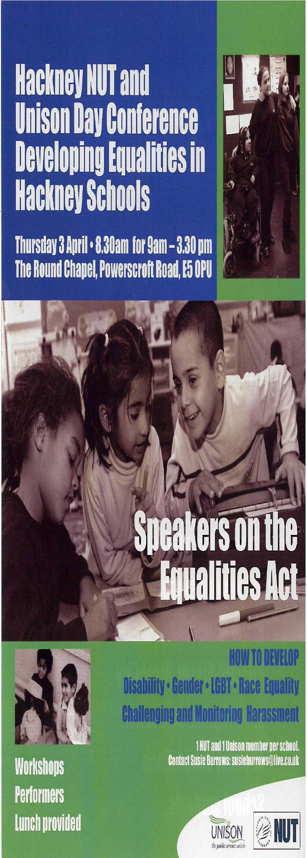
- Harrassment -­‐A person (A) harasses another (B) if—
  - A engages in unwanted conduct related to a relevant protected characteristic, and
  - the conduct has the purpose or effect of (i)violating B's dignity, or (ii)creating an intimidating, hostile, degrading, humiliating or offensive environment for
B.(s 26)
Additional protections for disabled people

- A person (A) discriminates against a disabled person (B) if—
- A treats B unfavourably because of something arising in consequence of B's disability, and
- A cannot show that the treatment is a proportionate means of achieving a legitimate aim. (S15)
Making Reasonable Adjustments
The first requirement is a requirement, where a provision, criterion or practice of A's puts a disabled

2013
person at a substantial disadvantage in relation to a relevant matter in comparison with persons who are not disabled, to take such steps as it is reasonable to have to take to avoid the disadvantage.
The second requirement is a requirement, where a physical feature puts a disabled person at a substantial disadvantage in relation to a relevant matter in comparison with persons who are not disabled, to take such steps as it is reasonable to have to take to avoid the disadvantage.
  - (5)The third requirement is a requirement, where a disabled person would, but for the provision of an auxiliary aid, be put at a substantial disadvantage in relation to a relevant matter in comparison with persons who are not disabled, to take such steps as it is reasonable to have to take to provide the auxiliary aid.
  - Failure to do the above is discrimination.
Remedies :Exhaust grievance and complaints procedure at school
For employee remedies at Employment Tribunal. For disabled pupils and students SENDIST For other Characteristics see redress at County Court.

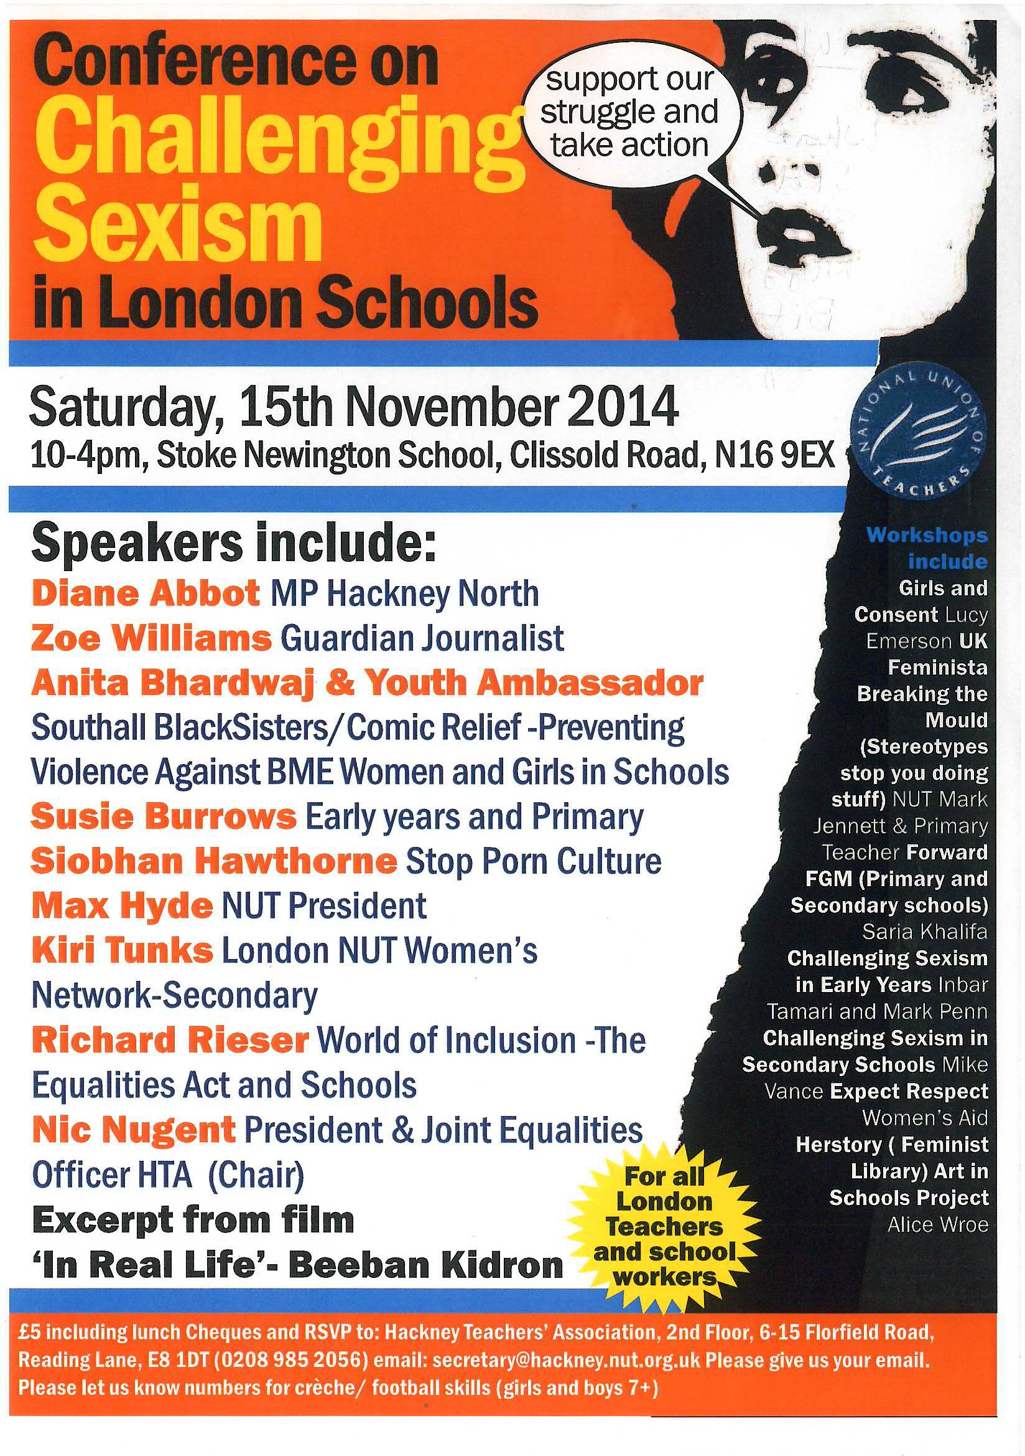
Declaration of Conference on Challenging Sexism in London Schools 15th November 2014
“This Conference believes that despite the formal, legal, equality that women have won, sexism and inequality are still a huge factor in shaping women’s lives today, and those of the students we teach and this is not acceptable.
We further believe this is having a particularly damaging effect on girls and young women we teach. Far from being ‘ironic’ or ‘empowering’, the rise of the ‘new sexism’ is damaging. Growing up in a world where it is normal for women’s bodies to be seen as sex objects affects the way that girls in our schools grow to view themselves and their place in society. Conference notes the persistently high number of women who routinely face sexual and/or violent assault within domestic relationships.
This Conference pledges to work to achieve the following:-­‐

- Full implementation of the 2010 Equalities Act which includes a duty to promote gender equality and eliminate discrimination and harassment.

- Pressure Government, Local Authorities, School Governors and School Academy Trusts who are responsible for this, to fund schools specifically for anti sexist education for boys and girls.

- A mandatory, quality Sex and Relationship Education (SRE) to be introduced in all schools. This should include:

  - the impact of objectification of young people through use of images in all types of media (internet, broadcasting, printed literature)
  - the damaging impact of widespread access to pornography on young peoples’ developing sexuality
  - girls, boys and consent
  - discussion of forms of violence against women and girls and FGM
  - issues affecting young girls and boys around their developing sexuality This is to be taught by teachers/people trained in the subject, considering all cultures.

Schools must:

- Ensure that all teachers and staff have a responsibility to consistently and on every occasion challenge sexism and gender stereotyping in all forms (physical, verbal, emotional, cyber) and to help girls and young women feel confident and secure, both academically and socially.

- Set up Anti-­‐Sexist initiatives that fully involve pupils in their implementation and development.

- Promote positive and non-­‐stereotypical images of girls, women, boys and men in the curriculum (e.g. through visitors, assemblies, Herstory, books, toys, displays and other resources.

- Encourage young people to build respectful relationships and identify and resist abusive behaviour(s).

- Encourage all pupils, regardless of sex or gender identity, to explore a wide range of interests/activities and to question stereotypical ideas about gender.
- Set up an Anti Sexist Working Group for staff to take this forward. We ask the NUT London
Women’s Network to publicize and monitor the above action points.”

The inclusion and attainment of Gypsy, Roma and Traveller pupils. Sean Glancy
What follows is an introduction to the ideas around how to improve the educational offer for Gypsy, Roma and Travellers. The list of questions below have been used in one form or another as a way of improving outcomes for pupils and provide ideas as to where schools are doing well and where more support could be required.
In the interests of brevity Gypsy, Roma and Travellers will be referred to as GRT’s in the rest of this article, what follows is not an attempt to encapsulate the total GRT experience across Britain.
Context

  - GRT pupils have the same rights as all others to unhindered access to education.
  - These communities have experienced a long history of racial prejudice and discrimination in England, Ireland and Eastern Europe. Many GRT families are reluctant to declare their true ethnicity voluntarily. Schools have a duty to create an inclusive culture that encourages all parents and pupils to be confident in ascribing themselves to their appropriate ethnic group.
  - Attainment trends show that GRT attainment levels have at the least not improved and some data suggests that they have fallen. Research consistently identifies GRT pupils as the ethnic groups most at risk from both the lowest attainment and the highest rate of exclusion from school. Roma and Travellers of an Irish Heritage are legally recognised ethnic groups.
  - Research evidence confirms that when GRT pupils are given the right learning environment and experience, they can be equally as successful as any other group.
  - GRT pupils are from nomadic traditions, communities that moved at different times of the year, often for economic reasons, or to escape difficult circumstances. Whilst many GRT’s still on occasion travel, the changing economic, social and housing circumstances that now exist in Hackney and London have acted to curtail a nomadic existence. Many GRT people will travel to participate in rites of passage, when they reengage with their wider extended families.
  - As well as social exclusion many GRT families experience economic exclusion, often living in overcrowded, low quality and insecure accommodation, frequently leading to high levels of mobility, moving from home to home.
  - In Hackney there are four recognised sites where Travellers live, however such are the numbers of GRT people in the borough data shows that far more GRT people live in housing of one form or the other. Aspects of GRT culture are often closely followed, schools need to be aware of such traditions if they are to be able to understand the needs of these communities.
The following questions are designed so that the work already being done can be recognised and areas which need development and/or support. Hope they help!
How does your school offer an open and warm welcome to newly arrived pupils, including GRT pupils? How does your school encourage parental involvement? Do GRT carers participate in the school life? Does school management support the welcome, induction, integration and achievement of GRT pupils? Do you know what GRT carers and pupils think of your school?
Is the language used when communicating with carers appropriate and clear? Are you aware of the language/s used at home?
How does pedagogy encourage inclusion and participation, where every pupil is valued?

Is there a flexible approach to the curriculum offer? Which pupils are offered vocational experiences?

Is attainment progress clearly understood and analysed so that learning can be maximised and attainment gaps minimised? Are GRT pupils identified as a social and educationally vulnerable group and thus monitored?

Are your school values inclusive of GRT pupils? Does your school celebrate identity and image? Do relationships between pupils, between staff and pupils and between staff, promote respect?
How are the values of SEAL integrated into the school life?

How much do you know about GRT cultures and lifestyles? Have you had any professional development in this area? Does your school have positive images of GRT communities? Has there been a curriculum audit which identifies where GRT cultures are reflected in the curriculum offer? Do you know what GRTHM is?
When does pupil career education happen in your school? How are career aspirations developed and are GRT pupils involved in this work?
How does an awareness of GRT cultures affect work on sexuality and gender roles? Is effective support for GRT pupils seen as a whole-­‐school responsibility?
Is there an ongoing school discussion about expectations for lower achieving groups of pupils?

When was the last time you spoke with the local Traveller Education Service?
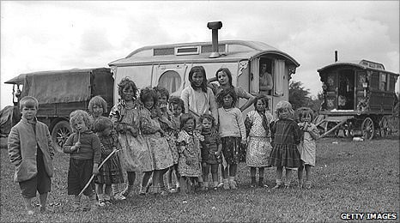

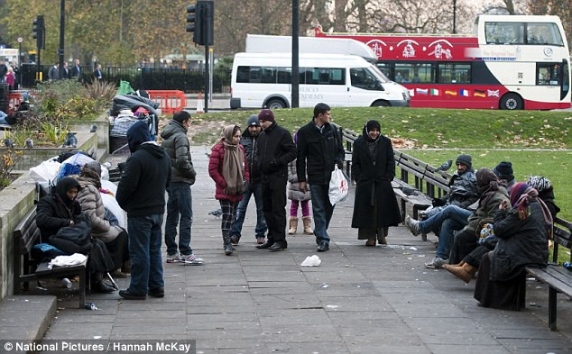

Equalities in Reception Claire Gray

Equality in the Classroom - Reception

The cohort of my class has changed over the years that I have been in school. This year group is very diverse and very young, with a big language gap. In our setting, we have some children from our own nursery and some from other centres. This usually works out as half and half. We stagger our intake in September and have the outsiders in first, to settle them. During our home visits, we build up a picture of the children's background and environment. We then try to create safe and recognisable spaces in the classroom and our outside areas, to be welcoming for them e.g. with images, materials (clothes) and photographs around.

Our phase leader has developed a system called "The Thinking Space", which is a board with pictures representing the class population, symbols and some words. This is where we encourage the children to go and talk about their problems and incidents which happen around the classroom/school. The idea being that the children, even if they are unable to verbalise the situation, can point to a picture, eg. ''I'm sad you hit me". The adults monitor the interactions and prompt what children may then want to say. "I'm sorry" is the general response. We also use the "Go-givers", which is part of the PHSE and Citizenship Education programme of the Learning Trust. This brings to life children from all areas and with a variety of differences e.g. wheelchair user, refugee, single parent. The children learn about their situations and talk about what they know about these situations, how they feel, how could they help these children. The children build up empathy with what they see and learn. Some have very strong views about what they are shown.

As a teacher, I learn a lot from the children's reactions to what they are presented with. One child, who is in fact homeless, reacted very badly to the refugee video and I was then able to help as well as recommending outside help for her. I also have a varied display of books and music around the classroom for the children to assess. Our last focus book, with the theme growing, was 'Jack and the Beanstalk/Jill and the Beanstalk'. We also read 'Jim and the Beanstalk'. Jack had no dad, Jill was bullied and Jim helped the giant who was going blind, needed a wig and had no teeth. You can always find a variety of books if you look.
Our school encourages parent volunteers and we get quite a few. We celebrate all the communities and as we are now an avid believer and participator in the ''Healthy Schools'' programme, we hold many events around home-made foods.
I have sent a survey round to all my teachers asking them for a few ideas for developing equalities in their classes. Hopefully i will be able to feed back some of these.

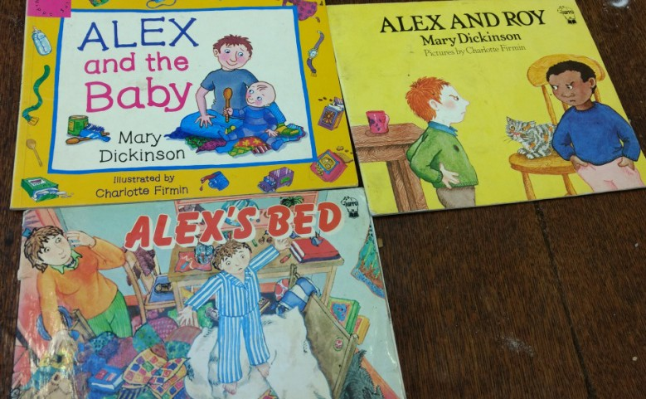
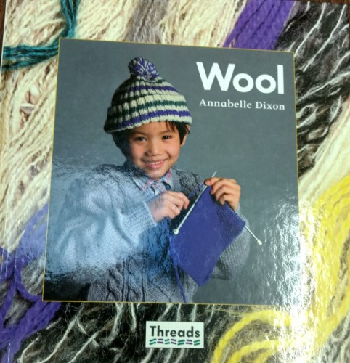

Equalities in Year 2 Class Hester Enthoven

In my opinion one of the many wonderful benefits of working in Hackney is having such a diverse range of races, cultures, abilities and religions within your classroom therefore equality can be taught in a realistic and meaningful way. Creating a classroom culture which is based upon equality is very important for children’s personal, social and academic education and below I have outlined a few ways I have done this (there are many more!)

To ensure equality is present in my classroom I make a point of teaching about many religions, allowing children to share their knowledge of their religion and have a dialogue about the similarities and differences between them, and what makes each unique. I also ensure the children’s different cultural backgrounds are celebrated by holding events such as world food day, or everyday by the children responding to the register in their home language.

For me, upholding equality in the classroom means ensuring all voices are heard, be these worries or happy thoughts. In practical terms this is hard to do daily so I have a ‘Worries, Smiles and Compliments’ box for the children to write notes to me. These are shared or dealt with when appropriate and beneficial. I believe it is also important to deal with issues as and when they arise and ensure that time is given for this. For example, if there has been a negative comment made or unfair treatment by one child to another (I find these usually arise in the playground) it is key not to delay addressing it but put whatever you are about to teach on hold and have a circle time to address the issue. To do this effectively it is important to build up a culture in the classroom where children feel comfortable to tell the truth and share. This can be created through effective PSHCE lessons early on in the year.

Teaching equality can begin with looking at gender. In my school we have a special safety PSHCE week. In this week we teach E-­‐safety, anti-­‐bullying and age-­‐appropriate sex education. For Year Two we did a very simple but effective activity: we had a Venn diagram of ‘boy’, ‘girl’ and ‘both’ and the children had to sort a selection of items such as a football boot, Barbie, car etc but also clothes such as a skirt or jumper. The children concluded that everything can be for either gender. This brought up lots of pre-­‐ conceptions to be dealt with but it can also bring up issues such as the fact that some people look like a boy but feel like a girl. It can be a good starting point for many discussions.

Never underestimate the importance and necessity of teaching equality, it doesn’t always need to be explicitly but can be done through everyday activities.

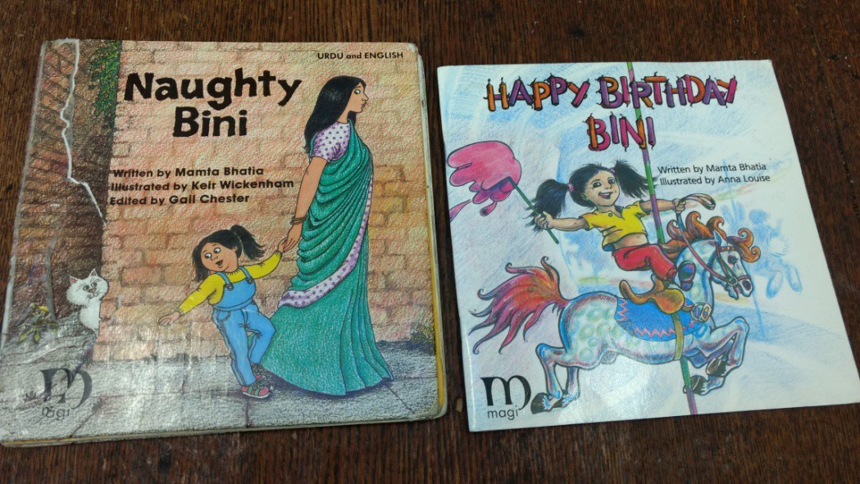

Equality in Primary Classroom Year 3
I always think it is fascinating that a group of children, however young, have a deeply ingrained sense of what is fair and what is right. My Year 3 class, with a very diverse set of backgrounds, are deeply sensitive to some issues, occasionally leading to uproar in the class as they rightly or wrongly condemn what one pupil has said. At other times there will be barely a murmur as one child makes a very one-­‐sided statement such as “Men are the ones who should provide for their family,” or asks a question rooted in deeply negative beliefs.
At all of these moments, I believe it is vitally important to take a few moments to unpick what has been said and to reach a consensus with the class as to whether the opinion shared is fair or not, before we move on with our day. Issues have emerged during the school day, ranging from who should wear pink and whether boys are allowed to have long hair, to whether it is appropriate to classify the skin-­‐tones of students and comment on their possible heritage. Although my class are very sensitive to the idea of racist discrimination, not one of them identified a problem with their widely shared assumption that our one Chinese pupil would know everything about traditional Chinese creation myths.
Sometimes the issue makes itself obvious, when many pupils object loudly to another’s opinion. At other times problematic opinions can be shared without objection and it is important to be on the lookout for these. When we discuss an opinion that has been shared, as a class we unpick it by looking for similar themes each time. Does this opinion categorise people by something such as race, gender or sexual orientation? Does this opinion over-­‐generalise or stereotype? Are we making an assumption about what one group thinks is ‘normal’?
Often it helps to reframe an opinion in order to highlight how unfair it really is. While the class may not react, or even start to agree with a statement such as “only girls should have long hair”, it is easily switched around to ask “Why can’t a boy have long hair?” or “Why can’t girls have short hair?” When one child says “Do Chinese people all know Karate?” we can ask “Do all people from Africa know how to do African drumming?” or “Do all English people know how to play tennis?”
We are all under a great deal of pressure as teachers, and free time in our timetables is ever diminishing under the weight of core subjects and assessments. However, I feel deeply that these issues cannot be shelved until later; that when opinions are shared that need to be openly discussed we cannot shy away from this or delay the conversation. It takes only a few moments to work together as a class to calibrate our moral compasses. I am proud that children leave my class having developed their sense of equality and fairness, which they will absolutely need to join the world beyond the school gates as tolerant and well-­‐ adjusted adults.
Michael Watts, Harrington Hill

Developing an Inclusion Policy in the Setting/Class for EY/KSI

Susie Burrows

Written for the pack 'All Equal All Different' (2004), updated 2017 and still very relevant. Can be used for KS2.

Many young people, who do not find racism acceptable, still engage in sexism, homophobia, or disabilism, by name-­‐calling or bullying, and some teachers ignore this. All schools need to have an ethos where all children feel welcome and safe. The school should challenge all forms of prejudice and promote equality through measures such as these:

- Teachers/practitioners need to promote an ethos in all classes where children feel able to talk about their lives and feelings, the class are encouraged to support one another, and work collectively. The effects of racism, including anti-­‐semitism, disabilism, sexism, homophobia
and prejudice eg. based on class or religion (anti-­‐Moslem) can be explained and discussed so the children develop empathy, are able to challenge discrimination and include those who may feel excluded, supporting them within and outside the classroom. Young children can be taught this by drawing on their great sense of fairness.

- It is essential to be aware of harassment which can take many forms, (from moving slightly away from a child on the carpet to physical attack), e.g. not wanting to sit next to a child who looks, acts or behaves differently, or not playing with a child who has a facial impairment or has a different ethnicity.
- Seemingly minor incidents should be discussed and brought out in the open so the victim is supported and the whole class understands the effects. Value the teaching of art, music, drama, dance and PE as much as other subjects. Skill and achievements in these areas, and the consequent self-­‐ esteem, lead to greater ability to achieve in all subjects. Use a wide range of teaching and learning experiences. Modern neuro-­‐science has shown that the brain is plastic and continually changing, depending on environmental stimuli. Sexism develops from different treatment as well as all forms of the media. Challenge sexist (and all other) assumptions as soon as they arise. This can be when a 3 year old says that boys can’t wear pink. If the teacher continually teaches that girls and boys can do anything and organises the activities so that all children partake, young children soon picks up this ethos.
- All members of staff should challenge stereotypical and prejudiced comments used in lessons, the playground and the surrounding environment. Explain why name calling is hurtful. Support staff should be trained in this, as well as teachers.
- Support pupils who encounter harassment in the community, understanding that children who live in fear cannot learn. Support and campaign for families who face deportation.
- Use assemblies, to deal with issues of prejudice. Use film/tv clips. Present life stories of, for example, disabled people and how negative attitudes affect them.
Use opportunities to celebrate the richness and diversity of different cultures. The following can be a focus: Holocaust Memorial Day (January 31st); LGBT History Month (February); Women’s History (March); Refugee Week; Traveller History (June); Black History (October); UK Disability History
(22nd November – 22ndDecember); a variety of religious days (from an anti-­‐racist perspective), being aware that multi-­‐cultural education on its own does not challenge racism; make sure to include white working-­‐class children, teaching about the writing, art and struggles for social equality that give dignity to working-­‐class people.
- Draw parallels between racism, sexism, disabilism, homophobia and discriminatory practices based on social class: to foster solidarity between all children.

- Develop an approach of celebrating achievement against each child’s previous achievements, rather than standardized attainment. Challenge the impact of normative testing. Try to get your school to use other forms of assessment eg. 'Learning for All'.
- Explore opportunities throughout the curriculum to promote inclusion e.g. circle time, circles of friends, use of media and film, visiting speakers from local minority ethnic communities and disabled people’s organisations. Use the adults working in school and parents, from a variety of backgrounds or ask people from local organisations.
- Display work from all pupils with achievements in any areas of the curriculum in and outside the school. Ensure the materials and content of lessons cover a wide diversity of different cultures and people.
- Review resources, such as books, posters and ICT software to ensure they are inclusive. In books a variety of people should be ordinarily included, not as an 'issue'. Fairy stories can be re-­‐told or re-­‐ written. Adverts can be analysed and re-­‐done. Even children in Early Years can do all these.
- Provide accessible school structures where pupils, parents and staff have a voice.

Making it Happen
- In order to allow the ethos described above to develop, teachers must ensure there is time and space each day when children feel free and comfortable to talk about anything in their lives
that interests or troubles them. This can be very difficult if your school expects a rigid timetable but it is crucial. It can be a starting point for discussing issues of how people are treated, e.g. if a child feels able to talk about their personal experience, or even to express bigoted views, the rest of the class can learn to be supportive or to challenge. This leads children to feeling safe enough to express their own fears. The teacher needs to teach where discriminatory attitudes come from, historically and currently, so children understand that all difference in people is acceptable and can be celebrated. If you just tell children not to use certain words it is pointless. If they understand the history of the words and the effect on others they understand why not to use them. This can be achieved with very young children because you can use their great sense of fairness and you teach them all day.
- It is more effective to bring issues into the open and deal with them collectively, rather than seeing individuals after the session, although this is sometimes also necessary. In all groups and classes, if anyone is being offensive in any way (however subtle) the teacher should stop the whole group/class and challenge this. They can all discuss the issue and the aim is to develop a positive and supportive class attitude to difference. The child who is being subjected to harassment, however seemingly minor, needs to know the teacher is on their side and that the rest of the class/ group know this. It helps if the school has a consistent policy applied by everyone but you can still do it on your own!
- Set up the class so children are, as far as possible, able to work autonomously, with easy access to equipment. Take a flexible approach to carrying out the tasks required by the National Curriculum.
- Set up a range of groupings with individuals, pairs, whole class/group and small groups. Ensure the composition is varied (taking account of children’s needs) – a mix of ability, impairment, social background, gender and ethnicity. More able children learn a great deal when having to explain an idea to someone less able.
- The teacher needs to show that all children are valued by openly praising each child’s individual efforts and achievements to the class and encouraging the class to do likewise. (I had a class of 5year olds who clapped when a child who found walking difficult managed to walk along a bench for the first time, although other children were able to achieve far more athletically.) This should be in all areas – creative, physical, social and academic, creating a strong ethos in classrooms and settings.

Making Reasonable Adjustments

All settings and schools are under a legal duty to anticipate the needs of disabled children in admissions, education and associated services in their policies, criteria and practices. (2010 Equalities Act.)

- Make sure that children who are wheelchair users or use walking aids e.g. frames or crutches, have the space/classroom set up so they can access everything;
- Ensure that children with visual or hearing impairments sit on the carpet or at the table in a place where they can fully participate;
. Children with learning difficulties should be able to access planned play, free play and all teaching and learning opportunities;
. Children with any medical need requiring them to eat, drink or go to the toilet more frequently than others, should be able to do so without feeling uncomfortable;
. Children who cannot stand for long should not queue but be allowed to go to the activity e.g. dinner and sit down with at least one friend (who can be varied) so they are not alone or just with an adult;
- If children find it hard to concentrate or stay still because of their underlying impairment, such as autism or ADHD, allow them to engage with other activities even when the rest of the group may be doing something else.

Making Friends

If you have developed the supportive ethos described, children will welcome and look after anyone new to the class/ group. They can all feel responsible for making them feel welcome and looking out for them.

As well as the whole class being responsible, it's good to specifically choose two children (a boy and a girl) to befriend a new child for the first few weeks. A child with a behavioural or learning difficulty can benefit a great deal from supporting someone else. If children do not make friends you need to intervene and help. This is so important, as children can be left to be ‘shy’ or picked on. ‘The intentional building of friendships' started in inclusive schools in Canada. This can be done by using a circle of friends.

Teachers need to be very aware of how friendship patterns are developing in the class/group so they can intervene where necessary. If you notice some confident children controlling the forming of friendships and making some children feel unwanted, you need to nip it in the bud because it can escalate and cause unhappiness. Children who are unkind are often unhappy themselves and are relieved when the teacher helps them behave differently. They also need praise when they change.

Teachers and practitioners have immense influence in Early Years and KS1 settings and if they make it clear what is acceptable, children do respond, especially to praise. Even very young children are able to take on this ethos and make it their own. Here are 2 examples out of hundreds. I taught a 5 year old white working class girl in a mixed age class with this ethos. Her mother came in one day and said ''Geri has told me to stop calling the man in the corner shop a 'Paki' and explained why. She's told me how you said the National Front went round 'Paki bashing' and attacking people just because they were Asian and that her friends in the class are from Bangladesh and even if they were from Pakistan they wouldn't want to be called 'Paki'. So now I've stopped!'' Another time a child joined my reception from the nursery and he said to another boy ‘my drawing is better than yours!’ The other boy said 'Susie doesn't have better in here. We all do our best in different ways.' The child never said his was better again and I didn't have to say anything.

You cannot force children to be close friends with everyone, but you can teach them to be tolerant, kind and respectful of others feelings and to treat each other supportively in and out of the classroom.

Children want a harmonious and happy environment as they spend many hours there and are relieved when the teacher enables this to happen. This applies to those who bully as well. Even children with difficult behaviour who are hurt or damaged by what has happened in their lives already, can flourish in a safe and supportive atmosphere.

Challenging Bullying and Discriminatory Language in our School and Developing a Circle of Friends
Susie Burrows, formerly St. Matthias Primary.
A pupil in Year 6 was frequently in trouble and presented very challenging behaviour. We discovered that he was also being bullied. We, as two EMA teachers, started anti-­‐bullying lessons in Year 6 and later throughout Key Stage 2. Children in Year 6 then offered to form a ‘Circle of Friends’ for the pupil.
The group in the ‘Circle of Friends’ and the rest of Year6 were very supportive and also began to successfully challenge bullying in the playground. They asked if they could do an Assembly for the school. They improvised scenes to show different sorts of bullying and to challenge some of the discriminatory language commonly heard in our playground.
These are some of their statements:
“Paki is a racist insult, started by racists who hate Asian people. People from Pakistan are Pakistanis, not Pakis. Salman is from Bangladesh. Therefore he is a Bangladeshi. Don’t cuss where people’s families come from.” Kayode.
“Idiot is a rude word from years ago, when people with learning difficulties were locked away from everyone else. Everyone’s brains work differently. Don’t call anyone idiot.” Tomi.
“Short Hair/Boy. It is sexist to think girls or boys can’t have short or long hair or do the same things. (Sexism has been going on for hundreds of years.) It is cool to have your own style. Don’t cuss people’s hair or how they look.” Christopher.
“Fat people are everywhere. They are mums, dads, our teachers, our friends. Fat, thin, big or small. Don’t make fun of people’s size.” Gabriella.
“Oxfam. Many famous and stylish people buy clothes at Oxfam, because they are unusual. It’s better to have your own style than to copy everyone else.” Salman.
“Your trainers. Children in some countries are forced into slave labour to make trainers like Nike. So there’s nothing cool about expensive trainers.” Ify
“Your Mum (with insults).You would hate your mum to be insulted. This is sexist, don’t do it!” Akeem.
“Gay can mean happy. But these days it’s often used as an insult. Many men love each other and many women love each other. There is nothing wrong with this. Don’t call people gay as an insult.” Shamal.

Bullying can be physical, verbal or silent.
- Silent bullying makes people feel bad inside.
- It makes people feel excluded.
- People may bully because they are insecure with their own life.
- Some people even kill themselves because they are bullied at school.
- There is bullying in society, let’s stop it in our school. We are the future!

We also ran drama classes in Years 5 and 6, teaching Assertive Behaviour, rather than Aggressive or
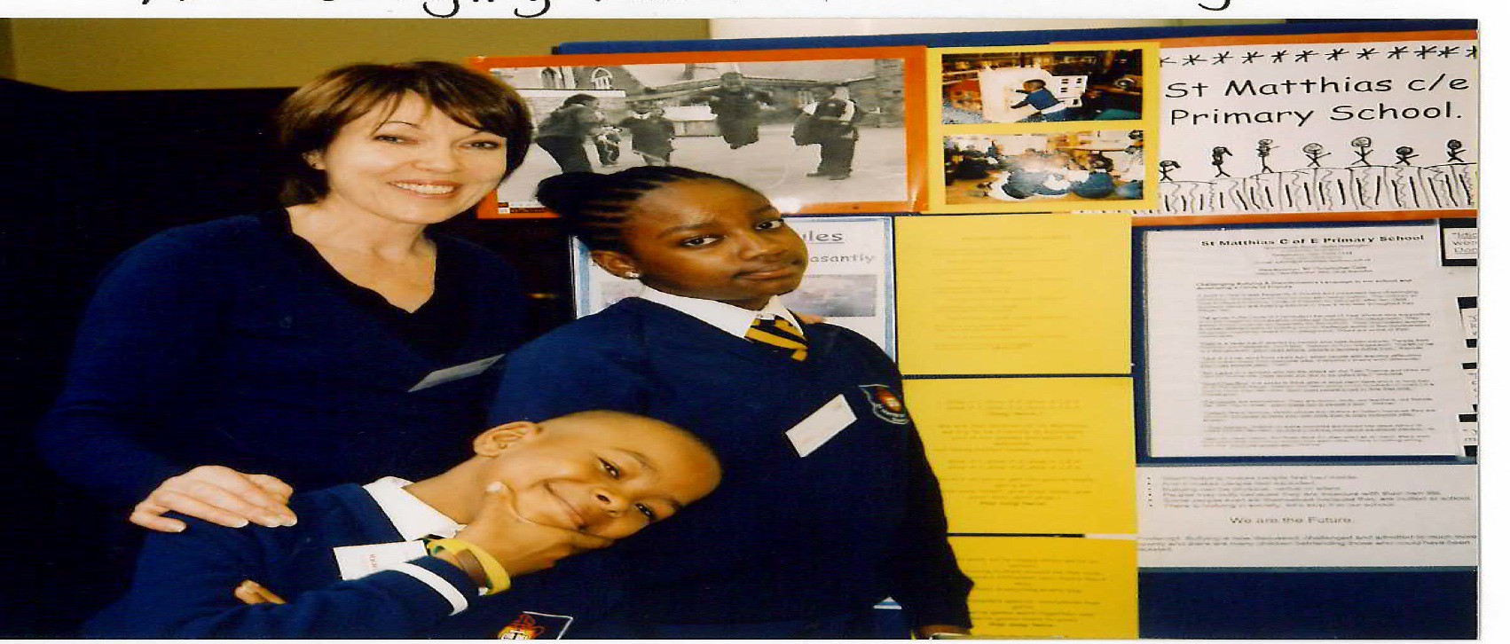
Passive. For 2 years we ran weekly Anti-­‐Bullying lessons in every class (Nursery to Year 6).
Discussing language used at playtime was a starting point. The Assembly given by Year 6 had a powerful effect on the rest of the school. They all began to challenge discriminatory words in the playground till they were rarely said. In the lessons, children talked openly about their feelings. Those being bullied explained how it made them feel. Those who bullied admitted to this and we explored the reasons. There were tears and support offered. The awareness
throughout the school led to children and staff noticing, challenging and supporting so that bullying was rare. Many children befriended those who could have been isolated. All teachers found this project very effective. All primary schools should do this work.

Early Years/ Primary Books

Headings are general and many books fall into many categories.

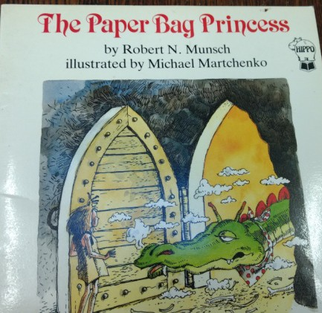
Anti-­‐ Sexist

-­‐ The Paper Bag Princess by Robert Munsch-­‐ Annick Press Ltd.
-­‐ Princess Smartypants by Babette Cole -­‐ Puffin Books
-­‐ Fire Across The Street by Manju Gregory -­‐ Mantra Publishing. Anti-­‐Racist
-­‐ Daisy The Dreamer by Martin Waddell -­‐ Little Mammoth
-­‐ Mrs. Christmas by Penny Ives -­‐ Picture Puffins
-­‐ The Bunk-­‐Bed Bus by Frank Rodgers -­‐ Picture Puffins. Anti-­‐Ageist
-­‐ Mighty Mountain and the three strong women by Irene Headlund -­‐ Hippo Books, Scholastic Publications Anti-­‐Ageist

Anti-­‐ Ageist
-­‐Katie Morag And The Two Grandmothers by Mairi Hedderwick -­‐ Picture Lions
-­‐ Odette, A Springtime in Paris by Kay Fender-­‐ Philippe Dumas -­‐ Gollancz
-­‐ Grandfather's Pencil and the Room of Stories by Michael Foreman -­‐ Andersen Press

Anti-­‐ Disabilist

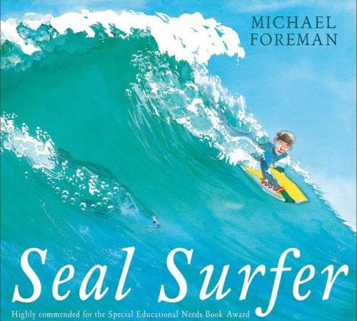
-­‐ Seal Surfer by Michael Foreman -­‐ Andersen Press
-­‐ Letang's new friend by Beverley Naidoo -­‐ Longman. Anti-­‐Racist
-­‐ Letang and Julie save the day
-­‐ Trouble for Letang and Julie
-­‐ The Boy Who Grew Flowers by Jen Wojtowicz -­‐ Barefoot Books. Anti-­‐Sexist
-­‐ A Nice Walk in the Jungle by Nan Bodsworth -­‐ Picture Puffins
-­‐ Dave and the Tooth Fairy by Verna Wilkins -­‐ Tamarind. Anti-­‐Racist
-­‐ Mama Zooms by Jane Cowen-­‐Fletcher -­‐ Scholastic Anti-­‐Sexist
-­‐ Franny and the Music Girl by Emily Hearn -­‐ Second Story Press
-­‐Dad and Me in the Morning by Patricia Larkin. Anti-­‐Sexist

Anti-­‐Racist

-­‐ Benjamin Zephaniah by Verna Wilkins -­‐ Tamarind. Anti-­‐Disabilist
-­‐ I see the rhythm by michele wood and toyomi igus -­‐ Children's Book Press, San Francisco
-­‐ Martin and Erica's Journey by Dr. Martin Stern -­‐ NUT and Holocaust Educational Trust
-­‐ The Children We Remember by Chana Byers Abells -­‐ Julia Macrae Books
-­‐ Tenzin's Deer by Barbara Soros -­‐ Barefoot Books
-­‐ Siddharth and Rinki by Addy Farmer. Illust.Karin Littlewood -­‐ Tamarind. Anti-­‐Sexist
-­‐ Baba's Gift by Beverley and Maya Naidoo. Illust. Karin Littlewood -­‐ Puffin. Anti-­‐Sexist and Anti-­‐Ageist
-­‐ Sun Slices, Moon Slices by Adele Geras. Illust. Karin Littlewood -­‐ Little Hippo, Scholastic
-­‐ The Great Migration, Paintings by Jacob Lawrence -­‐ Harper Collins
-­‐ Dia’s Story Cloth: The Hmong People’s Journey of Freedom by Dia Cha – Lee and Low
-­‐ Azzi in Between by Sarah Garland – Frances Lincoln
-­‐ The Colour of Home by Mary Hoffman – Frances Lincoln
-­‐ The Whispering Cloth by Peggy Shea – Boyds Mill Press
-­‐ Journey home by Lawrence McKay Jr. – Lee and Low
-­‐ One Day We Had to Run by Sybella Wilkes – Evans Bros., UNHCR

LGBT ( Descriptions are from Ellie Barnes www.educateandcelebrate.org)

-­‐ Mommy Mama and Me by Leslea Newman EY-­‐Tricycle Press
-­‐ Introducing Teddy by Jessica Walton ( EY gender and friendship)
-­‐ Two Mums and a Menagerie by Carolyn Robertson (2 mums and adoption) -­‐ Sparklypoo Publications
-­‐ Are You a Boy or Are You a Girl? by Sarah Savage and Fox Fisher
-­‐ William's Doll by Charlotte Zolotov ( Primary lesbian, gay, bi-­‐sexual and trans characters)
-­‐ Dad David, Baba Chris and Me -­‐ British Association for Adoption and Fostering (BAAF)
-­‐ Gracefully Grayson by Ami Polonsky (Primary trans, gender, family) -­‐ Hyperion
-­‐ Two Weeks with the Queen by Morris Gleitzman (Primary friendship, families, gay, AIDS) -­‐ Puffin
-­‐ The Boy in the Dress by David Walliams (gender, trans, friendship) -­‐ Harper Collins Children's
-­‐ Stella Brings the Family by Miriam Schiffer (girl with 2 dads, gay, family,adoption) -­‐ Chronicle books

General

-­‐ The Great Big Book of Families by Mary Hoffman and Ros Asquith -­‐ Frances Lincoln Children's Books
-­‐ A Garden in the City by Gerda Muller -­‐ Macdonald Children's Books
-­‐ How We Feel by Anita Harper and Christine Roche -­‐Kestrel Books
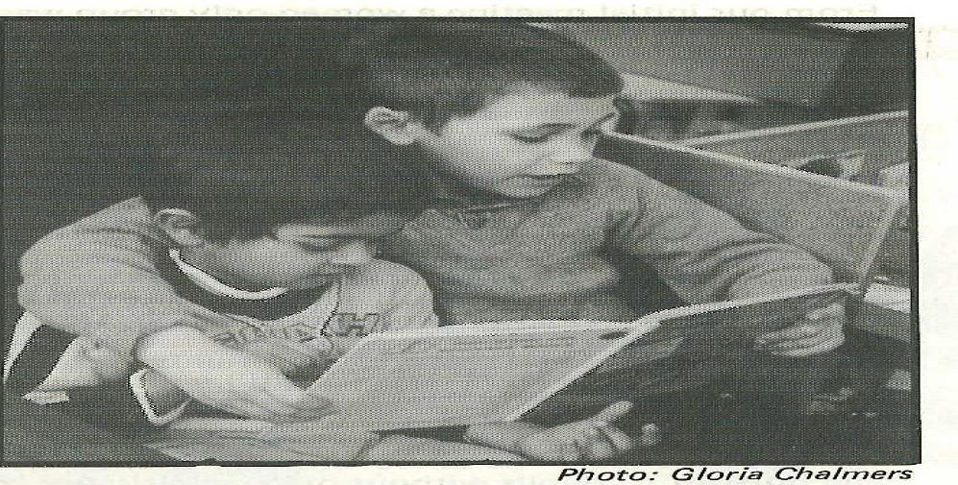
-­‐ How We Play
-­‐ How We Live
-­‐ A bus called heaven by Bob Graham -­‐ Walker Books
-­‐ All Kinds of Feelings series. Illust. Emma Brownjohn
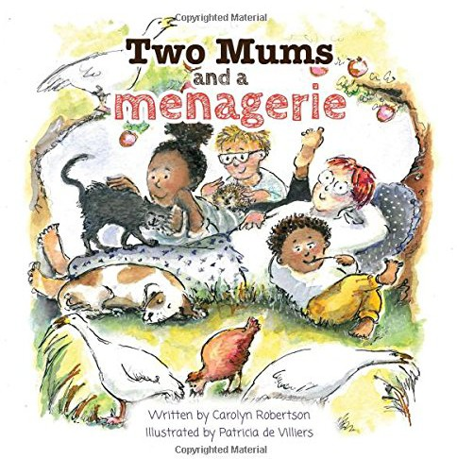

Gender, science education, genetics and equality. Conor McCrory

Despite girls routinely performing slightly better in Science at GCSE level than boys (1), they are routinely put off studying relative to boys at A-­‐level. This is particularly the case in the physical sciences, with Physics having a 3:1 ratio of males to females year on year (2). Some of the largest gaps in terms of disproportionate uptake are in Further Mathematics, Physics and Computing (3), while in A-­‐level Mathematics, there are a third more male entrants than female (4). Biology A-­‐level has a higher proportion of girls than boys (approximately 3:2) (4)

There is no question of these relative disproportionate uptakes in physical sciences and mathematical subjects being genetic in nature, rather their explanation must lie in the culture of schooling and social expectations. The Institute of Physics has undertaken research and produced recommendations for classroom practice aimed at address the lack of gender-­‐balance in the classroom, including a best-­‐practice checklist for science teachers. (5,6) Education workers in the science classroom must be aware of the sorts of analogies and examples they use to bring topics to life. Analogies and examples should as best as possible be drawn from the real world, and one that is familiar with a wide a range of students as possible, and avoid examples where familiarity may take on a gendered-­‐nature.

Teachers should be conscious of their questioning, including timing, technique, and time spent with students. Additionally it's recommended that teachers expose students to as wide a variety of scientists as possible when looking at 'real world' science.

Genetics and Equality
In the science curriculum, various topics, at all Key Stage, lend themselves particularly to discussion concerning equalities, or the topic themselves need to be approached in a more considered manner with regards to equalities. Aspects of the biology curriculum, particularly around genetics and disease bring up issues with the language that we use to describe certain diseases and conditions, and highlight the need to consider the social model of illness, often ignored in biology texts, in contrast to the medical model. Issues relating to economics and politics often arise in relation to disease prevalence, and these are hard to ignore if we are to teach responsibly with equality and social and economic justice in mind.

Additionally, the study of human variation often brings up issues of 'race' and creates an opportunity to consider what sort of categories are meaningful scientifically, and ones which are more social. The study of genetics highlights the need to consider determinism, and the limits, whatever they may be, of human potential -­‐ this could be around issues such as 'intelligence'.

- -­‐ https://www.tes.com/news/school-­‐news/breaking-­‐news/gcse-­‐results-­‐gender-­‐gap-­‐widens-­‐girls-­‐pull-­‐ further-­‐ahead
- -­‐ http://www.iop.org/policy/statistics/uk-­‐a-­‐levels/gender/page_67095.html
- -­‐ https://www.theguardian.com/education/datablog/2015/aug/13/a-­‐level-­‐results-­‐2015-­‐gender-­‐gap-­‐ pass-­‐rates-­‐subject-­‐popularity-­‐charts
4 -­‐
https://www.gov.uk/government/uploads/system/uploads/attachment_data/file/426646/A_level_subject
_take-­‐up.pdf
5-­‐ http://www.iop.org/education/teacher/support/girls_physics/resources-­‐and-­‐guidance-­‐for-­‐ teachers/file_68642.pdf
6 -­‐ http://www.iop.org/education/teacher/support/girls_physics/action/file_41603.pdf

Notes
A Teachers Guide for Physics www.iop.org
Girls in the Physics Classroom A Teachers’Guide for Action Institute of Physics Dec 2006 Inclusive learning in the physics classroom www.iop.org
Background This checklist is a set of questions designed to help teachers of physics to record

and extend their own gender-­‐inclusive practice. A level subject take-­‐up Welcome to www.gov.uk
A-­‐level subject take-­‐up May 2015, No. 150048 3 Introduction Ofsted’s report on science in schools ‘Maintaining curiosity’1 noted that most....
A-­‐level results 2015: gender gap, pass rates and subject A level results 2015: gender gap, pass rates and
subject popularity. www.theguardian.com

Challenging Sexism in Secondary Schools : Reflections, strategies Mike Vance -­‐ Education Consultant mvance@virginmedia.com

“Dominator culture teaches all of us that the core of our identity is defined by the will to dominate and control others….
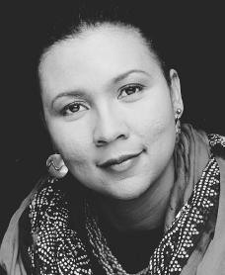
When culture is based on a dominator model, not only will it be violent but it will frame all relationships as power struggles.”

Bell Hooks
Teaching Community: A Pedagogy of Hope How does sexism manifest itself in your school Our context needs action
The Equality Act 2010 – a duty to eliminate discrimination, harassment and victimisation that is prohibited under the Act;
Sexist, sexual and transphobic bullying is commonly underpinned by sexist, homophobic, or transphobic attitudes
In order for these forms of bullying not to go unrecognised, schools must develop specific approaches for dealing with sexist, sexual and transphobic bullying that are aligned with their approaches to dealing with other forms of bullying.
When we walk the corridors or the playground it tells us a story about the power relationships in our schools. Do girls and boys enjoy equal use of space and are these spaces respected? The feedback from girls in schools is that they are not used equally. Girls have difficulty playing football in spaces that are traditionally dominated by boys and contrary to their experience in primary school are not invited or expected to join in games.

Specific duties
If schools focus on gender as one of their objectives they should carry out the following steps (HTA recommends all schools to do this)
Set out how it will achieve its gender equality objective;
Gather and use information on how school policies and practice affect gender equality in the workforce and in the delivery of services;
Consult stakeholders and take account of relevant information in order to determine gender equality objective(s);
Assess the impact of the current and proposed policies and practices; Report against the scheme each year and review at least every three years.

Misogyny in the culture of young people

In secondary schools we face the challenge of countering the impact of misogyny on young people through images of the body image, beauty and fashion. It is not something that comes from the young people in our schools but is sold through advertising, mass and social media and most importantly through the visuals that accompany music. It has created a new norm of expectation and new ways of behaving. It underpins the misogynistic humour and language that is everywhere and is used without understanding both the effect on the speaker and the listener, the oppressor and the oppressed. As teachers we recognize cultural expression but in no way should we tolerate unchallenged the language, images and attitudes towards women and girls that is sexist and prevalent in Rap and Grime. In addition there is also the question about how we deal with the prevalence of access to pornography and what it does to the male psyche and expectations of relationships. http://www.youtube.com/watch?v=9EtIqVKKVWY&list=PLblLwPEv0sf3kNYrlGENeqeY-­‐rKz7oU9B

Parallels with racial harassment?

In schools we have become increasingly competent in dealing with racial harassment. The Macpherson Inquiry into the death of Stephen Lawrence recommended that the definition of a racist incident is ‘Any incident which is perceived to be racist by the victim or any other person’

Racial harassment occurs when a person or group repeatedly uses discriminatory remarks, behaviours or practices to show racial intolerance/prejudice against a student or their colour, descent, culture, language or religion.

Examples
Making jokes, insinuations, humiliating comments or racially oriented remarks.
Criticizing and being intolerant in regards to the victim’s differences: his or her accent, clothing, hair style, customs and beliefs.
Acting seemingly disgusted or showing contempt in the victim’s presence. Finding excuses for not working with the victim.
Showing comic strips, pictures or images that are racially degrading.
The challenge facing us is to apply the same degree of vigilance to sexism in our schools.
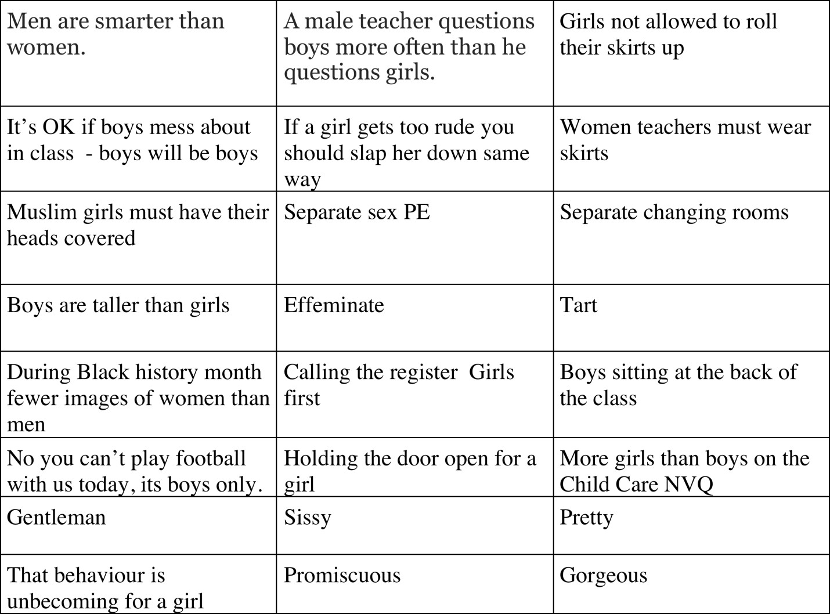
Signs of Sexism

Sexism What’s in a name
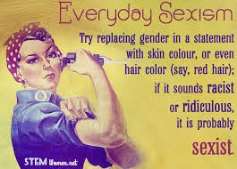
The language used by young people is gender loaded and as such reinforces gender stereotypes. If we look at some of the words and names that are used by
students in our schools then we can see how frequently they are used without challenge and though they have passed into the realm of “its ok”, “they don’t mind “
In a week in a school these are some words that were heard in both classrooms and in the other school spaces. Not all are derogatory but they define and locate social identities. Our students and their communities are so inventive that the
lexicon changes all the time but reflects the dominating forces in society.
Boy Woman Man White Nigger Yid Paddy Sket Whore (ho) Pussy Pussy hole Dickhead Dog Meat Feisty Motherf.. Prick Pimp
Girlfren Man-­‐dem Bwoi-­‐dem Girl Bumba-­‐claat Black Biscuit Bitch Buff Slag Peng Spastic G’allist Side chick Pratt Gorilla Homie
Beast Beef Cunt Boss Skank Kriss Slapper Asian
Pussy claat Rass – claat Waste man Disabled Baboon Monkey Chief Booboo Slut

Activity Look at the names heard in one week in school. Place them under the headings
Affirming (bigging you up), | Cussing | Neutral

Sexual Harassment

Girls complaints that they are sexually harassed frequently and it goes unreported and worse still unnoticed by teachers as it happens before in classrooms where we the adults are supposed to be in control. Here are some issues to think about:-­‐
Does a boy have to touch a girl for it to be sexual harassment? Does sexually suggestive language count as harassment?
If a boy stares at a girl or woman, is it sexual harassment?
Can you sexually harass a friend? What if it only happens once?

Womenwatch have outlined some actions that constitute sexual harassment.
- Touching, pinching, or grabbing someone else’s breasts, butt, or genitals
- Touching, pinching, or grabbing your own breasts, butt, or genitals in front of others
- Sexual comments, jokes, stories, song lyrics, or rumors

- Gestures and facial expressions (e.g., winking or licking lips)
- Inappropriate looks or staring at someone’s body
- Clothing pulled to reveal your body or someone else’s body
- Sexual pictures or drawings (e.g., a pornographic magazine)
- Demands for sexual activity
- Physical intimidation (e.g., standing too close to someone, following someone, blocking someone’s way so they can’t leave)
- Cyberbullying (when the Internet, cell phones, or other devices are used to send or post text or images intended to hurt or embarrass another person)

Key messages for schools
Preventing and responding to bullying should be seen as one overarching process – effective responses inform effective prevention work
Schools need to make effective use of the curriculum effectively to prevent sexist, sexual and transphobic bullying, and address some of the underlying attitudes that may underpin these forms of bullying.
Responses to sexist, sexual and transphobic bullying need to address and support the individual or group who have experienced bullying (and possibly their families), the individual or group engaging in bullying behaviour (and possibly their families) and the wider school community. Schools should always assess whether a referral to children’s services safeguarding agencies or specialist support services is necessary in cases of sexist, sexual and transphobic bullying.Issues of confidentiality and responding appropriately to sensitive issues and disclosures are especially relevant to sexist, sexual and transphobic bullying.

If not stopped, a pupil who is bullying may:
-­‐create a group culture where causing harm by bullying is seen as acceptable and which then tacitly accepts collusion with bullying as the norm;
-­‐understand that the school either condones the behaviour and the attitudes which underlie the behaviour or is powerless to prevent it occurring;-­‐be more likely to cause harm to others in adulthood;
-­‐engage in anti-­‐social and potentially criminal behaviour later in life.

Voices and action
Strategies -­‐ Learning climate and Teaching
Our focus in schools should be on Belief, Behaviour and Language through Teacher-­‐pupil interaction including learners’ engagement
- Staff consistently educate against using prejudicial or offensive terminology and model preferred terms
- Encouragement and support is given to learners investigating
- gender equality issues, for example as a focus in the study of
- a text or historical period
- Learners understand the purpose and aims of education for
- gender equality through familiarity with equality statements,
- and clearly communicated learning intentions
- Learners understand gender oppression within context of other oppressions operant in society
- Teachers are aware of the possible bias/differences in their questioning of girls and boys and take steps to monitor and if necessary improve their own practice: e.g. give equal “wait time” to girls and boys
- Teachers ask higher-­‐order, open-­‐ended questions of both boys and girls
- Teachers define terms and explain concepts relating to gender equality

“Dominator culture has tried to keep us all afraid, to make us choose safety instead of risk, sameness instead of diversity. Moving through that fear, finding out what connects us, revelling in our differences; this is the process that brings us closer, that gives us a world of shared values, of meaningful community.”

— Bell Hooks, Teaching Community: A Pedagogy of Hope

Raising Disability in the Secondary Classroom Richard Rieser rlrieser@gmail.com
It was the segregation, discrimination and exclusion of disabled people from community life, which led the Disability Movement to challenge the way in which people were treated and labelled by society, particularly by the medical profession.
The traditional model of disability in all societies ( prior to the medical model) seeks to explain difference by magic, superstition or the acts of all powerful deities. These vary between cultures and over time, depending on material circumstances but the thinking is largely negative. They are the root of many powerful stereotypes. However, there are also examples throughout history that run counter to the dominant ideas about disabled people, which demonstrate that love and relationships can lead to acceptance.

The Medical Model of Disability places the problem with the individual that only a cure will solve. It denies the individual their value, worth and individuality as they do not meet the accepted ‘norms’ of our society. Medical labels are often misleading, as no two people are alike. Medical labels tend to reinforce stereotypes of disabled people as patients who are ill, powerless and wholly dependent on the medical profession.
The Social Model of Disability challenges the medical profession’s definition and was developed by a group of disabled people known as ‘The Union of the Physically Impaired Against Segregation’ who managed to escape from institutional care in 1976. Their definitions are:
* Impairment – Lacking part or all of a limb or having a defective limb, organ or mechanism of the body.
*Disability – The disadvantage or restriction of activity caused by a contemporary social organisation which takes little or no account of people who have physical impairments and thus excludes them from participation in the mainstream of social activities. Disability is therefore a particular form of social oppression.
To take into account all forms of social oppression and all impairments, Disabled People’s International adopted and redefined the definition of disability in 1981 as:
‘The loss or limitation of opportunities that prevents people who have impairments from taking part in the mainstream life of the community on an equal level with others due to physical and social barriers’.
Many organisations which are run and controlled by disabled people work within and promote the Social Model of Disability. Many Councils throughout the country have adopted a Social Model definition.
Working in this way ensures equality of access and challenges discrimination at all levels within the organisation and the local and wider community. Attitudinal, environmental and physical barriers are the main issue.

Geography:Now the UN Conventions on the Rights of Persons with Disabilities has introduced a social model approach throughout the world. Ratified by 173 countries https://www.un.org/development/desa/disabilities

Activity to understand the difference between traditional, medical and social models
http://ukdhm.org/a4-­‐activity-­‐on-­‐traditional-­‐medical-­‐social-­‐models-­‐of-­‐disability

Who are disabled people? Equality Act Definition.
Today we have a legal definition in the 2010 Equality Act, which is largely the same as in the 1995 Disability Discrimination Act. This says a person is disabled if you ‘have a physical or mental impairment that has a ‘substantial’ and ‘long-­‐term’ negative effect on your ability to do normal daily activities’.
Substantial means more than minor or trivial impact on your ability to do normal day to day activities. This discounts the impact of medical treatment, prosthesis or aids.
Long term means 12 months or more or likely to last 12 months or more.
Visual impairment does not count if it is correctable by glasses or contact lenses.
Progressive conditions such as cancer, multiple sclerosis and HIV count from the moment of diagnosis.
The definition is to protect people from discrimination, not to allocate resources . Equality Act definition is a low threshold with 11.5 million people or 19.5% of population included.
Language about disabled people can be confusing. Most is negative because of the history of disabled people. A good activity for KS2,3 and 4 classes can be found at http://ukdhm.org/a7-­‐activities-­‐ks-­‐2-­‐3-­‐4-­‐ language-­‐and-­‐disabled-­‐people-­‐1 . http://ukdhm.org/activity-­‐matching-­‐words-­‐and-­‐meanings-­‐of-­‐disablist-­‐ language A broadsheet with greater in-­‐depth discussion can be found at http://ukdhm.org/2016-­‐ broadsheet and http://ukdhm.org/a-­‐8-­‐resource-­‐sheet-­‐the-­‐origin-­‐of-­‐negative-­‐words-­‐associated-­‐with-­‐ disability There are many works of literature, films and TV featuring disabled characters. Are these stereotypes or real people? http://ukdhm.org/2015-­‐broadsheet-­‐moving-­‐image-­‐portrayal-­‐of-­‐disabilitythen-­‐ and-­‐now and http://worldofinclusion.com/v3/wp-­‐content/uploads/2014/01/disability_in_media.pdf
Science can often be a cover for prejudicial attitudes and false science. The way eugenics was used against people with learning difficulties in the UK and against all disabled people in Nazi Germany are important lessons. http://www.open.ac.uk/health-­‐and-­‐social-­‐care/research/shld/education-­‐resources and in particular http://www.open.ac.uk/health-­‐and-­‐social-­‐care/research/shld/education-­‐resources/activity-­‐12-­‐ eugenics-­‐and-­‐false-­‐science and in Third Reich http://www.worldofinclusion.com/res/qca/Lest_We_Forget.pdf
History often leaves out disabled people. However, War creates disabled people http://ukdhm.org/v2/wp-­‐ content/uploads/2014/09/UK-­‐Disability-­‐history-­‐month-­‐2014-­‐Broadsheet.pdf Timeline http://ukdhm.org/v2/wp-­‐content/uploads/2016/03/B5-­‐Disability-­‐Time-­‐Line-­‐NHS-­‐North-­‐West.pdf Famous disabled people http://ukdhm.org/b4-­‐in-­‐depth-­‐biographies-­‐of-­‐disabled-­‐people-­‐who-­‐have-­‐made-­‐a-­‐ difference-­‐activities-­‐ks45 or less complex http://ukdhm.org/b3-­‐activities-­‐ks2-­‐ks3-­‐ks4-­‐disabled-­‐people-­‐ who-­‐have-­‐made-­‐a-­‐difference
Independent Living means having choices: the power to control what happens to us, sufficient support, being included and accepted into our local communities, education and leisure provision, having families and relationships. It does not mean doing everything for ourselves. The past casts a long shadow over disabled people and our struggle for equality and independence. Now the push for austerity is disguising an attack on equality. Particularly hard hit are disabled people, being 9 times more affected by the cuts

than non-­‐disabled people. Those with high support needs are 19 times more affected. False ideas about the majority of disabled people, as bogus claimants, are fuelled by the press and encouraged by politicians. From institutions to the workhouse disabled people have been segregated and mistreated.http://ukdhm.org/v2/wp-­‐content/uploads/2014/09/UKDHM_2013_BROADSHEET_FINAL.pdf
Art and Design. UKDHM 2017 is focusing on disability and art. How artists throughout time have portrayed disabled people. How disabled artists have produced art and how the Disability Arts Movement came about to use art to fight for a social model approach and anti-­‐discrimination legislation. http://worldofinclusion.com/v3/wp-­‐content/uploads/2017/03/NDACA-­‐Booklet-­‐1.pdf See for more resources and education pack. http://ukdhm.org/2017-­‐2/2017-­‐disability-­‐and-­‐the-­‐visual-­‐arts
Challenging Disablist Bullying. http://ukdhm.org/v2/wp-­‐content/uploads/2014/10/Challenging-­‐Bullying-­‐ and-­‐harassment-­‐of-­‐disabled-­‐people-­‐FINAL.pdf and http://ukdhm.org/10-­‐tips-­‐to-­‐tackle-­‐disablist-­‐language-­‐ based-­‐bullying-­‐in-­‐school-­‐a-­‐guide-­‐for-­‐staff

Tackling disablist language in schools: 10 top tips www.anti-­‐bullyingalliance.org.uk/send-­‐programme
10 tips to tackle disablist language based bullying in school: A guide for staff
The use of verbal abuse as a form of bullying of disabled children and young people is widespread. This has a significant negative impact on self-­‐esteem and achievement. To challenge it requires a consistent wholeschool approach involving staff, pupils, parents and carers. All members of the school community need to be equipped to always challenge and explain why such language is unacceptable.
Disablism is a relatively new word and teachers will be more familiar with the need to challenge ‘sexism, racism and homophobia’. The Oxford Dictionary defines disablism as ‘discrimination or prejudice against people who are disabled’.
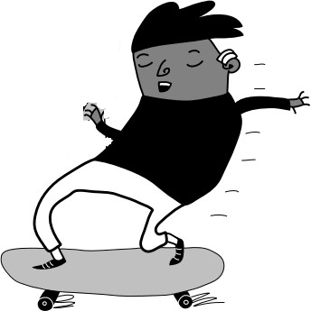
Words such as ‘retard’, ‘spastic’, ‘mong’, ‘cripple’, ‘lame’, ‘mental’, ‘nutter’, ‘idiot’, ‘moron’ ‘drrr.. brain’, ‘dumb’, ‘four eyes’, ‘cloth ears’, ’flid’, ‘gimp’, ‘stupid’, ‘thick’ are linked to impairment. Even when used without any intent to cause hurt they create an environment where
disabled pupils, staff, parents and carers are more likely to feel intimidated and at risk of harm.
Schools should create a positive ethos towards disabled people, and demonstrate the negative impact of disablist language on their lives. Successful prevention strategies include:
§ Understanding where disablist language comes from
§ Why it should be avoided
§ The damaging impact that language based disablist bullying has on the self
esteem, mental health and achievement of young disabled people.

This has to be owned by children and young people so they understand that name-­‐calling and derogatory jokes are all part of ‘othering’ and diminishing the essential humanness of the disabled person.
Top 10 Tips
- Ensure all staff and pupils understand that disablement is socially created. We, as disabled people, have impairments. This can cause us pain and may shorten our lives, but for most disabled people that is just the way we are. It is the barriers we encounter that disable us. Negative attitudes and prejudice lead to restrictions in the environment and the way organisations, such as schools, function. These barriers can be changed. We cannot. This is called the ‘social model of disability’.

- All disabled people are entitled to internationally recognised Human Rights. These are in the Equality Act (2010) with a requirement that all harassment towards disabled people and other social groups is eliminated. Schools must develop zero tolerance for disablist language. All staff must be equipped to challenge any pejorative language and other forms of bullying, by explaining the impact of such language. All such occurrences, however seemingly minor, should be recorded and followed up.
- Hold regular year group or whole school assemblies with disabled speakers and draw on work from pupils examining the consequences of the use of disablist language, bullying and hate crime. Demonstrate how these are all part of a negative escalating process of ‘othering’. Develop both a
sense of injustice and an empathetic response.

Recruit and train young people (including disabled young people) as peer mentors or anti-­‐bullying ambassadors.
- Set up working groups in each subject department or primary school to develop effective ways to introduce disability equality into the programmes of study of each subject and year. Monitor the frequency and effectiveness of these disability equality themed lessons.
- Challenge conformity and notions of ‘normality’ by celebrating the difference in all of us. Use the corridors, notice boards, classroom walls and books to reflect the inclusion of disabled people.
- Ensure all children and students are educated about the history of disablist language Link this work with an understanding of the history of disabled people’s oppression and what specific attitudes and behaviour it can lead to. Include what is acceptable and what is offensive language about disabled people.
- Regularly challenge wrong thinking and stereotypes about disabled people. Use newspapers, magazines, films, TV, jokes, literature and social media. Look at Eugenics as an example of false science. Include work in factual English (newspaper coverage, writing and discussion on position of disabled people), Literature (classic texts and examples of positive presence), Maths (statistics and geometry of access), Art (disabled artists and visual portrayal), Drama (analyse stereotypes in drama/films), History (attitudes and treatment at different times), Geography (analyse mapped distributions and environmental barriers), D&T (universal design), Modern and Classical languages (words and meanings, customs), PE and Sport (adaptations and disabled sports) and ICT (cyber bullying and access).

Recognise the multiple discrimination/prejudice that a young disabled person may face. We know that young disabled people are at significant risk of sexual bullying and need to understand more about how they are impacted by racist, homophobic and transphobic bullying
Make sure your school discusses these issues and provide circles of friends and support.
- The whole school, including all staff and governors need to agree to challenge disablist language in schools. Develop a non-­‐bullying ethos throughout the school. In the short-­‐term ensure the use of disablist language, name calling and jokes that demean are routinely reported and dealt with.
1 1A much more detailed analysis, responses, suggestions and resources for activities can be found in the ABA/World of Inclusion publication: Tackling disablist language based bullying in school: A Teachers Guide.

Diversity and Equality at Stoke Newington
This is work which is developing at Stoke Newington particularly around LGBT+ and Gender. The overarching methodology around diversity is based on the work developed by Elly Barnes and her year 7 tutor team (of which I was a part).
The four key areas are:
- Embedding the people/issues raised in the Equalities Act in the curriculum. (At SNS I have been given the role of focusing on LGBT+ and Gender).
- Showcasing and celebrating the work of students to their families in a Community Evening.
- Pastoral activities around different issues.
- A member of staff to deal specifically with discrimination/bullying when it happens in the student body.
- Curriculum
To have link members of department teams to carry out two tasks:
- an audit of what departments already do around diversity.
- discussions on how best to incorporate different diversities into their particular curriculum.
The link staff member to help develop at least one lesson/scheme of work for one Key Stage around a particular theme.
There would be monitoring to ensure that each Key Stage had a lesson/SOW on that theme by the end of the academic year.
- Showcasing
Display work in the foyer at key times of year – LGBT+ History month, International Women’s Day
Special assemblies/events in which student work is shown and celebrated. Parents and members of the community to be invited to take part. These are a very visible and important way to highlight these issues and affirm to students the value of their work.
- Pastoral activities
Assemblies – preferably run by individuals representing particular groups. EG for Holocaust memorial day one of our guest speakers was Professor Leslie Brent, a Kindertransport child.
Presentations to be used at tutorial times – delivered during key times, EG for Black History Month we used a set of resources entitled ‘Why did they come?’ – which looked at the history of immigration to the UK and importantly, what was the role of the indigenous population in welcoming them and challenging racism (which then includes the white ‘working class’) in our history.
- Dealing with discrimination.
You would want all staff to be able to challenge and deal with discriminatory language or action. However, this needs training to get consistency. You also need to have particular staff members or a named member of staff who are able to have honest discussions with students to enable resolution and understanding to take place.
Anna Gluckstein

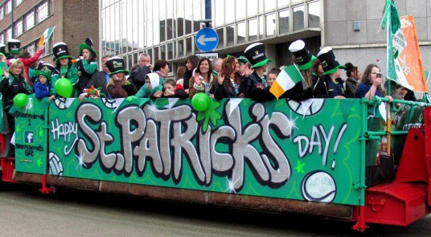
Who makes up our community? Stoke Newington School Presentation for Drop Down Day.
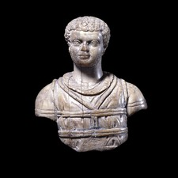
- When do you think the first Africans came to live in Britain?
The first recorded Africans came to Britain with the Romans in 60 AD. They were traders and Roman Legionnaires. There were African Roman emperors; this is statue of the black Roman Emperor Caracalla (Kara-­‐kalla).
The slave trade brought a few Africans as servants to England in the 1800s. The colonisation of Africa meant Britain ruled over 20 African countries including Egypt, Ghana, Nigeria, South Africa and Uganda.
Since the 1980s, the majority of black immigrants into the country have come directly from Africa, in particular, Nigeria and Ghana in West Africa, Uganda and Kenya in East Africa and Zimbabwe, and South Africa in Southern Africa.
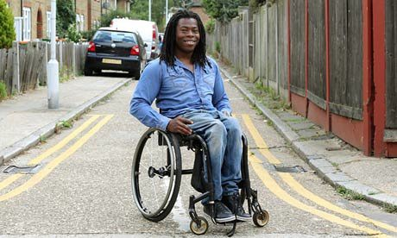
- This is a picture of Ade Adepitan. What do you know about him? Adepitan was born in Maryland, Lagos, Nigeria on 27 March 1973. At the age of six months, Adepitan contracted polio, which resulted in the loss of function of his left leg, and ultimately prevented him from walking. At the age of three, Adepitan and his family emigrated to Newham in London. Adepitan became a brilliant wheelchair basketball player. He played for the Milton Keynes Aces
and became a member of Great Britain wheelchair basketball team that won the bronze medal at the 2004 Summer Paralympics in Athens and the gold medal at the 2005 Paralympic World Cup in Manchester. He has since gone on to be a TV presenter and was made a Member of the Order of the British Empire (MBE) for services to disability sport. He was also presented with an Honorary Doctorate from Loughborough University, in recognition of his outstanding services to, and performances in, disability sport.
- How many live here today? Over 1.9 million black people live in Britain, around 3 percent of the population. 2011 – 11.4 % Black/Black British
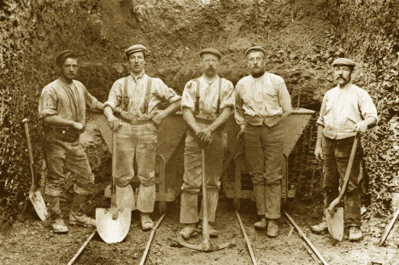
- Why did Irish people migrate to Britain?
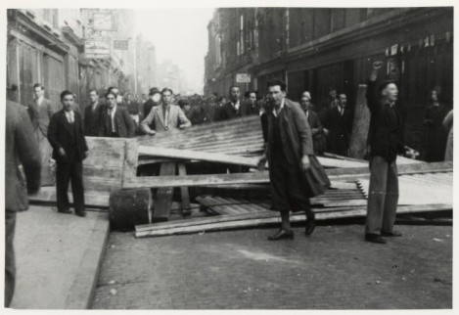
There has always been migration between Britain and Ireland. However in the 1840s, more than one million Irish people starved as a result of the so-­‐called ‘Potato Famine”. Hundreds of thousands of Irish people starved to death and millions left the country, many came to Britain. A second wave of Irish migration to Britain took place between 1930s and 1960s, they came to find work and a better life.
- This is a picture of the Battle of Cable Street – Do you know what role Irish dockworkers played?
- How many Irish people live in England, Scotland and Wales today? Nationally – 6.5 million have Irish heritage (one in ten) 2011 – just over

2% Hackney residents are from an Irish background.

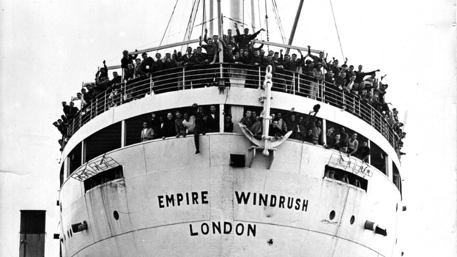
- Who are the Windrush generation? This migration event is often labelled "Windrush", a reference to the Empire Windrush, the ship that carried the first major group of
Caribbean migrants to the United Kingdom in 1948. The British Government encouraged immigration from the West Indies. It passed the British Nationality Act of 1948, which gave all Commonwealth citizens the right to a British Passport and thus the right to come and live and work in Britain. Public sector industries (NHS and transport) and private sector industries (car
manufacturers) were desperately short of labour. Successive British governments encouraged African Caribbean people to come to the UK to work in those industries. Today African Caribbean people play an important role in all areas of British life.
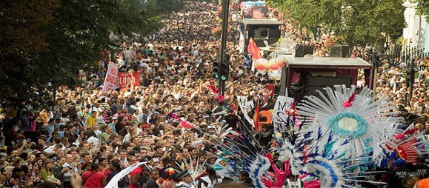
- Can you name the event African Caribbean's organise in London every year that attracts over a million people? The Notting Hill Carnival is an annual event that has taken place since 1966. It is organised by the West Indian community in West London. It is a celebration of black culture and in
support of better race relations. Today around one million people go to Carnival, making it one of the world's largest street festivals, and a significant event in British culture.
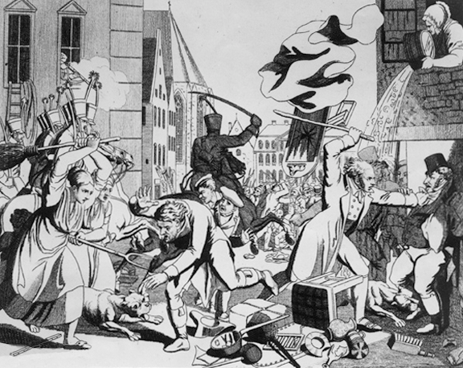
- How many live here today? 2011 – 8% (19,168) Black Caribbean/Black British Caribbean
- Why did Jewish people migrate to Britain in the 1880s? During the 1880s Jews suffered violent persecution in Russia and other Eastern European countries. Millions fled the region; 1.9 million (80 percent) went to America and 140,000 (7 percent) to Britain. By 1919 a quarter of a million Jews lived in Britain.

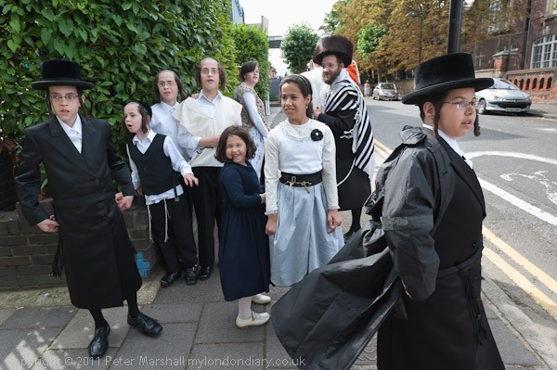
- Charedi community Stoke Newington Charedism is one part of the Jewish religion (much like how Christianity has Baptists, 7th Day Adventists etc). They started to come here from the 1890s as pogroms spread across Eastern Europe. They then increased their numbers after the Holocaust.

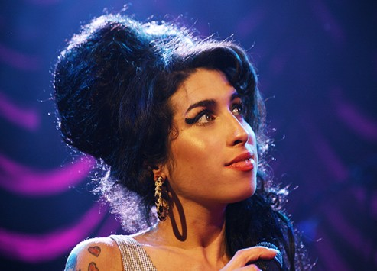
- Who are these famous Jewish women
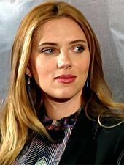
Her mother, Melanie Sloan, a producer, comes from an Ashkenazi Jewish family from the Bronx; Sloan's ancestors were Jewish immigrants from Poland and Minsk in the Russian Empire. Amy Winehouse musician.
- How many Charedi people live here now? 2011 – 7% of Hackney population are Charedi

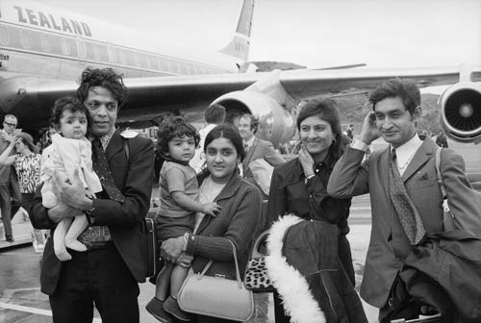
- Why did Asian people come to the UK? Asian people had been in the UK since the middle ages. From the 17th century onwards, the East India Company employed thousands of South Asian sailors, scholars and workers to work on British ships and ports around the world. After the break-­‐up of the British Empire (India was ruled directly by the UK from 1858-­‐1947) people came here to
escape civil war, to seek better economic opportunities and to join family members already settled here.
- Who is Amir Khan?
Amir Khan won the silver medal at the 2004 Summer Olympics in Athens. He then became a professional boxer. He is a former unified WBA and IBF light-­‐welterweight champion, he also held the WBC Silver welterweight title. He has become a cultural icon in the UK with TV audiences of up to 8 million watching his fights.
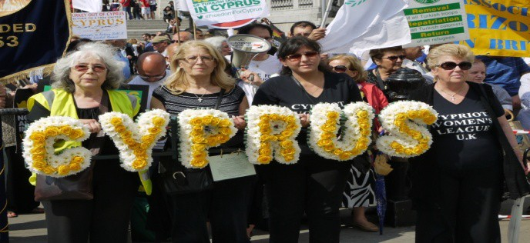
- How many Asian people live here now? 2011 – 9.8% (19,791) of residents identified as Asian or Asian British
- Why did Turks and Kurds come to the UK?
- Cyprus was a British colony up until 1960. This gave its citizens an automatic right to migrate to Britain. The intercommunal violence that swept the Cyprus during the 1950s and 1960s saw large numbers of Cypriots
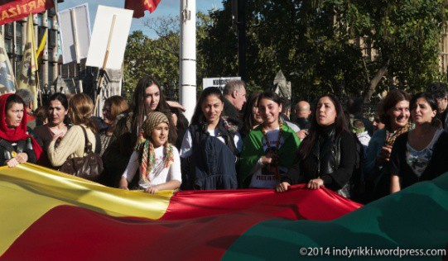
fleeing the violence and moving to the UK, most settled in London. The first was the Turkish Cypriots who migrated to Britain in the 1950s and 1960s. The second wave
began in the 1970s, many of these workers were recruited by Turkish Cypriots who had already established businesses
- Kurdistan is not a recognised country, Kurds can be found in regions of Iraq, Turkey, Iran, Armenia and Syria. Today, they form
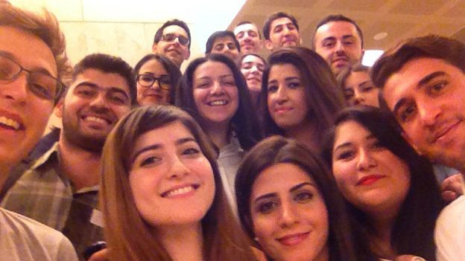
a distinctive community, united through race, culture and language, even though they have no standard dialect. They also adhere to a number of different religions although the majority are Sunni Muslims. The Kurds have been victims of the region’s many wars and occupations. Today, there are 500,000 Kurdish people living in Britain, most came during the 1980s and were fleeing persecution.
- From 1650 the Turks (Ottomans) built significant trading links with Britain. From that point onwards, small groups of Turkish business people and their families settled in Britain. ). In the 1980s, intellectuals, including students, and highly educated professionals arrived in the United Kingdom.

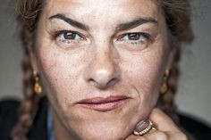
- This is Tracey Emin; she is one of Britain’s most famous artists and is of Cypriot heritage. She won the famous Turner prize for art and is seen as a hugely influential modern artist. Can you name a famous Turkish, Kurdish or Cypriot person?

- How many Turks/Kurds live here now? Approximately 6% of Hackney population are Turkish/Kurdish (limitations in Census classifications)
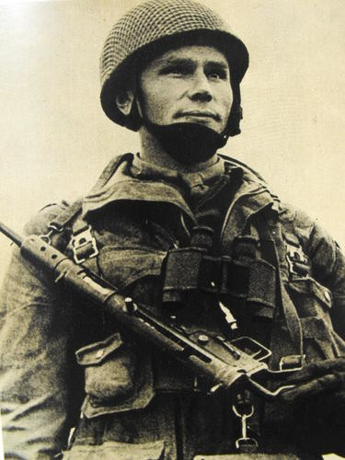
- This is a Polish paratrooper, what side did they fight on in World War Two?
After the Nazis invaded Poland in 1939, around 228,000 thousand joined the Allies armed forces. The Soviet Empire began to break up after 1989. A number of peaceful revolutions swept away the old order and replaced the dictatorial state controlled economies. A number of these countries applied to join the European Union (EU). In 2004 eight Central and Eastern European countries -­‐ the Czech Republic, Estonia, Hungary, Latvia, Lithuania, Poland,
Slovakia, and Slovenia joined the EU. In 2007 Bulgaria and Romania were granted limited EU status.

- All migrants have their own cuisine. Have you eaten any Eastern European dishes and can you name any?
Food such as beef goulash (a stew), dumplings and the famous alcoholic drink vodka, all come from Eastern Europe.

- How many live here today? Nationally – 2% of total UK population
Poles = 60% (800.000), Bulgaria -­‐ 65,000 ,Czech Republic including Slovakia -­‐ 45,000 , Estonia -­‐ 2,000 Hungary – 79,000, Latvia -­‐ 32,000 , Lithuania -­‐ 144,000 , Poland -­‐ 790,000 , Romania -­‐170,000 Slovenia – 2,000

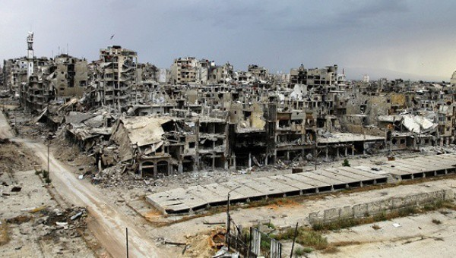

Saleh is a Syrian refugee now living in the Midlands, used to be the Syrian national team’s goalkeeper. He now wants to start playing in England.
25. How many Syrian refugees live here now?
- Why have Syrian refugees come to Europe? Syria’s civil war is the worst humanitarian crisis of our time. Half the country’s pre-­‐war population, more than 11 million people, have been killed or forced to flee their homes.
- What sport does Fahd Saleh play? Fahd

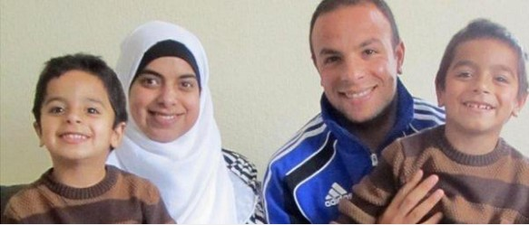

2015 – figures for accepting Syrian refugees Turkey – 1.7 million, Germany – 1 million , Britain -­‐ 5000

  - What have white English people done to fight racism and welcome all people?
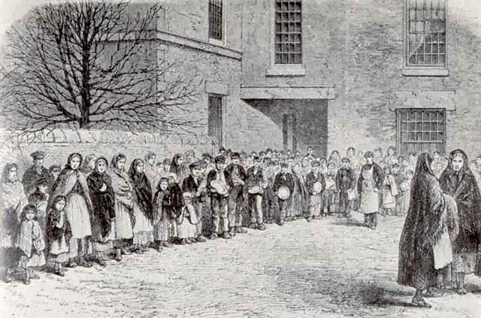
Lancashire cotton workers oppose slavery – why?
Despite severe financial hardship, Lancashire cotton workers supported the North’s war to end slavery as a matter of principle. The cotton workers campaigns played a major role in ensuring that the British
Government did not send military supplies to the Southern slave owning States.
  - This is a picture of the Battle of Cable Street – Do you know who was involved?
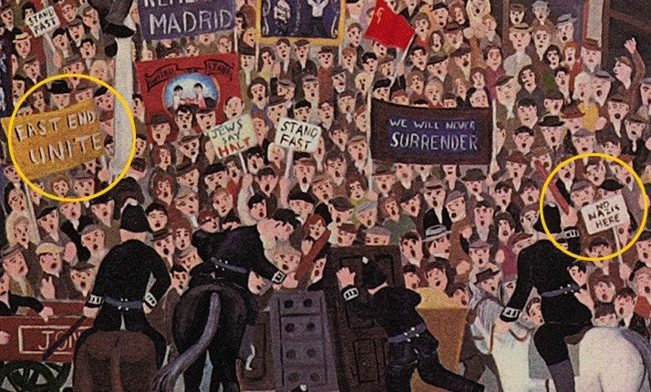
When the British Union of Fascists announced that it was going to march in East London against the Jews. It was Somalian Lascars (sailors), Irish dockworkers, Jewish people, English people, trade unionists, working people and their families, from the East End community united to oppose the fascists.

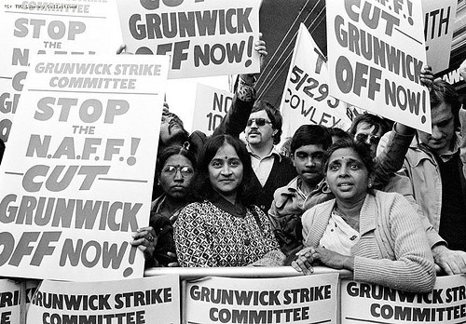
  - What are these women protesting about and who supported them?
This is a picture of the Grunwick strike. For two years 1976 – 1978 a predominantly Asian women workforce at Grunwick’s West London went on strike against poor working conditions and for union rights. British Trade unionists from across the country travelled down to support this strike.

  - Why were these people celebrating? In the 1970s supporters of Adolf Hitler tried to build a
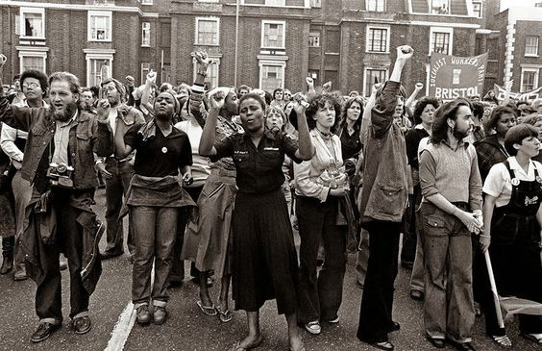
new Nazi movement in Britain. The organisation called the National Front (NF) wanted to hold a march in Lewisham, south east London. They claimed that black people were responsible for crime in London. Tens of thousands of local black and white people organised a protest against the NF. The Nazi march ended in chaos and the National Front was finished as a credible party. The picture shows anti-­‐racists celebrating the NF’s failure in Lewisham.

  - What have people done to protest against racism about Eastern Europeans?
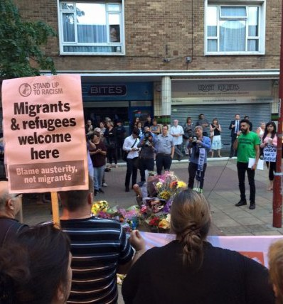
Arek Jazwick murdered, Harlow August 2016 The people of Harlow gathered to say “no to racism” In August 2016, Arkadiusz Jozwik aged 40, was murdered by a gang of up to 20 teenage racist thugs.
Known to his friends as Arek, he moved to the UK in 2012. He was targeted alongside his friend, because they were speaking Polish whilst walking through the town center. In the immediate aftermath of Arkadiusz murder the local Polish community and the organisation Stand up to Racism held a number of vigils and protests against this terrible racist attack.
  - What have British people done to help refugees? Large numbers of people in Britain support the
refugees. Over 200,000 people have signed a petition urging the British Government to admit more refugees into England. Stand up to Racism groups around the country have collected food, clothes and money for the refugee camp in Calais and have organised numerous convoys delivering much needed
aid for the refugees. The British Red Cross have collected over £250,000 to help refugees.
  - This is a photograph of LGBT+ people demonstrating against Islamophobia-­‐ why would they do this?
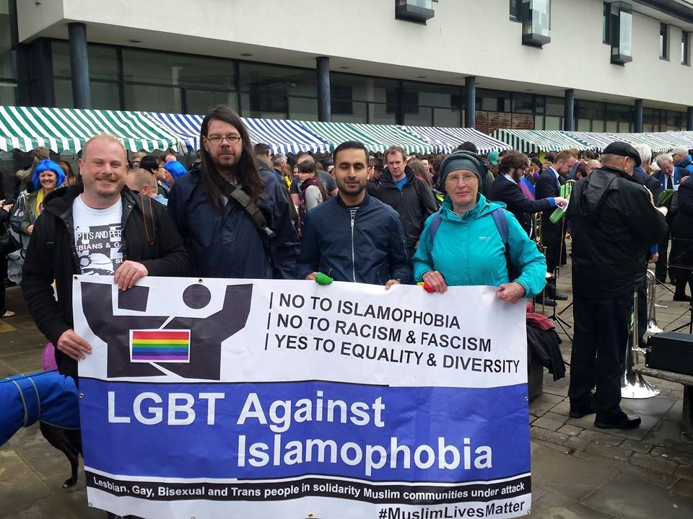
Since the early 2000s there has been a huge increase of racism in this country against Muslim people. (3,500 attacked last year). This group of LGBT+ people is protesting against this racism. They see that diversity must be defended for everybody.
  - Your task…… Choose any area you are interested in, and research images/people, design ideas you’d like to use in your tile.Watch demonstration on how to get and use tile template in Learning area. Computer/learning/ICT/CREATIVE DAY/Who is our Community?Show students how to access template tile and then save it in their own area. Show how they can save a picture and make it a background, how to add text boxes and how to change colours. Anna Gluckstein Stoke Newington School

Equalities and the National Curriculum (KS1-­‐3-­‐History and Geography). Dawn Gill

The National Curriculum prescribes what MUST be taught in all maintained schools in England. This does not form the whole curriculum, it is a basic minimum. Schools are expected to add to this minimum and each school must publish its own curriculum so that parents and others can be sure of what will be taught. Now, more than ever before, there are high expectations of teachers’ subject knowledge and professional expertise if they are to fulfil the requirements of the law. There is clarity of expectation for schools and for individual teachers, whatever their phase or subject.

Inclusion and the law
Through the statutory NC the government gives clear instructions to schools, not just on curriculum content, but also on inclusion: “Teachers should set high expectations for every pupil. They should plan stretching work for pupils whose attainment is significantly above the expected standard. They have an even greater obligation to plan lessons for pupils who have low levels of prior attainment or come from disadvantaged backgrounds. Teachers should use appropriate assessment to set targets which are deliberately ambitious.”
‘’A wide range of pupils have special educational needs, many of whom also have disabilities. Lessons should be planned to ensure that there are no barriers to every pupil achieving.”… “A minority of pupils will need access to specialist equipment and different approaches. The SEN and disability code of practice is clear about what should be done to meet their needs.”
“Teachers must also take account of the needs of pupils whose first language is not English… should plan teaching opportunities to help pupils develop their English and should aim to provide the support that pupils need to take part in all subjects.”
There is also direct reminder of what the law requires in relation to the 2010 Equality Act. “Teachers should take account of their duties under equal opportunities legislation that covers race, disability, sex, religion or belief, sexual orientation, pregnancy and maternity, and gender reassignment.”

Closing the gap
Schools are inspected and their positions in the exams league tables are scrutinised in relation to how effectively they are closing the gap between poorer pupils and their better-­‐off peers. Pupil Premium funding is provided in relation to each pupil eligible for free school meals, those ever-­‐in-­‐care and the children of forces families whose education may be fractured by frequent moves. However, schools’ interpretations on how best to close the gap are idiosyncratic and varied. To date, there is little in print about which methods are effective. Some focus on additional teaching, after-­‐hours, breakfast clubs, school trips to enhance pupils’ cultural capital. Some exclude their most difficult or disruptive pupils so that their grades don’t appear in the exam tables. Parents can select their children’s schools on how effectively they are closing the gap. Perhaps some do. The chances are that those actively studying the statistics will be looking for the schools with relatively few Pupil-­‐Premium eligible pupils, for the schools at the top of their local league tables. However, some schools aim to control the content of the curriculum to make it more challenging and inclusive. The best head teachers require their teachers to focus on what contribution each subject can make in helping to eliminate discrimination, advance equality of opportunity and foster good relations between different people. The content of the curriculum is central to this endeavour. How can primary and secondary teachers exploit this potential?

What follows is a consideration of both history and geography. Teachers of these subjects can plan the content of the curriculum to encourage pupils think critically about the past and creatively about the future. We must find new ways to challenge inequality and empower young people to become active participants in building a better, fairer and more equal society. And, in history and geography, there is huge potential, there for the taking! Empowering pedagogies, research, debate and discussion rather than a knowledge based curriculum are part, but not all of the answer. Debate and discussion must be based on growing knowledge. There is a false dichotomy in the curriculum, between knowledge and skills. We need both, to develop the powers of analysis, critical thinking and creativity. The NC geography curriculum is

knowledge-­‐based, whereas history has more obvious potential for critical analysis. Both have essential skills which can be turned to the purposes of creative thinking about the future of our world and its people.

History -­‐ historical enquiry A great strength of history is in teaching pupils to consider “How evidence is used rigorously to make historical claims, and discern how and why contrasting arguments and interpretations of the past have been constructed”. This, the study of the interests represented in the written and visual record, and in artefacts, is powerful in itself once it is recognised. The absence of narratives from oppressed groups and individuals becomes starkly obvious, once we decide to search for these in conventional resources such as textbooks. Pupils “should pursue historically valid enquiries including some they have framed themselves, and create relevant, structured and evidentially supported accounts in response. They should understand how different types of historical sources are used rigorously to make historical claims and discern how and why contrasting arguments and interpretations of the past have been constructed’. Teachers are encouraged to give pupils the intellectual tools required to undertake independent historical research, based on a critical analysis of evidence. Think of the power in this!
Challenging Racism If we were to comb through the history NC for opportunities to help young people understand where racism came from, and how it was used to justify colonialism, imperialism and genocide, we could find it with ease. It is there, in the sub-­‐text of the statutory guidance, for example in the section on “ideas, political power, industry and empire: Britain, 1745-­‐1901”, It is there in abundance in the non-­‐ statutory content. In any case, we can replace the non-­‐statutory content with other content, as long as it meets the statutory requirements. The NC requires “study of an aspect of social history, such as the impact through time of the migration of people to, from and within the British Isles”. The phrase used to counter anti-­‐immigrant rhetoric of the 1980s “We are here because you were there” tells a story in which the racism and exploitation in former colonies was imported to the UK, to the cotton towns of Lancashire and the steel mills of the Midlands, to meet the needs for ‘cheap labour’ in the interests of capitalism.
Indeed, the very concept of ‘cheap labour’ is a mindless acceptance of inequality and exploitation, and often, too, of racism, as when used still, in the context of a global economy, to justify the import of cheap clothing for our high street stores. The idea of ‘cheap female labour’ (because they are ‘better’ at certain tasks) brings sexism into the frame.

Challenging Sexism The potential for anti-­‐sexist education is easy to find. It’s there in the Key Stage 2 non-­‐ statutory guidance which lists Boudicca, Rosa Parks and Emily Davison, Mary Seacole, Florence Nightingale and Edith Cavell, those who challenged inequality based on sexism, as well as Queens Elizabeth and Victoria as examples of powerful monarchs. This is followed through in Key Stage 3, which offers opportunities to study women’s suffrage. Whilst it is true that most of the content of NC history seems to imply the doings of great white men, there’s plenty of low-­‐hanging fruit on women’s contributions to history, there in the non-­‐statutory guidance, and with a bit of research, for every block of chronology and its customary content, there’s more! It’s the attitude and intention of the teacher that is key.

Religious Diversity In relation to religious difference and intolerance and its impact on historical events; there’s plenty of content easily fashioned into a narrative which aims to challenge intolerance. The use of religion to justify genocide and wars of oppression in the past, for example in North and South America, Africa, Asia and Australasia, can do much to illuminate global issues of the present. Thus it is possible to link the geography of the present with its history. The imposition of particular ideas of ‘God’, and the religions based on these ideas and on the ideas of so-­‐called prophets, has much to answer for in understanding human intolerance and inhumanity. From then to now, whether we are looking at the expansion of empires or aiming to “gain and deploy a historically grounded understanding of abstract terms such as ‘empire’, ‘civilisation’, ‘parliament’ and ‘peasantry”. The statutory curriculum requires pupils to be taught about the development of Church, state and society in Medieval Britain 1066-­‐1509. This holds rich possibility for teaching about religious intolerance and the power of the state. The burnings-­‐at-­‐the-­‐ stake of Catholics, then of Protestants in the time of the Tudors, has much in common with what is happening in parts of the world today. Comparisons between the past and present are obvious if we

choose to consider the Middle East in the early 21st Century… the beheadings in the name of religion; the oppression of women; the struggles against oppression by brave individuals and the fortitude of ordinary people, trying to go about their daily lives in the face of the evils of what some would claim to be a religious war. Atheism has not always been the answer either.

Social Class Although the Equality Act of 2010 ignores the dire impact of social class in restricting the potential of more individuals than all of the other protected characteristics put together. The critically aware history teacher has plenty to go on in challenging inequalities based on social class. The potential is there for the taking throughout the whole of the National Curriculum in history, from Key Stage 1 to Key Stage 4, but is particularly obvious in Key Stage 3. In “Society, economy and culture: for example, feudalism, religion in daily life… farming, trade and towns, art, architecture and literature” and in the study of the Peasants’ Revolt. Pupils must “… gain historical perspective by placing their growing knowledge into different contexts: understanding the connections between local, regional, national and international history; between cultural, economic, military, political, religious and social history; and between short-­‐ and long-­‐term timescales.” From the feudal wars of medieval times, through the colonial wars between European powers in competition for land in the Americas, Africa and Asia, the suppression of colonial resistance, to the World Wars of the 20th Century, people from poorer communities have been manipulated into losing their lives in the economic interests of those with more wealth and power. This is social class in action! Some were valued more highly than others and the lives of the poor could always be wasted in the interests of the rich. There is a statutory requirement to teach about “challenges for Britain, Europe and the wider world 1901 to the present day…in addition to studying the Holocaust”. This could include (non-­‐statutorily) “women’s suffrage; the First World War and the Peace Settlement; the inter-­‐war years: the Great Depression and the rise of dictators; the Second World War and the wartime leadership of Winston Churchill; the creation of the welfare state; Indian independence and end of Empire; social, cultural and technological change in post-­‐war British society and Britain’s place in the world since 1945.

The Welfare State Grieving families were left in poverty, abroad and here. And … on to the Welfare State, which has played such a prominent role in the UK in saving poorer families throughout the UK from total destitution since the Second World War of 1945. Developing the Welfare State was a challenge for the Government of the day. It was a challenge for the existing health services of the time, as doctors, once paid by their patients, had to adapt to becoming employees of the state. They didn’t all like it. Private health care grew alongside the NHS, but everyone, rich and poor, cold get treatment. The 1944 Education Act was a landmark in terms of challenging inequalities of social class. Free school lunches, free uniforms, free school trips were available for children from families in receipt of National Assistance, as many were because they had lost their fathers, fighting in the Second World War. Labour was imported from the colonies to meet the labour requirements of transport and the NHS; racism in our cities became problematic. Resistance to racism grew, as it continues to grow today.

Resistance and challenge At least, to Britain’s credit, and the credit of our children’s families the British working class, Jewish people here, alongside others across the whole of Europe, in Asia, Australasia and the USA, fought to put an end to fascism in the early 1940s. Children can be taught to have pride in this.
Millions lost their lives, but for a clear purpose. Challenging fascism is a battle that must continue, through the ideologies that we promote in our schools and communities, throughout our lives. Fascism, which feeds on inequality and ignorance, continues to raise its head across Europe and the world. It is the teacher’s job to work tirelessly in exposing this; we each have our part to play in challenging inequality, ignorance and intolerance. In our pastoral role and throughout the curriculum, we must aim to meet the learning needs of all, in aiming to close the gaps between learners from poor and richer homes; between disabled pupils and others; those struggling to accept their own sexuality in a society which feeds our children on sexism to facilitate the exploitation of women; those suffering abuse leading to mental health problems… It’s our job. This is why we have chosen to teach. What huge potential is there for the taking, if history teachers seize their opportunities to challenge inequalities based on racism, sexism and social class.

Where’s the potential for a more truly inclusive curriculum? There were Africans who came with the Roman Army there is an African cemetery in York, dating to Roman times, providing evidence that there were Africans in Britain before the English got here. The History curriculum gives opportunities for individual research on other disabled leaders, President Roosevelt for example. ( See Raising Disability in the Secondary Classroom in this document.) The missing histories include GLBTQ, Black, Women, Disabled People. These were completely missing from the curriculum 40 years ago, but today they are reflected in the new National Curriculum, thanks to the work of teachers themselves. As members of groups such as All London Teachers against Racism and Fascism in the 1980s and teachers’ unions, teachers have made the essential difference in shifting perceptions on what counts as education in history. School history is no longer a compilation of the stories of great white men. We must now recognise other missing histories. It’s the teacher’s responsibility to take the lead. to make a difference and help pupils construct the narratives of the missing histories. The NC History curriculum requires that pupils “should pursue historically valid enquiries including some they have framed themselves, and create relevant, structured and evidentially supported accounts in response”. Teachers should set relevant challenges and research tasks which offer pupils opportunities to work as historians. If teachers aim to help eliminate discrimination; advance equality of opportunity and foster good relations between different people there is no better place to start than when planning and teaching history.

Geography The purpose of study states: “high-­‐quality geography education should inspire in pupils a curiosity and fascination about the world and its people that will remain with them for the rest of their lives. Teaching should equip pupils with knowledge about diverse places, people, resources and natural and human environments, together with a deep understanding of the Earth’s key physical and human processes. As pupils progress, their growing knowledge about the world should help them to deepen their understanding of the interaction between physical and human processes, and of the formation and use of landscapes and environments. Geographical knowledge, understanding and skills provide the framework and approaches that explain how the Earth’s features at different scales are shaped, interconnected and change over time.” This is great stuff! It’s a pity that it isn’t followed through intelligently in the statutory content. In the case of history there is non-­‐statutory guidance on how the statutory curriculum might be delivered, but for geography there is none. There is evidence of ignorance about the subject’s development since the 1980s, sloppy research and half-­‐baked thinking. There is no clearly expressed rationale for the choice of content. There is no mention of transnational corporations or the impact of a global economy on local economies and the de-­‐industrialisation of the so-­‐called ‘developed world’; the impact of the past on the present, in the economic links between poorer and richer parts of the world; nor on recent major climatic change, global warming, for example, although geological and climatic changes of past millennia are listed. Geography teachers may need a reminder that part of their legal responsibility is to “have due regard to the need to eliminate discrimination; advance equality of opportunity and foster good relations between different people”. The potential for equalities education is much less obvious in relation to geography than in relation to history. This will make it all the more exciting to find it and essential to share it with others!

Explaining the terms Had any self-­‐respecting professional geographer or trained geography teacher written NC geography, the terms ‘physical and human processes’ might have been explained, for the benefit of all the non-­‐specialists who find themselves teaching geography, particularly in primary schools also in some secondary schools.

Physical processes are the things that shape the land, such as volcanoes and the action of ice and water; the alternate heating and cooling, day and night or season by season, that can peel and split rocks, reducing them to sand. The action of rivers, which transport rocks and sand to the sea building up, over millennia, layers of sedimentary rocks of all kinds, metamorphosed and folded later in their geological history. The breakdown, transport and change of old volcanic rocks, here at the earth’s foundation, are events in a huge, long-­‐term physical system which results in changing the face of the earth. The seas themselves, home to millions of tiny creatures, whose shells and skeletons built up in shallow ocean beds,

have contributed chalk and limestone into the strata; cooked to high temperatures, limestone is metamorphosed into marble, mud into slate.The huge tectonic plates that the continents rest on: these are capable of movement, as molten rock beneath them, at huge depths in the earth below, swirls and rotates. This is also a physical process and part of a global physical system. The plates collide, scrape together or move apart. This causes the formation of mountains and an outpouring of hot lava between the plates as they move towards or away from each other, or just slide in different directions.

Climatic systems and weather are part of a huge atmospheric physical process, as are the movements of water in the sea, which bring cool waters towards the equator and take equatorial waters towards the poles. The equator is nearer to the sun than are the poles; that’s why we have hot and cold zones, both on land and the sea. There are the mechanisms in air and water to transport these elements from poles to equator and back again; we have the wind; the ocean currents; the water cycle, the hydrological cycle, linking the atmosphere with the seas and oceans to form a huge global physical system and its processes, all driven by the sun. The physical systems are miraculous!

Human and Social Processes It is important to know about physical processes if we are trying to explain anything about human processes and social geography. Some parts of the world are virtually uninhabitable, whereas others support plant and animal life in abundance. Some parts are rich in mineral resources. The history of colonialism and imperialism reflects the distribution of the earth’s mineral wealth and the bounty of its vegetation. Human populations have been exterminated in the quest for wealth and bounty. Others have been enslaved, moved from continent to continent to fulfil the requirements of foreign powers for ‘cheap labour’ in the plantations and mines of foreign powers. These movements could be described by geographers as ‘human processes’ or ‘social processes’. The exploitation of the colonies in the past is ‘history’. The exploitation of former colonies in present times is ‘geography’. And in Key Stage 3 geography, according to the National Curriculum, never the twain shall meet. Geography teachers will be aware that although physical processes are explained clearly in textbooks, there is limited regard for social processes. We are still at the point of describing spatial form, without properly explaining it.The geography National Curriculum requires that “pupils’ growing knowledge about the world should help them to deepen their understanding of the interaction between physical and human processes, and of the formation and use of landscapes and environments.” Oddly, though, none of the statutory content mentions any of the human processes outlined above. That’s because they are perceived as ‘political’. The geography curriculum seems to have been designed to avoid anything controversial or challenging. It offers an ‘education as knowledge’ approach to the curriculum. Learn this. No questions asked.

Geography is an exciting subject, and one which can thrill pupils, filling them with awe and wonder without the need of faith or religion. Geography is at once a science and an arts subject. There are lots of proto-­‐ specialisms that can be developed in Key Stages 1 to 3, as pupils work as researchers in human or social geography, geology or bio-­‐geography. Teachers are free to build on the bare bones of the National Curriculum to provide an exciting geography curriculum at all key stages. However, we should be aware of the need for explanatory frameworks in social geography, as well as in physical geography.

Key stage 1 geography
The purpose of teaching NC geography, as quoted above, may have been copied from some earlier document, because what follows in the statutory content is as deeply dismal as it is narrow in scope. Judging by this, the geography NC is unlikely to have been written by either a competent geographer or a teacher who understands how children learn. In Key Stage 1 pupils should to be taught to name and locate the world’s 7 continents and 5 oceans, and to name, locate and identify characteristics of the 4 countries and capital cities of the UK and its surrounding seas. This could signal a return to Gradgrind and a diet of rote learning… or an exciting opportunity for equalities education. There’s some place knowledge: “human and physical geography of a small area in the UK and a contrasting non-­‐European country”. The following section deals with “human and physical geography, including seasons and daily weather patterns in the UK and the location of hot and cold areas of the world in relation to the equator and the North and South

poles.” That seems to offer more potential for teaching about penguins than people.Then there’s a list of terms: “key physical features beach, cliff, coast, forest, hill, mountain, sea, ocean, river, soil, valley, vegetation, season and weather; and key human features including city, town, village, factory, farm, house, office, port, harbour and shop.” There are some pretty obvious omissions which probably indicate more about the social class origins of the NC writer than their knowledge of either geography or equalities: housing estates, flats, parks, community or sure start centres and NHS hospitals for example, these would be key human features for many of the pupils in our inner-­‐city schools. Oops! Wonder why these weren’t on the radar. Geographical skills – using maps, compass directions, aerial photographs, fieldwork to study the key human and physical features of their school and its environment. Aerial photographs, particularly, are useful tools in helping children see and map the areas that they live in – crowded, with no gardens, or areas of big gardens and big houses. Social inequality is reflected in spatial form. The teacher can draw attention to this, even with very young children.

A good starting point for equalities education in Key Stage 1 would be a unit on ‘Our families and where they have come from’. Ideally, geography can be linked with history and also with input on the 6 main religions practiced in the UK. Timelines, family trees, a large map of the world with coloured thread radiating out from the children’s home town to other parts of the world, one string for each child; all threads named, if there’s space – and more than a single thread for those of dual or multiple heritage. There will be opportunities for children to interview their parents and grandparents, via mobile phone or computer, to allow each pupil to build up, over time, an electronic or hand-­‐written written story about themselves, with sections about their family histories and geographies. This can give them an insight into chronology. Children can integrate photographs of family members into their personal histories. They can download photographs from the internet, to show the countries and villages mentioned by parents. They can follow GIS maps to see how they might get to their families’ ancestral homes, and print aerial photographs of where they live now and where their parents’ families came from. They can find out about the work that their parents and grandparents did in their countries of origin. They can research what it might be like to live as a child in these places. They can find out about religious and secular festivals. Such a starting point for the curriculum can give children a respect for the hardships that many of their parents have faced, whether their origins were local or further afield; this might provide an insight into the impact of social class on people’s lives

A later topic for a term or half-­‐term later in Key Stage 1 could cover place knowledge: “human and physical geography of a small area in the UK and a contrasting non-­‐European country”. This would allow pupils to build on their existing knowledge of their families’ origins. The locality of the school would be an easy way into this, followed by the study of a school and its environment somewhere else in the world, in Africa or Asia, perhaps, where education might not be free and children may walk many miles to get to school, or must work instead, to earn a living. Knowing about similarities and differences, wealth and poverty, different expectations of childhood can help children to develop empathy. Learning about children poorer than themselves can give even very young pupils an early political awareness and a greater understanding of the world. In such a geography-­‐led topic they might learn about the weather in a hot place. Local geography fieldwork could include opportunities to travel by wheelchair, to find out how accessible for disabled people are their local shops.

Children without parents A very obvious difficulty in using the family origins approach to planning is that not all children have a family with two, or even one parent, and not all parents know much about their own family origins, whether from the UK or elsewhere. Family work can be challenging for a teacher of bereaved children, those in care or those with fractured or unsupportive families. Some parents lack confidence in literacy and numeracy and not all have access to computers at home. For some children, there’s little easily available evidence of family histories. Adopted children usually come to their ‘forever families’ with life-­‐story details. Those in foster care could be less fortunate, as are children in need, who have drug or alcohol-­‐addicted parents. However, most teachers know their classes well. Communication with their school’s safeguarding team may be useful.

Links with other subjects-­‐English and Science
Integrated topic work is still used as the framework for curriculum planning in the better primary schools. It is being reinvented in those which fell for separate subject teaching where children’s motivation took a nose-­‐dive, along with their SATs results. The curriculum must be interesting and fun; integrated topic work makes it so, with each subject providing a context for others. The stories that children read in English could provide great insight into the lives of richer and poor children, here and in other parts of the world. Stories, including of boys who want to wear dresses and girls who want to be boys, can be woven into the fabric of the curriculum. You can challenge ‘boys’ jobs and girls’ jobs’, at home or in other parts of the world. Life-­‐ chances may depend on the gender ascribed to a child at birth. The notion that there are only two categories of human being, male and female, should be questioned.

The National Curriculum in science can be woven into a geography-­‐led topic which deals with boys’ and girls’ physical characteristics. KS1 science requires pupils to “identify, name, draw and label the basic parts of the human body and say which part of the body is associated with each sense”. Sexual parts are not mentioned in the drawings, or the 5 senses. “Pupils should have plenty of opportunities to learn the names of the main body parts (including head, neck, arms, elbows, legs, knees, face, ears, eyes, hair, mouth, teeth) through games, actions, songs and rhymes.” No sexual parts mentioned here either (and probably no songs can be found that are suitable for the classroom). However, the inability to describe and discuss sexual parts and sexual behaviour is an essential safeguarding issue. For too long children have had to keep secrets about sexual assault and paedophilia. It is wrong to deny them the terminology to enable them to talk about their own experiences. To shroud sex in secrecy from an early age may put children at risk. Behavioural problems and mental health issues in later school life are often related to having kept adults’ secrets.

Key stage 2 geography
“Pupils should extend their knowledge and understanding beyond the local area to include the United Kingdom and Europe, North and South America. This will include the location and characteristics of a range of the world’s most significant human and physical features. They should develop their use of geographical knowledge, understanding and skills to enhance their locational and place knowledge.” Key Stage 2 Has more emphasis on the naming of countries and cities, physical features, knowledge of topographical features (hills, mountains, coasts, rivers) and a requirement that pupils should “identify the position identify the position and significance of latitude, longitude, Equator, Northern Hemisphere, Southern Hemisphere, the Tropics of Cancer and Capricorn, Arctic and Antarctic Circle, the Prime/Greenwich Meridian and time zones (including day and night).” The equalities issues outlined above, in connection with Key Stage 1 could be revisited as the curriculum spiral revisits the geography of place: any region of the United Kingdom, a European country, and a region in North or South America will have contrasts of wealth and poverty, differences in lifestyle and economic opportunity. Different types of land-­‐use and trade.

Key stage 3 geography
The NC states that “Pupils should consolidate and extend their knowledge of the world’s major countries and their physical and human features. They should understand how geographical processes interact to create distinctive human and physical landscapes that change over time. In doing so, they should become aware of increasingly complex geographical systems in the world around them. They should develop greater competence in using geographical knowledge, approaches and concepts [such as models and theories] and geographical skills in analysing and interpreting different data sources. In this way pupils will continue to enrich their locational knowledge and spatial and environmental understanding.” The NC doesn’t say that geographical knowledge, approaches and concepts, its models and theories may be narrow and are merely descriptions of the status quo; the theories are often pseudo-­‐theories, based on outdated and narrow theoretical frameworks, unchallenged since the ‘60s. The teacher can decide on any content that might add value to the bare minimum currently advised by the DFE. It is fortunate that the

Geography curriculum is non-­‐statutory, beyond this narrow content. As long as this is covered, teachers can design the geography curriculum, extend and develop it to help young people understand equalities and the world in which they live. Human geography offers huge potential.

Models and theories. Geography is the study of spatial patterns – patterns in space. Maps illustrate spatial patterns at all scales from small-­‐scale and local to global in scale. Human spatial patterns tend to reflect the physical patterns, as settlements usually occur where there is easy access to food and water, and where it is possible to exploit natural resources. A town or city forms a human spatial pattern, as does a country or a continent, or a pattern of global trade routes. Geographical models are based on current patterns. What counts as a model in geography is, usually, a description which can be generalised. Thus the model of the typical Western City is described as having concentric circles, built around a commercial core. The land value is greater at the centre, which is at the hub of local or national transport hubs. Buildings tend to be higher. The land here is more expensive than land more distant from the centre. The central business district, the CBD, is surrounded by housing for the poor, those who must travel cheaply to work in the service industries and retail trades; some of them are likely to be recent migrants from within or beyond the country. Some of this zone may have been built in Victorian times and may have undergone recent gentrification. Parts of it may have been demolished to make room for tower blocks as storage systems for low-­‐paid workers and the unemployed. Further out there is a zone of housing for the middle classes, here there may be larger gardens and more roomy homes. Home-­‐owners typically earn more than the minimum wage which is common in retailing or the service industries. And further out still, in the transition from city to countryside, are the homes occupied by richer city-­‐workers, the bankers and captains of industry and their managers. There may be riding schools and recreational facilities not easily found in the inner urban areas.

A model becomes a theory. Somehow, a model, which starts out as only a description of the status quo, acquires the status of theory. Students study their own town or city to see how closely it corresponds to the model. Will it or won’t it? Hypotheses ‘test’ the ‘theory’ of a particular spatial pattern. Thus status quo descriptions are given the status of geographical theory. This is pseudo-­‐science passing as theory in geography. It may be obvious that a human spatial form such as a city reflects patterns of wealth and poverty. Such a spatial form would not exist without inequality; it relies on inequality for its structure and function and could collapse without the poor to serve the rich, without the relatively rich to perpetuate wealth and poverty by fixing their own salaries and the wages of their workers. This is a capitalist city, built on inequality, to serve the purposes of capitalism. If we are to explain the spatial form, as well as describe it we will need explanatory frameworks. How were differences in wealth and poverty created, and how are inequalities perpetuated, to whose benefit and to whose disadvantage? In terms of geographical enquiry, this is the missing link. We need to add explanation to description of the status quo.

Scale We can look at spatial patterns at a number of different scales and the story is similar. The rich exploiting the poor. The poor serving the economic interests of the rich. Histories of colonial exploitation and a present of neo-­‐colonial exploitation via the global economy. The roots and development of racism feed social class structure in the UK and globally. We know that trade links required the transport systems of Africa to reach the coast in the past – as they still do. We know that tariff barriers are designed to stop economic development in countries which produce agricultural commodities for Western markets; cocoa grown in Ghana cannot be sold easily in the UK because its price is determined by tariffs on the import of manufactured chocolate. There are numerous examples. Gambling on the commodity markets can push down prices paid to producers whilst pushing up prices paid by consumers. Fair trade touches such a small percentage of the goods trades in the commodity markets. Somehow, the Key Stage 3 geography curriculum ignores this. Teachers should not.

What pupils should be taught The National Curriculum in geography states that at Key Stage 3 pupils “should be taught to: extend their locational knowledge and deepen their spatial awareness of the world’s countries, using maps of the world to focus on Africa, Russia, Asia (including China and India), and the

Middle East, focusing on their environmental regions, including polar and hot deserts, key physical and human characteristics, countries and major cities. “Place knowledge should help them understand geographical similarities, differences and links between places through the study of the human and physical geography of a region in Africa and a region in Asia.” Human and physical geography should lead to understanding, “through the use of detailed place-­‐based exemplars at a variety of scales, the key processes in: physical geography relating to: geological timescales and plate tectonics; rocks, weathering and soils; weather and climate, including the change in climate from the Ice Age to the present; and glaciation, hydrology and coasts”. “Human geography relating to: population and urbanisation; international development; economic activity in the primary, secondary, tertiary and quaternary sectors; and the use of natural resources. They should “understand how human and physical processes interact to influence and change landscapes, environments and the climate; and how human activity relies on the effective functioning of natural systems”. Geographical skills and fieldwork should be taught “to build on their knowledge of globes, maps and atlases, and apply and develop this knowledge routinely in the classroom and in the field” and to “interpret Ordnance Survey maps in the classroom and the field, including using grid references and scale, topographical and other thematic mapping, and aerial and satellite photographs, and to use Geographical Information Systems (GIS) to view, analyse and interpret places and data”. Pupils should “use fieldwork in contrasting locations to collect, analyse and draw conclusions from geographical data, using multiple sources of increasingly complex information”. That is the whole of the statutory content at Key Stage 3.

Geographical Terminology. The geographical language that the National Curriculum requires pupils to learn is a very restricted code. We have, in Key Stage 3 “population and urbanisation; international development; economic activity in the primary, secondary and tertiary quaternary sectors and the use of natural resources.” No critical analysis of exploitation of natural resources and people at any level; no conflicts of interest. Terms such as colonialism, imperialism, exploitation, global economy, transnational corporation, global warming, climate change… these cannot be found in the statutory National Curriculum. The statutory requirement to teach geography ends with Key Stage 3. If geography is taught at all (and in some schools it is sketchily covered because Ofsted doesn’t inspect it), the recipients of NC geography probably won’t be learning much. The NC contains no geographical terminology to enable us to talk about inequality, exploitation, unequal trade relationships, tariff barriers, transnational corporations and the irrelevance of national boundaries. These are obvious gaps which can be plugged by conscientious and committed teachers.

Political? The content of the geography curriculum has always been highly political via what is included and what is excluded. The current National Curriculum in geography is a curriculum for ignorance, likely to promote an unquestioning acceptance of the status quo. This is of huge relevance if teachers are required to “have due regard to the need to eliminate discrimination; advance equality of opportunity and foster good relations between different people”. Adherence to the NC could ensure that there is no chance of this at all in geography lessons. Discrimination…what’s that?

Planning the Curriculum. There is little obvious opportunity for equalities education in Key Stages 1 or 2 geography, unless the teacher is skilled in developing integrated topic work to give the curriculum content a clear context, to make it meaningful and intelligible to children. Without that, the geography curriculum will be very dull. Plan history and geography together, with equalities in mind. The curriculum would be severely restricted if geography were the lead subject because knowledge of North and South America are required content, but not Africa or Asia; these are saved for Key Stage 3, with a focus on physical regions, countries and major cities. A history-­‐based curriculum framework gives more freedom in Key Stages 1 and 2, to challenge inequalities based on racism, sexism, social class and disablism. There are also opportunities to challenge the sex stereotyping and sexually determined categorisation which can be so damaging to children’s mental health. Religious education, English and Science can enrich some of the history-­‐based topics.Dawn sadly died soon after she wrote this in 2017. She is greatly missed by all who knew her.

EQUALITY RESOURCES GENERAL AND FOR USE WITH PUPILS/STUDENTS.
Here you will find a good cross section of resources to inform teachers and use with pupils and students. All Equalities-­‐Letterbox Library Early Years to Primary www.letterboxlibrary.com

Disability Equality Disability History Month 22nd November to 22nsd December www.ukdhm.org www.worldofinclusion.org Disability Equality and Inclusion films, books, resources, lesson plans, work for Anti-­‐Bullying Alliance
www.ukdhm.org different theme each year with broadsheet for Staff and many resources. Theme 2017 Art and Disability
https://www.anti-­‐bullyingalliance.org.uk/tools-­‐information/all-­‐about-­‐bullying/sen-­‐disability/disablism-­‐ class Anti Bullying Alliance
https://www.anti-­‐bullyingalliance.org.uk/tools-­‐information/all-­‐about-­‐bullying/sen-­‐disability/disablist-­‐ language Disablist Language
http://worldofinclusion.com/v3/wp-­‐content/uploads/2014/01/Challenging-­‐Bullying-­‐and-­‐harassment-­‐of-­‐ disabled-­‐people-­‐FINAL.pdf
http://worldofinclusion.com/resources/#early-­‐years
http://worldofinclusion.com/resources/#curriculum primary and secondary with videos of good practice and many lesson resources and ideas
http://ukdhm.org/resources/2016-­‐disability-­‐and-­‐language http://ukdhm.org/resources/2015-­‐resources portrayal in moving image http://ukdhm.org/resources/2014-­‐resources/ war and impairment
http://ukdhm.org/resources/2013-­‐independent-­‐living Celebrating Our Struggle for Independent Living:No Return to the Institution or Isolation also many resources for class on disability in general ks1-­‐ks5
http://ukdhm.org/resources/2012-­‐hate-­‐crime
http://www.open.ac.uk/health-­‐and-­‐social-­‐care/research/shld/education-­‐resources education resources for schools and colleges on the history of learning disability, 1900 to the present day. 18 different activities ks1-­‐4 across curriculum.
http://www.open.edu/openlearn/health-­‐sports-­‐psychology/social-­‐care-­‐social-­‐work/secret-­‐history-­‐ sterilisation ks3-­‐5 Open University
http://worldofinclusion.com/res/disimg/Disabling_Imagery_text.doc Disabling Imagery? A teaching guide to disability and moving image media. Written by Richard Rieser ks2-­‐ks5 http://www.worldofinclusion.com/res/alleq/21222_A3_Posters.pdf Primary posters of inclusion http://worldofinclusion.com/res/every/Everybody_Welcome1.pdf Colour Secondary posters of inclusion http://worldofinclusion.com/res/every/Everybody_Welcome2.pdf www.redweather.co.uk/disabilityinthecurriculum QCDA Disability and Curiculum film clips 9 films of schools working on the project
www.graeae.org Graeae Theatre Company leading disabled theatre group http://www.candoco.co.uk Candoco Dance company – leading disability dance group http://report-­‐it.org.uk/disability_hate_crime1 Challenging Hate Crime

Gender Equality Womens’ History Month-­‐ March https://womenshistorymonth.wordpress.com Let Toys be Toys http://lettoysbetoys.org.uk/schools/ )Both include lesson plans up to Year 9
Let Books be Books http://lettoysbetoys.org.uk/letbooksbebooks/ ) http://local.teachers.org.uk/hackney/EqualityMatters/ChallengingSexismConference15Nov2014.cfm NUT Breaking the Mould https://www.teachers.org.uk/educationandequalities/breakingthemould ‘Stereotypes Stop You Doing Stuff’, ‘It’s Child Play’, Boys’ Things and Girls’ Things
NUT Prevent Sexual Harassment and Bullying https://www.teachers.org.uk/files/Policy-­‐Prevent-­‐sexual-­‐ harass-­‐bullying.pdf

NUT Women Chain Makers http://www.teachers.org.uk/files/Chainmakers-­‐A4-­‐24pp.pdf NUT London Women’s Network https://twitter.com/LNWN_NUT
NUT Silence is not always golden https://www.teachers.org.uk/files/Violence%20_0.pdf Violence Against Women and Girls CPS http://www.cps.gov.uk/Publications/docs/cps_vawg_report_2014.pdf http://www.cps.gov.uk/Publications/equality/vaw/index.html
Institute of Physics Opening Doors –opportunities for girls and women http://www.iop.org/publications/iop/2015/page_66430.html http://www.theguardian.com/lifeandstyle/womens-­‐blog/2013/nov/29/children-­‐sexism-­‐school-­‐survey-­‐girl-­‐ guides Guardian
http://www.theguardian.com/education/2014/mar/21/sexism-­‐schools-­‐holding-­‐female-­‐teachers-­‐back-­‐ heads-­‐hunt
http://www.theguardian.com/society/2013/nov/26/gangs-­‐sexual-­‐violence-­‐warzones
The Great Initiative – www.thegreatinitiative.org.uk (working with girls and boys to disrupt gender stereotypes and promote equality)
White Ribbon Campaign – www.whiteribboncampaign.co.uk (Men speaking out about womens’ abuse) Institute of Physics – www.iop.org (resources and research on girls’ under-­‐representation in Physics) Royal Society-­‐ https://royalsociety.org/topics-­‐policy/diversity-­‐in-­‐science STEMM
Stop Porn Culture http://stoppornculture.org/
STEM http://www.stem-­‐e-­‐and-­‐d-­‐toolkit.co.uk/the-­‐strands-­‐equality/gender-­‐useful-­‐links
Southall Black Sisters School Project http://www.southallblacksisters.org.uk/whole-­‐school-­‐project/ Women’s Aid http://www.womensaid.org.uk/
Forward ( FGM) http://www.forwarduk.org.uk/key-­‐issues/fgm Object-­‐Challenging Sexual Objectification www.object.org.uk Herstory Alice Wroe https://twitter.com/herstory_uk
Sex Education Forum http://www.sexeducationforum.org.uk/resources.aspx
Early Years http://www.zerotolerance.org.uk/sites/all/files/ZT%20Early%20Years%20Guide.pdf MsUnderstood http://www.msunderstood.org.uk/
UK Feminista http://www.ukfeminista.org.uk http://ukfeminista.org.uk/take-­‐action/generation-­‐f/
http://ukfeminista.org.uk/wp-­‐content/uploads/2012/03/Cut-­‐It-­‐Out-­‐End-­‐cosmetic-­‐surgery-­‐advertising.pdf Men in Childcare http://www.nurseryworld.co.uk/nursery-­‐world/news/1105549/childcare-­‐fight-­‐sexist-­‐ discrimination
Lose the Lads Mags http://www.losetheladsmags.org.uk/about/ NSPCC Boys and Girls Speak Out Gender and Sexual Cultures
http://www.nspcc.org.uk/globalassets/documents/research-­‐reports/boys-­‐girls-­‐speak-­‐out-­‐summary-­‐ english.pdf
Equalititeach http://www.equaliteach.co.uk/sexism-­‐in-­‐school/4581545256 http://www.letterboxlibrary.com/acatalog/GENDER_EQUALITY.html
Girl Guides Ass. Equality for Girls http://girlsattitudes.girlguiding.org.uk/pdf/2013_Attitudes_EqualityForGirls.pdf Home Office This is Abuse
https://www.gov.uk/government/uploads/system/uploads/attachment_data/file/276921/ThisIsAbuseDG. pdf
Home Office Violence to Girls and Women https://www.gov.uk/government/uploads/system/uploads/attachment_data/file/321104/VAWGcommsIn sightPack.pdf
Home Office Expect Respect –Guide on Teenage Relationships http://www.womensaid.org.uk/core/core_picker/download.asp?id=3238
Mary on the Green Campaign to have a statue of Mary Wollstencroft on Newington Green http://www.maryonthegreen.org

LGBT Equality LGBT History Month-­‐ February http://lgbthistorymonth.org.uk/ http://www.educateandcelebrate.org Ellie Barnes with lots of books, resources and lesson plans Stonewall Resources for Primary, Secondary and FE. https://www.stonewall.org.uk/get-­‐ involved/education?gclid=CjwKEAjwvYPKBRCYr5GLgNCJ_jsSJABqwfw7KsQIuYhOWh27cyRnJ65XCmh7S66M WynX2IsKOfJzpRoCCfzw_wcB
http://www.stonewall.org.uk/resource-­‐type/posters http://www.stonewall.org.uk/our-­‐work/education-­‐resources
Challenging Hate Crime http://report-­‐it.org.uk/homophobic_and_transphobic_hate_crime Rainbow http://rainbowteaching.co.uk/index.php/resources
Pride books, Lesson Plans Early Years, Primary and secondary http://www.educateandcelebrate.org/resources http://www.schools-­‐out.org.uk/ Lots of Classroom resources http://the-­‐classroom.org.uk http://www.lgbthistorymonth.org.uk/schools/main.htm USA
https://www.theguardian.com/education/teacher-­‐blog/2013/feb/04/lgbt-­‐history-­‐month-­‐teaching-­‐ resources
https://www.teachers.org.uk/files/trans-­‐flyer-­‐a5-­‐-­‐9809-­‐.pdf why Trans matters https://www.tes.com/articles/transgender-­‐teaching-­‐resources a range of resources https://www.theguardian.com/teacher-­‐network/teacher-­‐blog/2014/oct/29/transgender-­‐supporting-­‐ students-­‐school-­‐lgbt
http://genderedintelligence.co.uk/about-­‐us/our-­‐aims Our mission is to increase understandings of gender diversity through creative ways. Our vision is of a world where people are no longer constrained by narrow perceptions and expectations of gender, and where diverse gender expressions are visible and valued.
Support young people 8-­‐25, Islington.
http://www.solgrid.org.uk/wellbeing/wp-­‐content/uploads/sites/23/2014/11/Andy-­‐Moffat-­‐resource1.pdf Challenging homophobia in primary schools an early years resource , Birmingham's Bullying Reduction Action Group
www.naht.org.uk/_resources/assets/attachment/full/0/44457.pdf NAHT Tackling homophobia and transphobia in schools. Likely questions from Inspectors
https://uktrans.info/70-­‐topic-­‐overviews/328-­‐resources-­‐for-­‐schools UK Trans Info Resources for Schools

Race Equality Black History Month-­‐ October
NUT Racism and Anti Semitism :Issues for Teachers and Schools https://www.teachers.org.uk/files/active/0/TacklingAnti.pdf
Challenging Hate Crime http://report-­‐it.org.uk/racist_or_religious_hate_crime1 http://www.kickitout.org/?gclid=CjwKEAjw9_jJBRCXycSarr3csWcSJABthk07IDYVKXHr876OkXmsnZcSL3poV EnQNvpMifuxpVIghRoChu7w_wcB Kick it Out
http://www.srtrc.org/education/ Show Racism the Red Card http://www.bbc.co.uk/education/clips/z73s34j BBC Bitesize with Benjamin Z on Racism and real school stories
http://www.insted.co.uk/links.html very wide range of useful resources
https://s3-­‐eu-­‐west-­‐1.amazonaws.com/srtrc/SRtRC-­‐Education-­‐Pack-­‐2012.pdf Schools Pack https://www.amnesty.org/en/latest/education/2016/03/three-­‐education-­‐activities-­‐for-­‐young-­‐people-­‐to-­‐ challenge-­‐discrimination/ Art posters, South Africa &Travellers http://refugeeweek.org.uk/resources/education-­‐resources/classroom-­‐resources/ Refugee Week https://www.teachers.org.uk/sites/default/files2014/refugee-­‐teaching-­‐guide_updated.pdf ‘Welcoming Refugee Children to your School’ NUT http://www.cps.gov.uk/northwest/working_with_you/hate_crime_schools_project/schools_project rac ist_and_religious_hate_crime/ CPS Useful resources
www.ase.org.uk Association of Science Education ‘Ethnicity and Gender Issues in Science’ http://www.blackhistorymonth.org.uk/listings/ Black History Month 365-­‐All year round https://www.theguardian.com/uk/blackhistorymonth?INTCMP=SRCH Index of up to date resources

https://www.theguardian.com/education/2011/sep/26/black-­‐history-­‐month-­‐resources https://teachers.theguardian.com/teacher-­‐resources/21031/Black-­‐History-­‐of-­‐Britain-­‐Timeline https://www.theguardian.com/teacher-­‐network/2015/sep/28/how-­‐to-­‐teach-­‐black-­‐history-­‐month-­‐2015 http://www.bbc.co.uk/worldclass/19716258
https://www.parliament.uk/education/teaching-­‐resources-­‐lesson-­‐plans/black-­‐history-­‐month/ https://www.webanywhere.co.uk/blog/2011/10/black-­‐history-­‐month-­‐resources/ KS1 & KS2 http://www.school-­‐portal.co.uk/GroupWorkspaces.asp?GroupId=1055709&WorkspaceId=1988816 http://www.blackhistorymonthuk.co.uk/teach/home.html Teachers’ packs for KS2 and 3. www.collaborativelearning.org/historyblackonline.html Resources that promote collaborative learning/ speaking and listening
African Achievements, Liberation and Aspirations -­‐ curriculum teaching pack containing 29 lesson plans for key stages 1-­‐4, written, developed and compiled by Carl Hylton, Saluka Saul and Michelle Wettleton for the Leeds Bicentenary Transformation Project (West Indian Centre, 10 Laycock Place, Leeds LS7 3JA), published by Education Leeds, ISBN 1 874555 15 X
Belonging -­‐ a cross-­‐curriculum learning experience for Key Stage 3: a series of short films and a book containing a range of classroom activities, published by Manifesta and the Runnymede Trust http://www.runnymedetrust.org/projects/belonging.html
Football and Freedom: learning about South Africa's history, culture and context -­‐ web-­‐based materials for schools about ethnicity equality and antiracism, using the World Cup 2010 as a focus, produced by Kick It Out, the National Union of Teachers and Action for Southern Africa (the successor to the Anti-­‐Apartheid Movement), Kick It Out, Haringey Council and Link Community Development. http://www.kickitout.org and http://www.teachers.org.uk/node/8688
Stop Racist Bullying: classroom activities and a DVD (8 minutes 30 seconds) produced by the Tees Valley Brighter Futures group of young refugees and young people seeking asylum. http://www.abrighterfuture.org.uk
The Triangle Project: cross-­‐curricular resources in commemoration of the Bicentenary of the Abolition of the Slave Trade -­‐ available from Ethnic Minority Achievement Team, London Borough of Lambeth, telephone 020 792 69850
Young, Muslim and Citizen -­‐ identity, empowerment and change -­‐ a set of 18 activities for use in citizenship and mosque-­‐based education -­‐ Runnymede Trust. http://youngmuslimcitizens.org.uk/
'Developing a Culturally Inclusive Curriculum' was planned, taught, trialled and evaluated by teachers and the Ethnic Minority Achievement staff in Enfield, Hackney and Newham. It's available through Mantra Lingua: http://www.mantralingua.com/product.php?productid=103&cat=0&page=1
www.milton-­‐keynes.gov.uk/ emass -­‐ a variety of classroom resources The Ahmed Iqbal Ullah Education Trust was created in 2001. It grew out of the work of the Ahmed Iqbal Ullah Race Relations Resource Centre, founded in Manchester in 1999. They have some excellent resources to order. The website address is: www.racearchive.org.uk
The Danger of a Single Story, a lecture by Chimamanda Adichie given in Summer 2009 about stories and story-­‐telling, and much else. About 19 minutes in length. http://www.youtube.com/watch?v=D9Ihs241zeg www.recoveredhistories.org Narratives of people involved in the slave trade of the 18th and 19th centuries, taken from the collection of Anti-­‐Slavery International. Large digitized collection of pamphlets, letters, sermons, speeches. There are special presentations on topics like the Middle Passage, Revolts, well illustrated with eyewitness accounts.
www.movinghere.org.uk This project led by the National Archives has a great collection of photos, personal accounts and lots more. (Not just black British, also Irish, Jewish, Chinese, South Asian etc). Includes: -­‐ How to trace your family history -­‐ Passenger lists for the ships which brought people from the Caribbean to Britain in the 1950s You can search by individual names. (Click on ‘search our catalogue’ and tick the digitised resources box.)
www.theimmigrantsproject.org Interviews with people who have come to settle in Reading from other parts of the world, including Barbados and Jamaica
www.plantations.bb Provides lists of Barbadian slaves who bought their freedom between December 1831 and July 1834. You search by parish, then owner, but listing by slave name will be coming soon. This

information was compiled from original records at the Barbados Department of Archives by Geraldine Lane, author of Tracing ancestors in Barbados. There is also a database of tombstones and monumental inscriptions, chiefly from Barbados, with over 14,000 inscriptions from before 1951; and another database of burials.
www.jamaicanfamilysearch.com Created by one woman, Patricia Jackson, this website gives transcriptions of Jamaican documents from 1655-­‐1947. There is a subsection on Slavery, with lists of baptisms, manumissions, etc. In some cases, the actual transcripts are supplemented by very useful background notes, which put the material into context. There are some free pages, but you need to register and pay a fee to see 85% of the collection.
www.ancestry.co.uk Has digitized copies of slave registers for lots of islands. To find them, select the Card Catalogue and enter the name of the island. You can search by name, parish or slave owner. NB You must register to see them, and there is a fee. For further information about the background to the registers and how to search check out the National Archives website. Search for Slave registers from the home page or go direct via this link: http://yourarchives.nationalarchives.gov.uk/index.php?title=How_to_use_the_slave_registers_on_Ancestr y#top%20idtop
http://www.bl.uk/reshelp/findhelpregion/americas/caribbean/ How to find your way round the British Library’s collection of items about the Caribbean. Not just books, maps and other printed items. They have an extensive sound recording collection including oral history, popular music and even bird songs. (Unfortunately you may have to go up to London to listen to them.) Try this as well for a further selection of British Library images -­‐ www.bl.uk/onlinegallery/onlineex/carviews/index.html
www.casbah.ac.uk Locations of major research collections of black and Asian history in the UK. Based at University of Warwick
The Martin Luther King Jr Research and Education Institute http://mlk-­‐ kpp01.stanford.edu/index.php/resources/index.php This site has multimedia, support documents, sermons, timelines, lesson plans and much more. The Year 9's particularly enjoyed the Children's Crusade work.
The Open University http://www.open.ac.uk/crete/movingwords/pages/oration/king.htmalso -­‐ including a really interesting way of looking at the spoken word in the 'I have a dream' speech. Although the site isn't aimed at children you can take activities from it and use some of the resources to produce some really interesting work. One of our schools used this to explore how important oracy is and how speeches are written. Then they applied this to his 'What is your life's blueprint?' where he spoke to junior high children about what they were going to do with their lives. http://seattletimes.nwsource.com/special/mlk/king/blueprint.html Black and Asian History Map -­‐
Channel 4 www.channel4.com/history/microsites/B/blackhistorymap Multicultural History -­‐ BBC www.bbc.co.uk/history/society_culture/multicultural The Black Presence in Britain www.blackpresence.co.uk

Challenging Anti-­‐Semitism
Addressing Anti-­‐Semitism: Why and How? A Guide for Educators http://www.osce.org/odihr/29890?download=true
Teaching Materials to combat Anti-­‐Semitism http://www.osce.org/odihr/29890?download=true Teaching Materials to Combat anti-­‐Semitism -­‐ Part 1: Anti-­‐Semitism in Europe up to 1945Organization for
Security and Co-­‐operation in Europe 2 April 2007. These teaching materials were developed by ODIHR and the Anne Frank House in Amsterdam, in co-­‐operation with experts from several OSCE participating States. Part 1 examines the history of anti-­‐Semitism.
http://www.osce.org/odihr/24567?download=true
Teaching Materials to Combat anti-­‐Semitism -­‐ Part 2: Anti-­‐Semitism: a never-­‐ending struggle? http://www.osce.org/odihr/24568?download=true

Teaching Materials to Combat anti-­‐Semitism -­‐ Part 3: Prejudices. You too?
http://www.osce.org/odihr/24569?download=true

Education on the Holocaust and on Anti-­‐Semitism: An Overview and Analysis of Educational Approaches

An overview of current teaching on the Holocaust and on Anti-­‐Semitism in the OSCE participating States, with recommendations.2006
http://www.osce.org/odihr/18818?download=true Holocaust Memorial Day 31st January UCL Centre for Holocaust Education
https://www.holocausteducation.org.uk/teacher-­‐resources https://www.holocausteducation.org.uk/teacher-­‐resources/materials https://www.teachers.org.uk/files/active/0/TacklingAnti.pdf NUT Mosaic – victims of Nazi persecution

The NUT and the Holocaust Educational Trust worked together to produce online resources that are intended to help address some of the most common misconceptions about Nazi ideology which arise in different victim groups. Who was persecuted, How and Why? These teaching materials which are aimed at secondary school pupils include a powerful collection of case studies, focusing on the persecution by the Nazis of different groups of people. Case studies include experiences of trade unionists and the persecution of black people, persons with disabilities, Poles, Soviet PoWs, Gay men and Jehovah’s Witnesses. Guidance notes for teachers are also included. https://www.teachers.org.uk/teachingresources/holocaust

Travellers Gypsy, Roma and Traveller History Month-­‐ June https://www.learningtrust.co.uk/schools/schoolsinfo/Pages/GRTHM.asp http://www.natt.org.uk/resources/resources-­‐overview/ books and resources http://www.natt.org.uk/wp-­‐content/uploads/2011/02/resources-­‐report.pdf evaluation Traveller Education Service, The Learning Trust, 1 Reading Lane E8 1GQ https://www.learningtrust.co.uk/schools/schoolsinfo/Pages/Travellers.aspx
Moving Forward Together: Raising GRT achievement DCSF. Contains many examples of good practice, and not your usual National Strategies tome! http://dera.ioe.ac.uk/2386
The Travelling People – available from Hackney TES, a primary resource but useful as a brief introduction to aspects of GRT communities and history.
Wilkin, Derrington and Foster: Improving the outcomes for GRT pupils, Literature Review. DCSF 2009 https://www.lancsngfl.ac.uk/projects/ema/download/file/Improving%20the%20Outcomes%20-­‐
%20Document%20Review.pdf
O’Hanlon and Holmes: The education of Gypsy and Traveller Children: Towards Inclusion and Educational achievement. Trentham Books
Derrington: Gypsy Traveller Students in Secondary Schools: Culture, Identity and Achievement Trentham Books
DCSF Raising the achievement of GRT pupils, DVD https://www.sgsts.org.uk/SupportForVulnerablePupils/EMTAS/Shared%20Documents/GRT%20-­‐
%20Raising%20the%20Achievement%20of%20GRT%20pupils.pdf Tyler: Traveller Education: Accounts of good practice. Trentham National Association of Teachers of Travellers www.natt.org.uk
www.travellermovement.org.uk The Traveller Movement is a national community charity promoting inclusion and community engagement with Gypsy, Roma and Traveller communities.

Religion
Challenging Islamaophobia Show Racism the Red Card
https://s3-­‐eu-­‐west-­‐1.amazonaws.com/srtrc/ISLAMOPHOBIA-­‐ED-­‐PACK-­‐FINAL-­‐PDF.pdf https://education4liberation.wordpress.com/2012/10/09/challenging-­‐islamophobia-­‐a-­‐whole-­‐school-­‐ approach Pul Vernell
NUT Advice 2009 Conflict in the Middle East – issues for schools https://www.teachers.org.uk/files/Gaza-­‐ 6pp-­‐A4-­‐6289_0.pdf
https://www.teachers.org.uk/equality/equality-­‐matters/education-­‐and-­‐extremism NUT Education and Extremism-­‐Guidance on Prevent
http://educateagainsthate.com/ Government Prevent strategy resources

Challenging Misconceptions in Islam Advice to Teachers Huffington Post http://www.huffingtonpost.co.uk/andrew-­‐jones/challenging-­‐misconception_b_8585842.html Guidelines for Educators on Countering Intolerance and Discrimination against Muslims OSCE Office for Democratic Institutions and Human Rights (ODIHR) 2011
http://report-­‐it.org.uk/files/scrimination_against_muslims-­‐
_addressing_islamophobia_through_education_osce_unesco_coe_document.pdf Challenging Hate Crime
http://www.report-­‐it.org.uk/racist_or_religious_hate_crime1

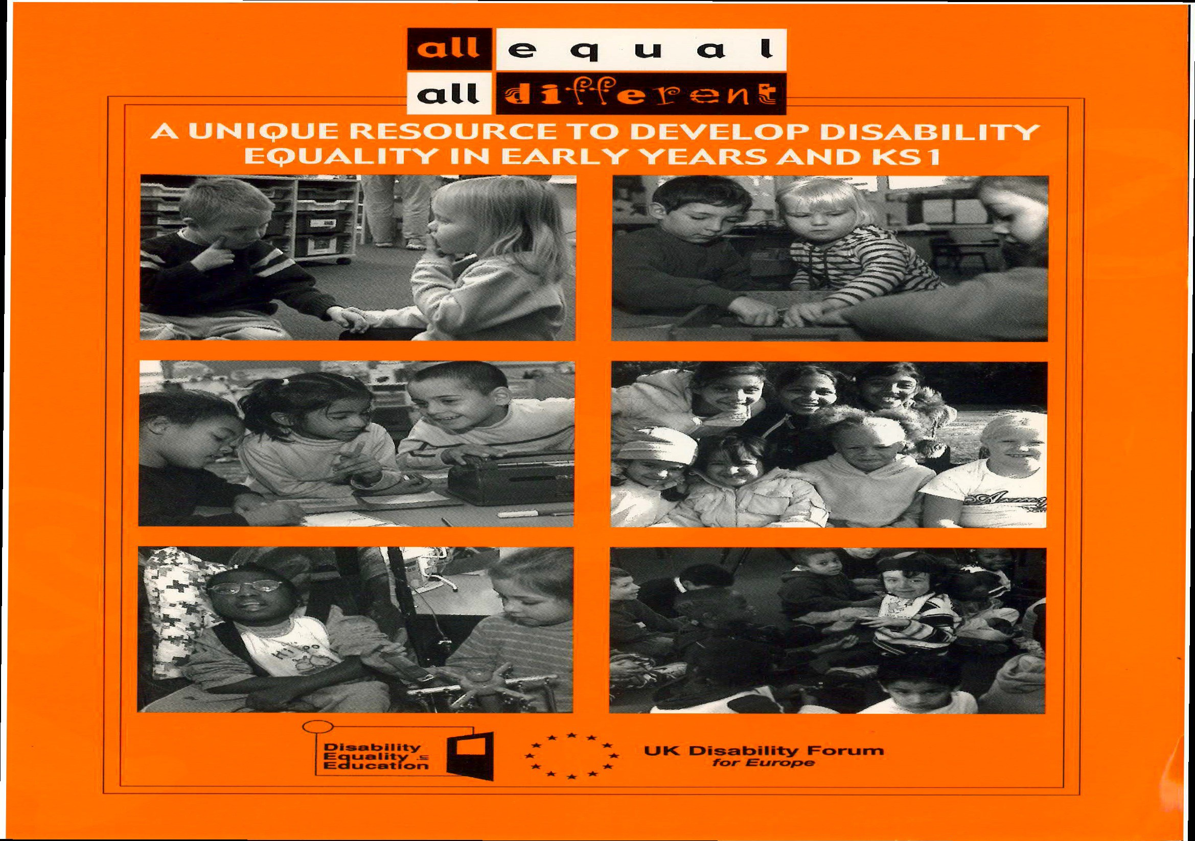
http://worldofinclusion.com/res/alleq/21222_A3_Posters.pdf

School Staff Equalities Case Studies
    - Maternity leave
A female teacher takes up a new post at your school which is an academy. She was previously teaching at a maintained school in another borough for 5 years. She took a term off before taking up her new post. In November she approaches you as School Representative as she has just discovered she is five months pregnant and is worried she may not be entitled to maternity leave or the right to return to her job.
      - What do you advise her?
      - How would it be different if:-­‐ a) it was a maintained school? b) she had worked at the academy for 1 year?
      - How will you present her case to the head teacher?
      - What other support will you give her?
    - Age/Capability/ Menopause
A female teacher has been at your school for 15 years and been teaching for 29 years. She holds two TLRs and is on Upper Pay Spine 3. She has always had excellent appraisals and is a popular and well liked colleague. She has recently been taking more time off work because her menopause is severely affecting her. This has been 2-­‐3 days a month for the last 4 months. She has a letter from her GP identifying the impact on her and saying it is likely to last for another eight months or more. The head teacher has informed her that he is commencing Capability procedure against her. She only tells you her concerns after the initial interview of the Capability procedure as the head teacher did not make it clear what the meeting was about.
      - What do you advise her?
      - How do you respond to the head teacher?
      - What other support do you give the member?
    - Disability
A male 56 year old teacher in the Leadership Team at your school, asks your help. He confides in you that he is slowly losing his hearing in both ears but has been too frightened to tell the head teacher. However, he has increasingly not carried out his job effectively as he has misheard requests and information given to him. The head teacher has now asked to see him formally, with a union rep.

- What do you advise him to do?
- How can you support him when he meets the head?
- How else can you support the member to carry on his teaching role?

    - Racism

A Black teacher from Nigeria has been teaching at your school for 9 years. Previously he was a principle of a school in Lagos. He came to England to study for his M.Ed. During the course he met and married a British national and was given indefinite leave to remain. He worked as a science teacher at the unqualified rate and after passing a Maths and English GCSE which was granted qualified teacher status 5 years ago. Twice the post of Head of Department has become vacant and twice he has applied and been turned down.
Feedback he received was he was overqualified and did not have enough experience of the British school examination system. He has heard that the Head of Science appointed a year ago will be leaving at the end of the year, wants to apply again and asks for your help.
      - What do you advise him ?
      - What other help can you provide?
      - How would you involve the other NUT members in the school?

    - Homophobia
A gay teacher at your school does not disguise their life style and sexuality.
He recently married his partner and there was a picture in the local paper. A group of older pupils in the school have called him pejorative names when he is in the playground. He comes to you, as NUT Rep, to ask what he should do. A week later one of these pupils has accused the gay teacher of sexually molesting him and he has come with his parents to complain. The teacher denies vehemently that he was ever with this boy on his own and ever did anything to him.
      - How do you support this teacher?
      - What should be done in the school?
      - What are some of the ways the culture of the school can be changed?

    - Sexual Harassment

A young female teacher in a mixed comprehensive is in her probationary year. She has been subjected to some touching while walking to her lesson along a crowded corridor. On a previous occasion, a group of Year 10 boys have been too familiar with her asking if she has a boyfriend and what does she do sexually with him. She is embarrassed and in tears in the staff women’s toilet and does not know what to do or whom to talk to.
- As the NUT Rep what do you advise her?
- What do you do?
- What response should the school have?

R. Rieser June 2017

Barriers Visible and Invisible Barriers: the impact of racism on BME teachers The Runnymede Trust and NUT Dr Zubaida Haque and Sian Elliott 2017
Overall, the BME teachers’ survey and interviews revealed that there are large differences in perceptions and career progression among BME teachers, and that, more importantly, discrimination based on race is one of the more significant and deep rooted factors that affect the experience of teaching and career progression for BME teachers. Differences in experiences in school and career progression are particularly marked for Black Caribbean and Black African teachers in comparison to other minority ethnic groups. Age, length of experience in teaching and geographical location were also important factors influencing the experience of BME teachers in primary and secondary schools.

Key findings
What did the findings from the survey and focus groups tell us? Who are the respondents?
- Overall 1,027 respondents completed the questionnaire. The majority of the teaching sample worked at secondary school level (51%). 35% worked in primary schools and the remaining respondents worked in nursery, post-­‐16 further education colleges and pupil referral units.
- Two thirds of the sample were class teachers, 11% head of year and 11 respondents at head teacher level. Black respondents were more likely to be in senior roles compared to their Asian counterparts. However, Asian respondents were on average younger than their Black peers; around half of the Asian teachers were aged less than 35 years, compared to around a third of their Black peers under the age of
35. Asian teachers were also less likely to have been teaching for 10 years or more than their Black counterparts.
- Just under half of the sample had entered teaching through the traditional PGCE route, 14% through non-­‐traditional routes and 6% had overseas training. Inclusive and non-­‐inclusive schools
- 40% of the survey respondents taught in schools where less than 5% of the staff were from BME backgrounds. This is important to note because the survey showed that a higher proportion of BME staff in a school was associated with respondents feeling that the ‘school was an inclusive and welcoming environment for staff of all ethnic backgrounds.’
- Conversely, the survey showed that a higher proportion of BME pupils in a school was associated with a lower proportion of respondents (teachers) feeling that the ‘school was an inclusive and welcoming environment for students of all ethnic backgrounds’. This was a prevalent view among primary school teachers as well as younger BME teachers and could not be explained by the data. But it may raise a bigger question about the equality of treatment of BME children in schools.
- Younger (under age 35) BME teachers were more likely to have ‘positive experiences in school’ which included feeling valued by managers, feeling positive about the appraisal system and feeling that the school was an inclusive environment for them. This also manifested itself in ethnic differences in perceptions of career support, with slightly higher proportions of Asian respondents feeling supported by their managers in their career development and progression compared to their Black peers. In addition, Asian teachers were more likely to agree (compared to their Black peers) that staff in the school were more comfortable talking about race/racism. Career progression

- Black teachers in the survey were more likely to apply for promotion than their Asian peers; 40% of Indian and Pakistani teachers had never applied for promotion. Black teachers were also more likely to be successful in their career promotions. Some of these patterns may be explained by age demographics given the younger age of Asian respondents in this survey. • A third of the sample had never applied for promotion, and over 80% of this group were female. However, whilst males were more likely to apply for promotion, the survey revealed that they were more dissatisfied with the application process and outcomes, and less likely to agree, than their female counterparts, that they were treated equally in their career promotions. Views and experiences as BME teachers
- The focus group interviews revealed that the BME participants viewed themselves as important ‘role models’ for BME students – both in terms of protecting students from a ‘Prevent’/Islamophobic narrative, but also in terms of giving them positive role models to focus on. • Whilst there were many teachers who were positive and felt supported by the senior leadership teams in their school, there were also many BME teachers, who reported feeling isolated and lacking in management support with regards to incidences of racism 5 Barriers and career progression. This was a stronger view among Black teachers (in comparison to their Asian peers) and was reinforced in the survey findings.
- BME teachers from all ethnic groups complained about being given stereotypical responsibilities (e.g. behaviour responsibilities or Black History Month) instead of challenging intellectual Teaching and Learning Responsibility (TLR) roles. Black teachers, in particular, spoke about being labelled ‘troublemakers’ or being viewed as ‘aggressive’ if they challenged any decisions.
- There was unanimous agreement amongst BME participants that there should be more BME staff in the school workforce generally (and within their schools specifically) but reasons for BME staff representation varied widely.
Most agreed that role models for students were desirable, but others went further to argue that it was a necessity to protect students from being stereotyped or misunderstood. The findings from the qualitative research reinforced the survey findings – with most BME teachers identifying persistent discrimination, “microaggressions” and unfair and unequal treatment in their everyday teaching lives.
Many of the reported negative experiences included being denied promotion without institutional clarity, cultural or racial stereotyping in terms of teaching roles/extra roles and lack of support or firm action (e.g. zero tolerance) in relation to racist incidences against staff in school. Across the interviews and surveys, the experience and perception of discriminatory and unequal treatment dominated the discussions, although without much prompting BME teachers were also keen to report positive leadership from heads and ‘good relationships’ with other members of staff.
Full Report at https://www.teachers.org.uk/sites/default/files2014/barriers-­‐report.pdf

Pregnant and Adopting employees' rights https://www.gov.uk/working-­‐when-­‐pregnant-­‐your-­‐rights Pregnant employees have 4 main legal rights:
- paid time off for antenatal care
- maternity leave
- maternity pay or maternity allowance
- protection against unfair treatment, discrimination or dismissal

‘Antenatal care’ isn’t just medical appointments -­‐ it can also include antenatal or parenting classes if they’ve been recommended by a doctor or midwife.

Employers can’t change a pregnant employee’s contract terms and conditions without agreement -­‐ if they do they are in breach of contract.

Employers must give pregnant employees time off for antenatal care and pay their normal rate for this time off. The father or pregnant woman’s partner has the right to unpaid time off work to go to 2 antenatal appointments.

Pregnancy-­‐related illnesses

Maternity leave and Statutory Maternity Pay will start automatically if the employee is off work for a pregnancy-­‐related illness in the 4 weeks before the baby is due -­‐ it doesn’t matter what has been previously agreed.

Compulsory maternity leave

If the employee isn’t taking Statutory Maternity Leave, they must take 2 weeks off after the baby is born -­‐ or 4 weeks if they work in a factory.

Telling the employer about the pregnancy

Employees must tell their employer about the pregnancy at least 15 weeks before the beginning of the week the baby is due.

If this isn’t possible (e.g. because they didn’t know they were pregnant) the employer must be told as soon as possible.

Employees must also tell the employer when they want to start their Statutory Maternity Leave and Statutory Maternity Pay.
Employees can’t take time off for antenatal appointments until they’ve told the employer about the pregnancy.

Health and safety for pregnant employees

When the employee tells her employer she’s pregnant, the employer should assess the risks to the woman and her baby.

Risks could be caused by:

- heavy lifting or carrying
- standing or sitting for long periods without adequate breaks
- exposure to toxic substances
- long working hours

Where there are risks, the employer should take reasonable steps to remove them, e.g. by offering the employee different work or changing their hours.

The employer should suspend the employee on full pay if they can’t remove any risks, e.g. by offering suitable alternative work.
For full details about the regulations see the Health and Safety Executive website.
Pregnant employees who think they’re at risk but their employer disagrees should talk to their health and safety or trade union representative. If your employer still refuses to do anything, talk to your doctor or contact the Health and Safety Executive.
http://www.hse.gov.uk/mothers/faqs.htm#q4

Statutory Maternity Leave and Pay

When you take time off to have a baby you might be eligible for:

Statutory Maternity Leave
Statutory Maternity Leave is 52 weeks. It’s made up of:

- Ordinary Maternity Leave -­‐ first 26 weeks
- Additional Maternity Leave -­‐ last 26 weeks

You don’t have to take 52 weeks but you must take 2 weeks’ leave after your baby is born (or 4 weeks if you work in a factory). The earliest that leave can be taken is 11 weeks before the expected week of childbirth, unless the baby is born early.

Eligibility

You qualify for Statutory Maternity Leave if:

- you’re an employee not a ‘worker’-­‐ have a contract of employment
- you give your employer the correct notice

Correct notice. At least 15 weeks before your due date, tell your employer when the baby is due and when you want to start your maternity leave. Your employer can ask for this in writing.

Your employer must write to you within 28 days confirming your start and end dates. It doesn’t matter how long you’ve been with your employer, how many hours you work or how much you get paid.

If the baby is born early. Leave starts the day after the birth if the baby is born early. The employee must give you the child’s birth certificate or a document signed by a doctor or midwife that confirms the actual date of birth. The employer must write to them confirming the new end date for their leave.

Statutory Maternity Pay (SMP)

To qualify for SMP you must:

- earn on average at least £113 a week
- give the correct notice
- give proof you’re pregnant
- have worked for your employer continuously for at least 26 weeks up to the ‘qualifying week’ -­‐ the 15th week before the expected week of childbirth

Statutory Maternity Pay (SMP) is paid for up to 39 weeks. You get:

- 90% of your average weekly earnings (before tax) for the first 6 weeks
- £140.98 or 90% of your average weekly earnings (whichever is lower) for the next 33 weeks

SMP is paid in the same way as your wages (for example monthly or weekly). Tax and National Insurance will be deducted.

Local Authority’s and schools can offer more than the statutory amounts if they have agreed local or national maternity schemes.

To qualify for the Hackney Learning Trust Occupational Maternity Pay (OMP)/Occupational Adoption Pay (OAP), an employee has to fulfil the same requirements as for SMP/SAP, but must also have completed a minimum of one year’s continuous service with one or more local authorities by the beginning of the 11th week before the EWC i.e. 63 weeks of continuous service before the EWC (in the case of maternity) or by the beginning of the matching week (in the case of adoption).
OMP/OAP is paid for a maximum of 26 weeks, with the payment broken up as follows:
12 weeks Full average weekly pay (offset against any statutory payments (SMP/SAP) made during this time).
2 weeks 90% average weekly pay + SMP/SAP* 12 weeks 50% average weekly pay + SMP/SAP* 13 weeks SMP only
13 weeks Unpaid
* Payments in these weeks will not exceed full average weekly pay.
The ‘average weekly earnings’ is the employee’s average earnings between the 23rd and 15th week prior to the EWC .Employers must make sure your maternity leave and pay policies are clear and available to staff.
There are rules on when and how to claim your paid leave and if you want to change your dates. You can work out your maternity pay and leave online.
You may also be eligible to get Shared Parental Leave and Pay.
Employment rights when on leave
Your employment rights are protected while on Statutory Maternity Leave. This includes your right to:
- pay rises
- build up (accrue) holiday
- return to work

Teachers’ protection from harassment at school
All teachers have specific protection at work from harassment on grounds of age, disability, race, nationality, gender, sexual orientation-­‐lesbian, gay or bi-­‐sexual, transgender, religion, religious belief, philosophical belief or lack of religion or belief under the Equality Act 2010. You are protected whether the alleged harasser has the same protected characteristic as you or not and you are protected whether you are a permanent, fixed term, full-­‐time, part-­‐time, supply or agency teacher. Your colleagues, managers and governors are prohibited from harassing you. If you are an agency teacher working on a day to day or longer term contract, your agency and the schools in which you are working are prohibited from harassing you.

What about harassment by pupils, parents or visitors?
Your employer must take steps to prevent and deal with unlawful harassment at work by a third party who is not your employer or a colleague, such as a pupil or parent. Where third party harassment has occurred, your employer may be liable if it was aware that the harassment had taken place and it did not take reasonable steps to prevent it happening again. So it is important that you report any harassment and that your employer records it.

What is harassment?
Age.It is unwanted conduct, on grounds of age, physical or mental impairment, which violates your dignity, or creates an intimidating, hostile, degrading, humiliating or offensive environment for you.
Harassment is unlawful whether it is on grounds of your actual age or your apparent age or even on grounds of the age of the people you associate with. Harassment can be on grounds that you are within an age range, for example, that you are in your 20s, 30s, 40s, 50s, 60s or 70s.
Disability harassment would include hostile and intimidating behaviour by colleagues towards you because you have a physical or mental impairment. It could also include degrading or humiliating behaviour towards you such as unjustified criticism, unsupported allegations that you are not ‘pulling your weight’, or pressure on you to take ill-­‐health retirement against your wishes. Intimidating or degrading behaviour, such as name-­‐calling or offensive disablist 'jokes' by pupils or colleagues or graffiti could amount to harassment.
Race. Harassment on grounds of race would include hostile and intimidating behaviour towards people on grounds of their ethnic origin. Or it could include subjecting you to degrading treatment because of your racial origins. Intimidating or humiliating behaviour, such as name-­‐calling or offensive racist ‘jokes’ by pupils or colleagues, or racist graffiti could amount to harassment. The harassment itself does not have to make explicit reference to race but if the reason behind the harassment is race, then it will be unlawful. Even if the conduct is not directed at you personally, you may feel intimidated by insidious behaviour which creates an offensive work environment for you.
Sexual Harrassment on grounds of sex would include hostile and intimidating behaviour by colleagues towards a woman because she is a female senior manager, or degrading and humiliating behaviour towards a teacher because he is the only man in a school. It would also include harassment of a woman because she is pregnant or breast-­‐feeding. The harassment itself does not have to make explicit reference to sex or gender but if the reason behind the harassment is sex or gender, then it will be unlawful.It is also sexual harassment to treat a man or woman less favourably because she or he has accepted or rejected sexual advances.
Sexual Orientation Harassment would include hostile and intimidating behaviour by colleagues towards lesbian or gay people generally or humiliating behaviour towards you because you have a same-­‐sex partner. Intimidating or degrading behaviour, such as name-­‐calling, offensive homophobic or biphobic ‘jokes’ by parents, pupils or colleagues or graffiti, or requests to hide your sexual orientation from pupils, could amount to harassment. The harassment itself does not have to make explicit reference to sexual orientation but if the reason behind the harassment is sexual orientation, then it may be unlawful.
Transgender harassment is harassment on grounds that you propose to undergo, are undergoing or have undergone gender reassignment. Gender reassignment is the medical and social process whereby you change your birth sex to match your chosen gender identity. The Equality Act has removed the former

requirement that the gender reassignment process must take place under medical supervision. The legal definition is limited to gender reassignment and does not cover harassment on grounds that you are, for example, a transvestite person, although harassment on the grounds that you are perceived to be undergoing gender reassignment is likely to be unlawful. Even if the conduct is not directed at you, you may feel intimidated by insidious behaviour which creates an offensive work environment for you.
Religous harassment would include hostile and intimidating behaviour by colleagues towards people of a particular faith or humiliating behaviour towards you because you follow a particular religion. Intimidating or degrading behaviour, such as name-­‐calling, offensive religious 'jokes' by pupils or colleagues or graffiti could amount to harassment. Even if the conduct is not directed at you personally, you may feel intimidated by insidious behaviour which creates an offensive work environment for you. The harassment itself does not have to make explicit reference to religion or belief but if the reason behind the harassment is religion or belief, then it will be unlawful.

What sort of behaviour is covered?

Harassment on grounds would include hostile and intimidating behaviour by colleagues towards you because you are a protected characteristic. It could also include degrading or humiliating behaviour towards you because you are older than, and do not socialise with, your younger colleagues. The harassment itself does not have to make explicit reference to your protected characteristic but if the reason behind the harassment is your protected characteristic, then it will be unlawful. Intimidating or degrading behaviour, such as name-­‐calling or offensive ‘jokes’ by colleagues or pupils or graffiti, could amount to harassment. A single incident might constitute harassment if it is sufficiently serious. A series of incidents is likely to amount to harassment especially if you have given a clear indication that the behaviour is unwanted.

What should I do if I think I am being harassed?
If you can, ask for the behaviour to stop.

Offensive pupil/student behaviour should be reported under the pupil/student discipline procedure or in writing to your head teacher or principal.

Gather all the written evidence that you have for example letters, emails, texts and relevant screenshots. Keep a diary of all incidents of unwanted conduct including dates, times, places, the names of any witnesses, and your response to the conduct or behaviour.

Ask your NUT rep or school or college office for copies of harassment and bullying policies. The NUT urges all employers to adopt clear harassment and bullying policies and procedures for dealing with workplace harassment fairly and quickly.

Discuss your concerns with your NUT workplace rep. Your colleagues may have made similar complaints and you may be advised to tackle the issue with them collectively.

You or your rep might decide to contact the NUT for further advice.

If informal approaches to Head do not work make a complaint that must be investigated.

More specific guidance https://www.teachers.org.uk/help-­‐and-­‐advice/self-­‐help/d/discrimination

Adapted Richard Rieser

Staff Employment Equality Guidance Age Equality
TUC The health and safety of older workers – Guidance https://www.tuc.org.uk/equality-­‐issues/age-­‐ equality/workplace-­‐issues/health-­‐and-­‐safety/health-­‐and-­‐safety-­‐older-­‐workers

TUC Managing Age https://www.tuc.org.uk/equality-­‐issues/age-­‐equality/managing-­‐age-­‐%E2%80%93-­‐new-­‐ edition-­‐2011

Disability Equality

NUT – Disability Discrimination Guidance for Members https://www.teachers.org.uk/sites/default/files2014/ee9-­‐disability-­‐discrimination.doc
Reasonable Adjustments for Disabled Members https://www.teachers.org.uk/sites/default/.../ecr-­‐9-­‐ reasonable-­‐adjustments_0.doc
Disability Harrassment https://www.teachers.org.uk/sites/default/files2014/ee8-­‐disability-­‐harassment.doc

Unison guidance for school leaders on preventing work-­‐related mental health conditions by tackling stress https://www.unison.org.uk/content/uploads/2015/03/TowebPreventing-­‐mental-­‐health-­‐conditions-­‐by-­‐tackling-­‐ stress-­‐at-­‐work-­‐Jan-­‐15.doc2.pdf

TUC Sickness Absence and Disability Discrimination https://www.tuc.org.uk/sites/default/files/tucfiles/sickness_absence_and_disability_discrimination_feb2013.pdf
TUC Epilepsy in the Workplace https://www.tuc.org.uk/EpilepsyintheWorkplace

TUC Autism in the Workplace https://www.tuc.org.uk/equality-­‐issues/disability-­‐issues/disability-­‐resources/autism-­‐ workplace
TUC Trade Unions and Disabled Members: Why the social model matters https://www.tuc.org.uk/equality-­‐ issues/disability-­‐issues/campaigning-­‐disability-­‐equality/resources/trade-­‐unions-­‐and

TUC Dyslexia in the Workplace https://www.tuc.org.uk/equality-­‐issues/disability-­‐issues/disability-­‐ resources/dyslexia-­‐workplace
Gender Equality

TUC Tackling Sexual Harassment in the workplace https://www.tuc.org.uk/equality-­‐issues/sexual-­‐ harassment/tackling-­‐sexual-­‐harassment-­‐workplace-­‐tuc-­‐guide-­‐trade-­‐union
TUC Domestic Violence: a guide for the workplace https://www.tuc.org.uk/equality-­‐issues/gender-­‐ equality/violence-­‐against-­‐women/domestic-­‐violence-­‐guide-­‐workplace

TUC Still just a bit of banter? Sexual harassment report For anyone who thinks that sexual harassment has been consigned to the past – a relic of the days of Benny Hill and Carry On films – new research from the TUC on sexual harassment in the workplace will come as a nasty surprise. https://www.tuc.org.uk/equality-­‐issues/sexual-­‐harassment/gender-­‐equality/still-­‐just-­‐bit-­‐banter-­‐sexual-­‐ harassment-­‐report

Equal Pay https://www.tuc.org.uk/equality-­‐issues/gender-­‐equality/equal-­‐pay

Maternity Matters 2017 NUT https://www.teachers.org.uk/sites/default/files2014/maternity-­‐matters-­‐ may-­‐2017_fi.pdf

NUT State Pension Age Increase for Women March 2016 https://www.teachers.org.uk/pay-­‐pensions-­‐ conditions/pensions/state-­‐pension-­‐age-­‐increase-­‐women-­‐march-­‐16
LGBT Equality

https://www.teachers.org.uk/sites/default/files2014/AntiHomophobic-­‐6326.pdf NUT – Working for a Fairer future – LGBT equality in education with guidance for school reps.
https://www.ucu.org.uk/media/5014/Trans-­‐equality-­‐in-­‐post-­‐school-­‐education/pdf/forum_trans_guide_20121.pdf UCU Advice on Transgender in Post Schools
TUC LGB & T workers and mental health https://www.tuc.org.uk/equality-­‐issues/lesbian-­‐gay-­‐bisexual-­‐and-­‐ transgender-­‐rights/lgbt-­‐advice-­‐information/lgb-­‐t-­‐workers

TUC LGB&T Equality at Work 2013 https://www.tuc.org.uk/equality-­‐issues/gender-­‐equality/lesbian-­‐gay-­‐bisexual-­‐ and-­‐transgender-­‐rights/lgbt-­‐advice-­‐information
Gires Transition of a Teacher in School Summary of the Law and Good Practice http://www.gires.org.uk/assets/Schools/The%20Memorandum%20of%20Understanding%20teacher%20transition.p df
Race Equality and Anti Racism

Barriers Invisible and Visible to BME Teachers Runnymede Trust 2017 https://www.teachers.org.uk/sites/default/files2014/barriers-­‐report.pdf
TUC Tackling Racism in the Workplace https://www.tuc.org.uk/publications/tackling-­‐racism-­‐workplace-­‐ negotiators%E2%80%99-­‐guide

TUC organising against fascism in the workplace https://www.tuc.org.uk/black-­‐workers/organising-­‐against-­‐
fascism-­‐workplace
Employing Refugees https://www.refugeecouncil.org.uk/assets/0003/4097/Employing_Refugees_-­‐
_Guide_to_documents_required_Dec_2014.pdf

NUT Specific guidance on all areas of the Equalities Act in the Workplace can be found at https://www.teachers.org.uk/help-­‐and-­‐advice/self-­‐help/d/discrimination

